Youth Extenders Sustain Healthy Living in Calaveras County

SUMMARY
Calaveras Unified (CUSD) is a rural school district serving approximately 2,800 students, TK-12th grade. CalFresh Healthy Living UCCE (CFHL UCCE) has a long-standing partnership with the district, providing nutrition education, physical activity lessons, and gardening support since 2017. In FFY24, CUSD and CFHL UCCE partnered to train students from Calaveras High School to teach nutrition and physical activity to students at a neighboring elementary school.
In FFY25, the project grew to include bussed transportation for youth extenders to an additional elementary school and collaboration between leadership groups at Calaveras High and Valley Springs Elementary. This collaboration between leadership groups at Calaveras High and Valley Springs Elementary has been impactful, strengthening partnerships and extending the project’s reach in CUSD.

BACKGROUND
CFHL, UCCE programming at Calaveras High School (CHS) has historically focused on cooking-enhanced nutrition education. Every year, CFHL, UCCE educators collaborate with CHS staff to recruit and enroll interested students into 3 separate class periods for weekly cooking-enhanced nutrition education lessons.

In FFY24, 15 students from these classes were trained as Teens-as-Techers extenders in the CATCH and 4-H Cooking 101 curricula. As extenders, they led nutrition education and physical activity lessons at San Andreas Elementary (a neighboring school) and activities at the biannual “Ag Day” events at CHS. To participate in the lessons and activities, students received permission from their guardians and school district to take “walking field trips” to San Andreas Elementary (SAE) to teach these lessons. In FFY24, teens-as-teachers reached approximately 150 elementary students in 5 separate class periods with student-led physical activity lessons.

The strong support from parents and the school district is a critical community asset. This investment in youth leadership strengthened the teens-as-teachers program in FFY24 and fueled its expansion in FFY25

SOLUTION
Building on the success of the youth-extender program in FFY24, both students and staff were eager to expand on the program.
The teens-as-teachers continued supporting the biannual Ag Day events, reaching approximately 300 3rd graders with food safety demonstrations and healthy snack tastings.
CATCH lessons at San Andreas Elementary (SAE) continued, with CHS students taking walking field trips to lead physical activity lessons with 3 class periods of younger students. In FFY25, CHS students held multiple “CATCH Days” at SAE, allowing them to refine their lesson delivery, explore their favorite activities, and build relationships with younger students.
The Calaveras High School teens-as-teachers program also expanded to Valley Springs Elementary School (VSE), where student leadership groups collaborated to lead a “CATCH Field Day” with the entire elementary school. In this project, six high schoolers and eight 4th graders co-lead CATCH activities during lunch, providing approximately 450 students opportunities to engage in physical activity with their peers. Student leaders structured these activities to be fluid and elective, with no mandatory activities or timed transitions. Their goal was to encourage their peers to engage in these activities on their own time using equipment already on campus. In addition to leading CATCH activities, students prepared and served infused water and healthy snack tastings to promote healthy eating behaviors and to share favorite recipes with their peers.
Support from the school district is imperative for this project, as the district structures youth-leadership activities into the culture and instructional time at their schools. Beyond that, CUSD overcame the chief logistical barrier by funding and arranging van transportation for high school students travelling to VSE.

“We went to San Andreas Elementary and did some PE with them. It was pretty fun! I feel like I learned a lot… How to control a group and talk to a group, and to get better with speaking.”
-Derek, CHS Student (11th Grade)
“I’m really taking away the fact that I can cook now…And I learned better skills on how to speak because you have to present in front of the class, and during the CATCH lessons you have to speak.”
-Aaron, CHS Student (11th Grade)
“Cooking Academy is going to help me because I want to be a teacher, and it’ll help me get used to being in front of students and teaching.”
-Jordan, CHS Student (12th Grade)
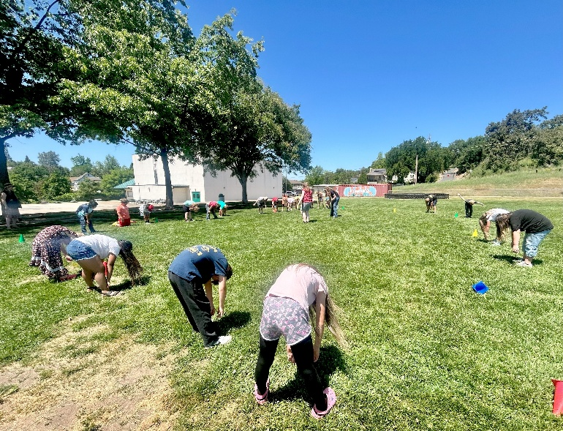
San Andreas Elementary students participate in a CATCH lesson lead by Calaveras High School extenders. May 2025. Photo credit Bambi Baechler.

OUTCOME
The Calaveras High School teens-as-teachers program has seen tremendous success in FFY24 and FFY25, enrolling 21 youth volunteers in these years.
CATCH lessons at San Andreas Elementary have reached approximately 242 students in FFY24 and FFY25 with peer-lead physical activity.
The 2025 CATCH Field Day at Valley Springs Elementary reached approximately 450 students with physical activity opportunities and healthy eating information.
The biannual Ag Day events at CHS reach approximately three hundred 3rd graders per year, extending healthy living knowledge and a culture of youth leadership. These events are important, as they lay the foundation for future students to engage in youth leadership opportunities. For example, the 4th grade students at Valley Springs Elementary who led the 2025 CATCH Field Day event met their teens-as-teachers partners at the previous year’s Ag Day event. This familiarity with youth leadership and their older peers enabled younger students to step into leadership roles and collaborate across campuses.
This collaboration is successful due to investment from Calaveras Unified School District, CalFresh Healthy Living UCCE, and—most importantly—individual students and teachers. It is a community movement strengthened and supported by University resources, and is therefore sustainable beyond FFY25.

