SUMMARY
CalFresh Healthy Living, UCCE (CFHL, UCCE) in collaboration with Mother Lode Rehabilitation Enterprise (MORE), provided 12 adults with five-session TWIGS (Teams With Intergenerational Support) classes, aligned with physical activity from the Eat Smart, Live Strong curriculum. The goal of this series was to create a learning environment for MORE clients where they could engage independently in a hands-on kitchen taste testing experience. This program offered the space for clients to practice fundamental cooking skills, as well as, build confidence in making informed decisions about their health. From this program, clients advocated their desires to cook more in their homes with family or with their friends in their community living facilities.

BACKGROUND
Mother Lode Rehabilitation Enterprise (MORE), is a local non-profit organization that for over 50 years has supported adults with disabilities. MORE works to find solutions that ensure equal opportunity for adults with developmental disabilities. They achieve this by focusing on four objects that help the clients maximize their independence through employment, self-advocacy, health, and safety. Since 2018, CFHL, UCCE educators have helped to further these objectives by providing evidence-based nutritional lessons in food preparation and nutrition.

In FFY 2023, the clients of MORE expressed interest in more hands-on opportunities. In response, CFHL, UCCE adapted the TWIGS curricula for this population in order to expand on their nutrition knowledge and offer hands-on taste test preparation in MORE’s facility’s kitchen.

SOLUTION
The TWIGS curriculum was adapted to a five-lesson series with physical activity components integrated from Eat Smart, Live Strong curricula, hands-on nutrition education activities, and hands-on cooking demonstrations. Precautions were taken when it came to kitchen preparations. The CFHL, UCCE nutrition educator, worked to acquire safety knives, silicone adaptive aids (to make utensils easy to hold), and heat/burn guards (used for working with skillets). Working with MORE, CFHL, UCCE nutrition educators created a safe, inclusive environment that accommodated all clients in the classes. Clients were able to safely prepare their own taste test samples, while having fun doing it!

“I had an awesome time!”
-Kane, MORE client
“I think for the first time in their lives they feel confident regarding feeding themselves. This has been a game charger for them.”
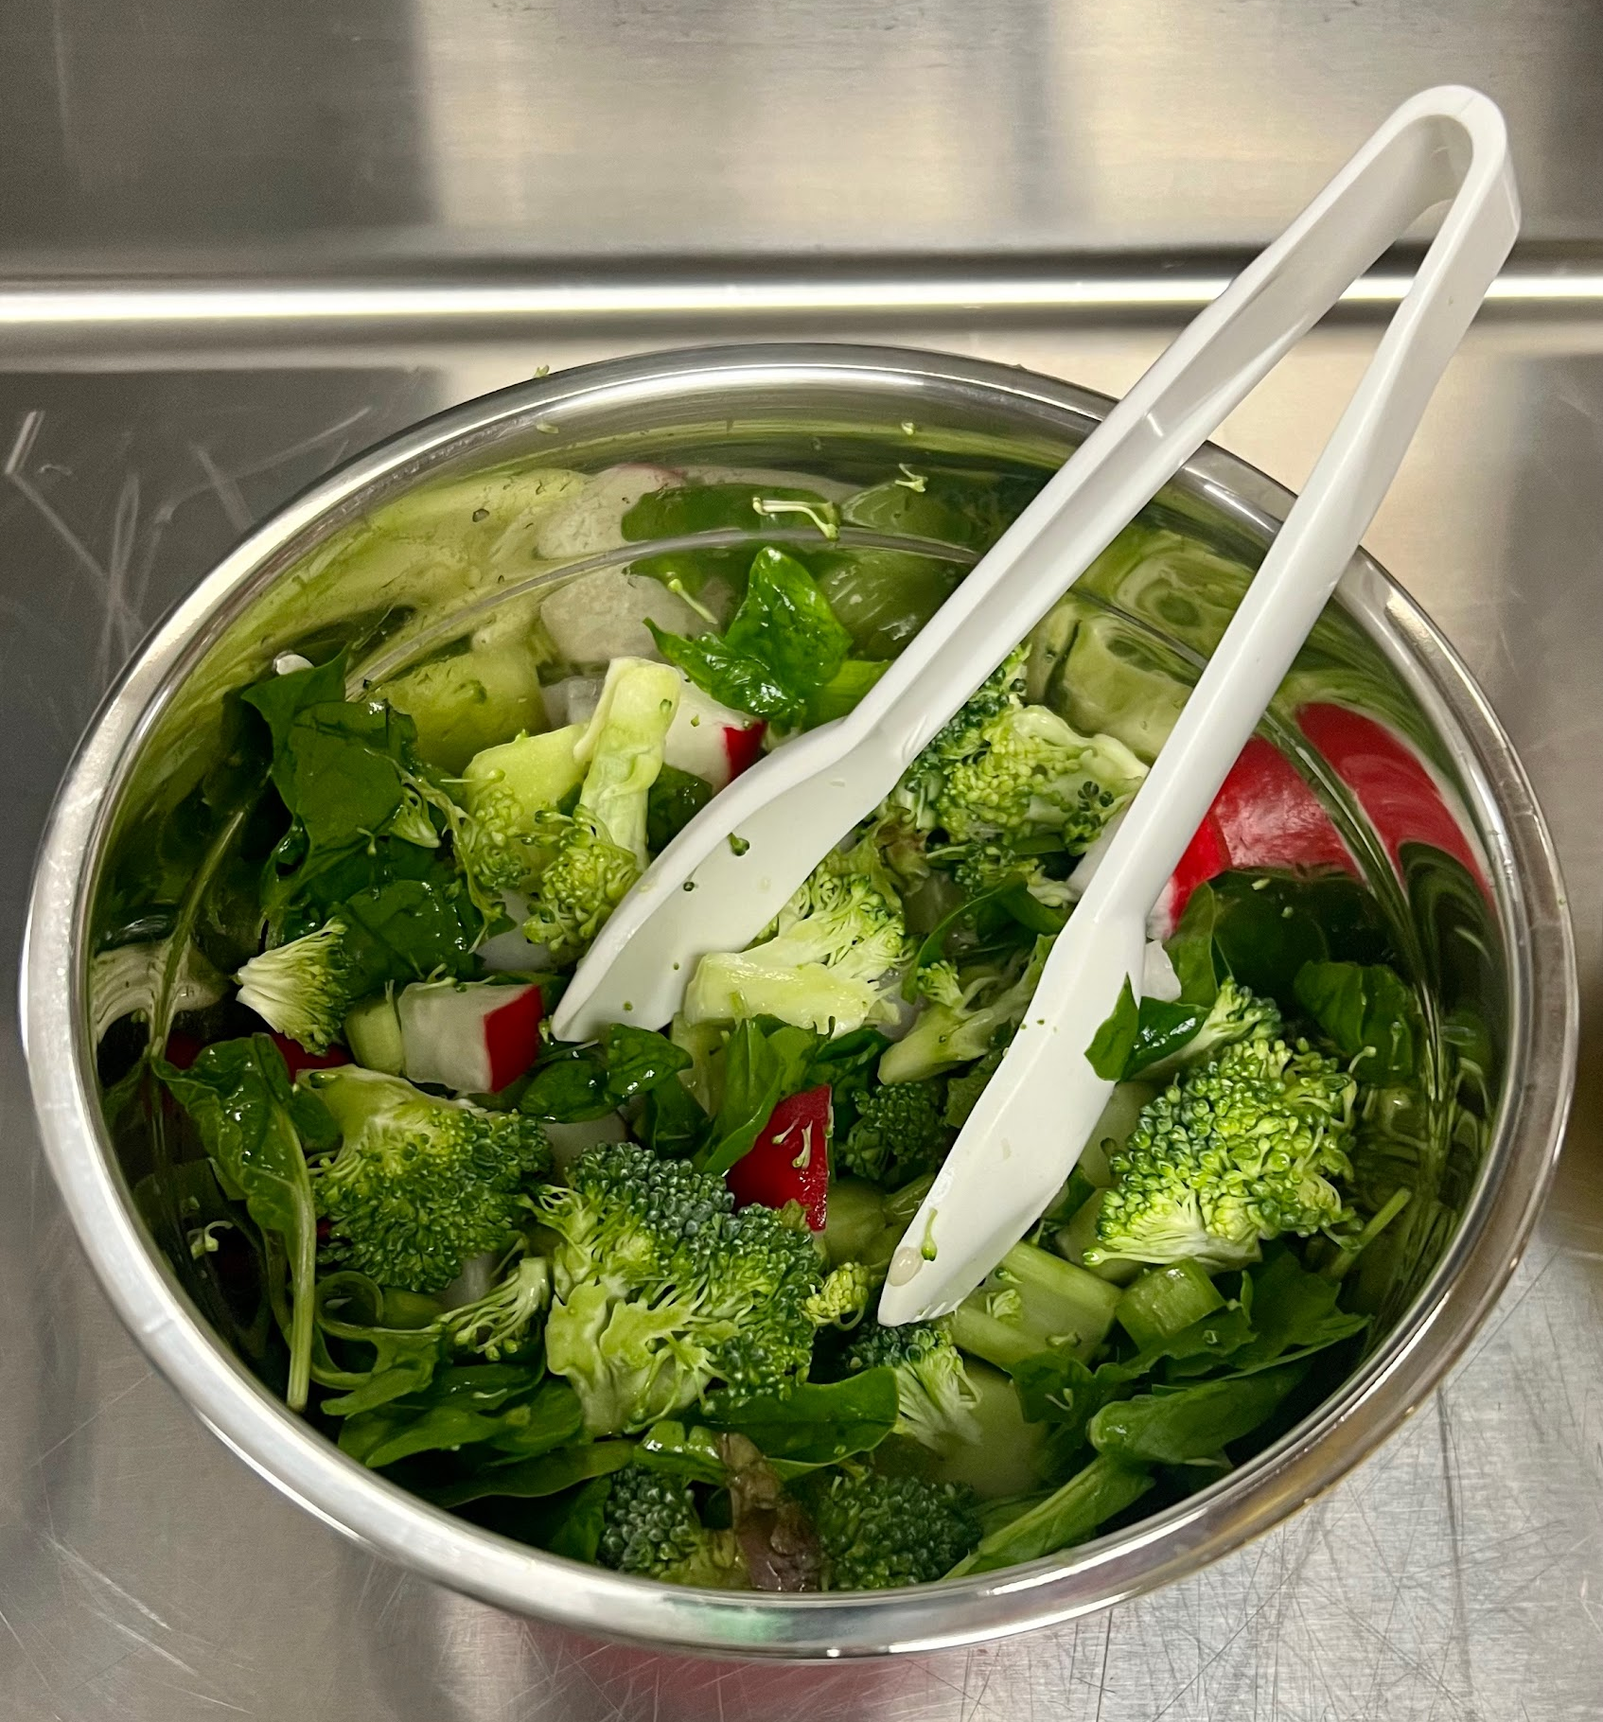
-Luanne, MORE Staff

Finished “Plant Part Salad” taste test (recipe from foodhero.org).

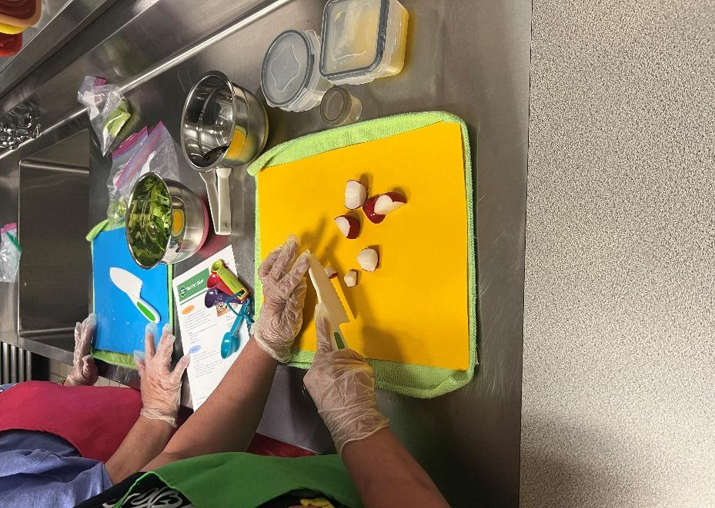

MORE client preparing their “Plant Part Salad” taste test (recipe from foodhero.org) as part of their TWIGS adaptive lesson “Eat Your Plants.”.

OUTCOME
Twelve MORE clients signed up for the opportunity to complete a five lesson nutrition series that involved kitchen safety, hands-on taste test preparation experience, and physical activity. CalFresh Healthy Living, UCCE and MORE intend to continue this lesson series and introduce new cohorts of clients to experiential learning through hands-on nutrition lessons. Our MORE clients are eager to be exposed to more challenging recipes.CFHL, UCCE intends to offer them the chance to continue this series in the new fiscal year, once they have graduated from these first five lessons. We have been hearing from staff and clients that due to these lessons, guardians and family members are eager to have their assistance in the kitchens!
CFHL, UCCE educators will also continue working with the University of California Master Gardeners of El Dorado to facilitate co-led garden-based nutrition education. In addition, MORE and CFHL, UCCE have been working on a Community Participatory Action Project using the Stanford Our Voice Discovery Tool mobile app focusing on the accessibility of physical activity space at the MORE facility.

