Expanding Garden Partnerships at Arc of Amador

SUMMARY
CalFresh Healthy Living, UCCE in partnership with Arc of Amador and the UCCE Master Gardeners of Amador County facilitated garden programming with Arc clients, incorporating composting and cooking elements that reach 60 on-site participants. CFHL, UCCE partnered with Master Gardener volunteers to coordinate the donation of compost bins to the Arc site and facilitated biweekly TWIGS (Teams with Intergeneration Support) lessons with Arc clients.

BACKGROUND
For over 50 years the Arc of Amador and Calaveras has provided support services to individuals with disabilities so that participants can better work, learn, and live in everyday life. The day program in Amador County focuses on building independent living skills aligned with an individual's life goals.
CFHL, UCCE has historically collaborated with Arc of Amador, offering garden-enhanced nutrition education and cooking lessons at the site. A compost project involving multiple organizations was suggested to develop sustainability and create educational opportunities that bridge the gap between gardening and cooking classes. Harvesting and composting can facilitate a sense of responsibility and better understanding of plant life cycles and local food systems.

SOLUTION
In partnership with the UCCE Master Gardeners, CalFresh Healthy Living, UCCE coordinated the donation of two Geobin composting containers from Amador Solid Waste and CalCycle in August 2023 and then led a compost lesson with 6 participants at Arc of Amador. These participants established the 2 Geobin composters, adding “greens” from their cooking classes and “browns” from their garden work. These composting containers are used in biweekly garden and cooking lessons that reach 64 on-site participants, as well as their families and advocates.

This collaboration has been a valuable teaching tool for our consumers and has helped them fulfill their community access goals. It has made them more aware of responsible environmental stewardship, the process of growing sustainable crops, and the importance of healthy eating. Additionally, the CalFresh staff has treated the Arc consumers with respect and kindness. We are very grateful for this collaboration and hope that it continues going forward.
- Jerrell Blake, Director of Community Services, ARC of Amador

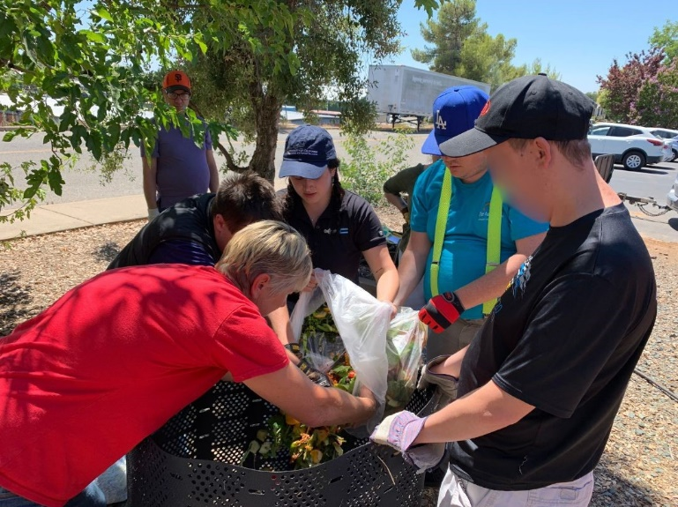
Arc participants add “greens” to “browns” during a composting lesson with CFHL, UCCE educators and Master Gardener volunteers.

OUTCOME
The composting project at Arc of Amador has encompassed 11 hours over 11 lessons in FFY24. In addition, CFHL, UCCE has facilitated 9 hours of cooking lessons over 9 separate sessions. These cooking lessons reinforce the participants’ knowledge of the composting cycle, as participants compost their food scraps for use in the on-site garden. Soil from the compost bins will be used for planting during garden lessons in FFY2025, allowing participants to complete the composting cycle. In addition, maintaining the composting bins was added as a “house job” at Arc of Amador. “House jobs” are a paid practice where participants choose a job they are responsible for every quarter. CFHL, UCCE supported the participants in charge of composting by developing a Composting 101 document as well as extender-training Arc of Amador staff in an adapted version of the TWIGS composting lesson. This practice greatly increases the sustainability of the composting project, garden work, and cooking lessons as it ensures Arc of Amador staff and participants are integrating healthy activities into their daily programming.

