The Resource Connection & CFHL, UCCE: Fostering Early Childhood Health

SUMMARY
In partnership with The Resource Connection (TRAC), CalFresh Healthy Living, UCCE facilitated a comprehensive nutrition education program—involving direct education, indirect education, and Policy, System, and Environmental (PSE) changes—at 8 Head Start Early Childhood Education (ECE) sites in Calaveras County. This intervention directly reaches 124 preschool students with direct education, as well as their families and learning sites through indirect education and PSE channels.

BACKGROUND
The Resource Connection (TRAC) provides early childhood education services, Women Infant Children (WIC) benefits, food bank commodities, crisis intervention services, and Children’s Advocacy services to the residents of Calaveras and Amador counties. TRAC early childhood education program consists of six Head Start sites, two Early Head Start sites, and a home visitor program, serving 124 students and their families.
Due to educator vacancies and COVID-19 distance learning requirements, direct education and PSE projects with TRAC Head Starts stopped in FFY2021. CFHL, UCCE continued its programming with the Resource Connect via indirect education Harvest of the Month newsletters shared with families. With the addition of new staff members in FFY2023, CFHL UCCE educators expanded programming with TRAC to include direct education and Physical Activity PSE channels.

SOLUTION
CalFresh Healthy Living, UCCE is partnering with The Resource Connection (TRAC) facilitating direct education, indirect education, and PSE changes with 124 students and families at 8 Head Start Preschools in Calaveras County. This multifaceted approach increases students’ knowledge of healthy eating and physical activity via direct education using the Go, Glow, Grow curriculum. CFHL, UCCE staff educate families about healthy living via indirect education newsletters and resources, and address policy, system, and environmental aspects of health by increasing structured physical activity at ECE locations using the CATCH curriculum. The resulting program is a comprehensive health intervention that reaches each Head Start student in Calaveras County, as well as their families and learning sites.

“Love how [CFHL, UCCE educator] Mary and her role allows children to actively engage in trying new foods and physical activity. Our friends have made corrections through nutrition and physical activity and a healthy body”.
-Roxanne Hiller, Site Supervisor West Point Head Start

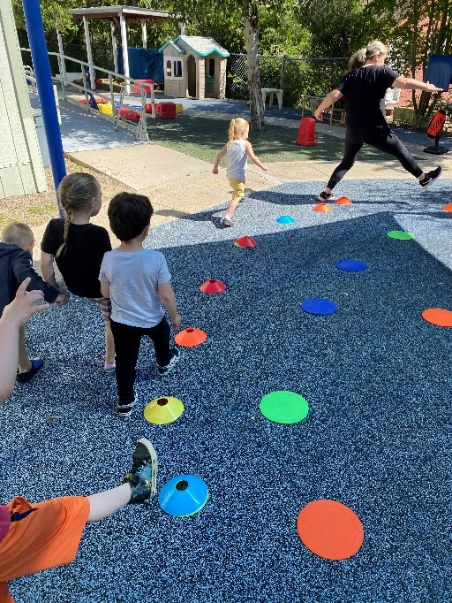

Students “Parading Around” with dinosaur steps during a CATCH ECE lesson.

OUTCOME
From January to June 2024, CFHL UCCE educators conducted 48 direct education sessions over 46 hours, reaching 124 students. These students received the complete Go, Glow, Grow lesson series including recipe tastings and take-home newsletters in both Spanish and English.

Using the Teacher Observation Tool, Head Start staff at each site report that “Compared to the beginning of the school year, more students now can identify healthy food choices” and “Compared to the beginning of the school year, more students now are willing to try new foods offered at school”.

In addition, staff at Murphys Head Start reported that “a few parents have said their child wants to help them shop after this intro to foods”. Not only are students more aware of healthy food choices, that awareness is translating into actions such as trying new foods at school and an increased involvement in food procurement at home.
Head Start sites also introduced a PSE change—increasing structured physical activity—by incorporating the CATCH ECE curriculum into class time twice per month. This intervention, evaluated via the Physical Activity Teacher Activity Tool, was effective in increasing students enjoy and opportunities for physical activity. Head Start partners reported that “We encourage this kind of activity and movement throughout the school year so it is so wonderful to have this kind of support…We highly recommend a program like this continue”. This staff and student engagement is crucial in developing sustainable PSE changes in Calaveras County ECE programs.
Future plans for the partnership between The Resource Connection and CFHL, UCCE include a continuation of direct nutrition education with students, indirect education with families, and PSE efforts related to physical activity. The partnership will expand to include direct education with adults and families at Head Start sites, focusing on intergenerational aspects of nutrition and health.

