Developing Healthy Life Skills at Mt. Tallac High School

SUMMARY
CalFresh Healthy Living, UCCE facilitated cooking-enhanced nutrition lessons with students from Mt. Tallac High School in South Lake Tahoe. Students were matched in groups of 3 to 4 and received 90-minute lessons featuring recipes tailored to their cultural and personal preferences. In total, CFHL, UCCE educators facilitated 15 sessions of cooking-enhanced nutrition lessons with Mt. Tallac HS during Spring 2024, reaching 53 unique students.

BACKGROUND
Mt. Tallac High School is a continuation school in El Dorado County's South Lake Tahoe. The historic partnership between CFHL, UCCE and Mt. Tallac HS consisted of nutrition education using the Hunger Attacks/Money Talks curricula as well as a Teens as Teachers project involving Mt. Tallac students delivering physical activity CATCH lessons at Tahoe Valley Elementary School. However, this programming paused in 2020 during the COVID-19 pandemic.

For the 2023/2024 school year, Mt. Tallac High moved campuses to the same location as the South Lake Tahoe UCCE office. This close proximity contributed to CFHL, UCCE educators rekindling the partnership in FFY24. In program planning discussions, Mt. Tallac HS staff identified cooking skills as an area of interest as students transition into adulthood. CFHL, UCCE met this need by coordinating with school staff to facilitate weekly cooking lessons during regular school hours using the Food Smarts for Kids curriculum.

SOLUTION
A barrier to programming at this site is the students' work schedules. Many students go straight to work after their school day and are unavailable for afterschool programming. Additionally, many continuation high school students are behind on credits and have busy class schedules. This is an obstacle to programming, as it makes it difficult to incorporate lessons during the school day. To integrate CFHL, UCCE programming into the school day, Mt. Tallac staff built a structure where students received fine arts credits for participating in CFHL, UCCE cooking lessons.

To facilitate experiential learning, small groups of up to four students were paired based on culinary interests and lifestyle similarities. One group consisted of 4 expecting or new mothers. Other groups were paired based on the cuisine the students expressed interest in. 13 groups of students rotated weekly throughout the semester to ensure each Mt. Tallac student had the opportunity to attend lessons. On the day of their lesson, students walked from their classrooms at Mt Tallac HS to the UCCE office. The ability for students to transport themselves to lessons removes a significant barrier to coordinating programming. Lessons consisted of a 60-minute cooking segment followed by a 30-minute nutrition education segment using the Food Smarts for Kids curriculum. CFHL, UCCE educators used SNAP-Ed recipe resources to tailor each lessons' recipes to the interests and cultural needs of students. Examples include fish tacos, vegetable stir-fries, sesame noodles with broccoli, strawberry spring rolls, and quick breads.

It was wonderful to be able to provide lessons in living healthy life-styles to my students who do not receive this type of education through our curriculum. Learning by "doing” and exposure to future career pathways is invaluable!
-Amy Jackson, Teacher at Mt. Tallac Continuation High School

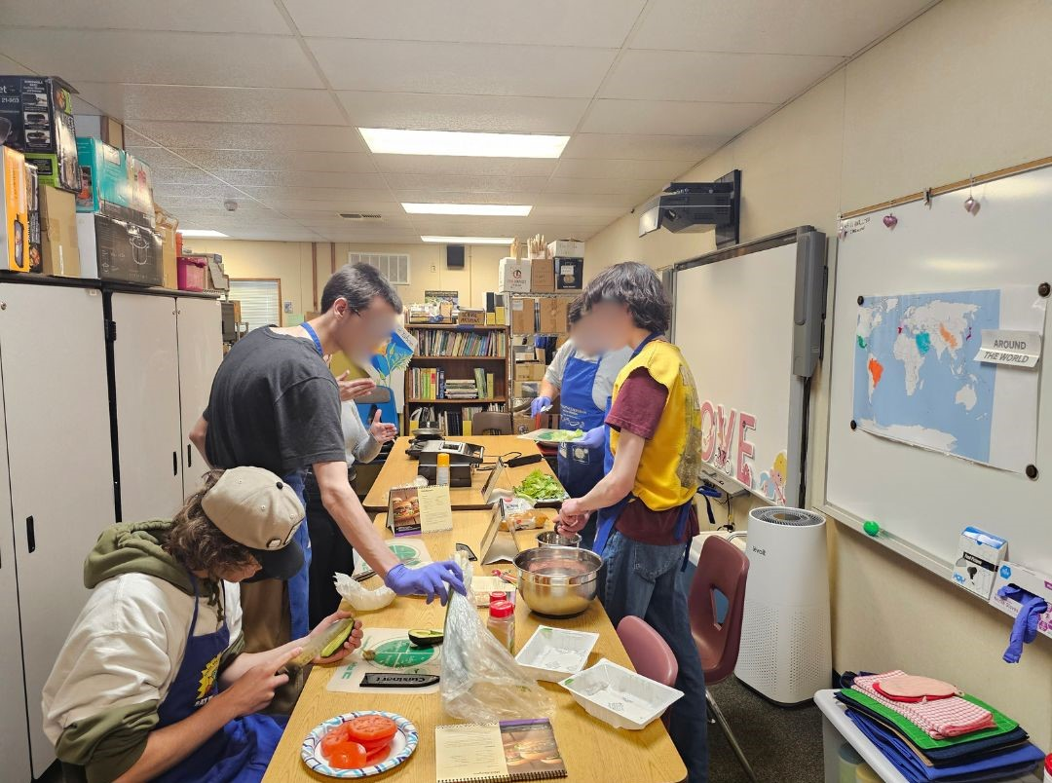
Mt. Tallac students make Mini-Burgers from an EatFresh.org recipe.

OUTCOME
CalFresh Healthy Living educators used the Teacher Taste Tool to evaluate these lessons. When prompted "Before today's class, how many of you have tasted *featured recipe* before?", only 29% (12/41) of polled students responded "Yes". This demonstrates that the intervention was successful in introducing students to new foods/recipes, as a majority of students had not tried these foods before. When prompted "How many of you are willing to eat *featured recipe* again?", 93% (38/41) of polled students responded "Yes". This demonstrates that these lessons facilitated positive experiences with healthy foods that the students are willing to recreate. Not only did they gain the skills to cook healthy foods, but they are motivated by their experiences to try the recipe again.
In addition, several students came to lessons with advanced cooking knowledge from their experience in the restaurant industry. Experienced students had the opportunity to coach their peers during the lessons, developing leadership and teaching skills. These cooking lessons facilitate positive, encouraging learning experiences that give students the skills to create healthy meals on their own. The tools they've gained are invaluable as students transition into their adult lives. In total, CFHL, UCCE educators facilitated 15 sessions of cooking-enhanced nutrition lessons with Mt. Tallac HS during Spring 2024, reaching 53 unique students.
Cooking-enhanced nutrition lessons with Mt. Tallac High School will continue in FFY2025 with the goal of scaffolding students’ skills towards more nuanced recipes. Groups of students will attend a series of lessons—rather than a single session—to further hone their cooking and nutrition knowledge.

