SUMMARY
A county grant opportunity and partnership between local organizations contributed to a district-wide project for six school gardens at Amador County Unified School District. The county partners included CalFresh Healthy Living, UCCE (CFHL,UCCE), Farms of Amador, UC Master Gardeners, and Amador County Department of Public Health. Through a school garden grant, this group worked to establish and reinvigorate six K-12th grade school gardens. By the end of the Spring semester of the 2022-2023 school year, six schools of fifteen in ACUSD had school gardens that were active and producing fruits and vegetables. These gardens served as an educational tool in combination with TWIGS curricula focusing on soil and seed starting at three of the six awarded schools.

BACKGROUND.
School gardens play a crucial role in educating students about farm-to-school, local food systems, and regenerative food systems. Many school sites lack funding, knowledge, and time that could be dedicated to developing, improving, and maintaining these gardens.
In Amador County a partnership was formed between CFHL, UCCE, Farms of Amador, UC Master Gardeners and Amador County Department of Public Health to address and these barriers by offering financial awards, education, volunteers, and time focused on the betterment of these gardens for school-aged children.

SOLUTION
A total of eight UC Master Gardeners were assigned to the awarded schools to support various garden projects and implementation. UC Master Gardeners extended water pipes at Jackson Elementary to reach the garden beds for drip irrigation to be installed in collaboration with educational programs.

“As a Master Gardener, I am pleased and appreciative of the value of exposing young people through the school system to the world of gardening. I am so glad the school district has staff who equally support those objectives.”
-John E. Otto, UC Master Gardener in Amador County
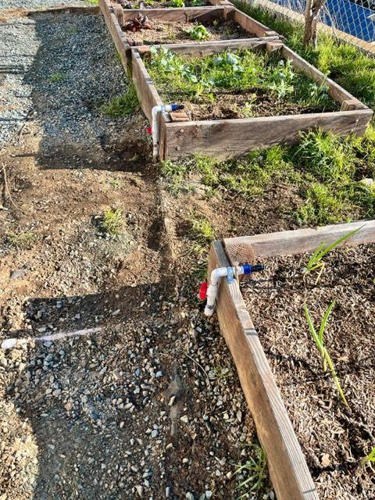
Water pipe extenders installed at Jackson Elementary in Amador County for drip irrigation systems.

OUTCOME
A total of six schools were awarded the Farms of Amador grant for $500 each to be used for the development or maintenance of school gardens.
The future goals for the project and collaboration between organizations is to continue fulfilling each school’s goals for their garden spaces which include winter garden crops, pollinator plants, and the completion of drip irrigation systems. In the upcoming school year, another goal is to offer more garden-enhanced educational opportunities and create more engagement with these schools' garden spaces, such as connecting Harvest of the Month curricula to the bounty of fresh fruits and vegetables the gardens will produce.

