PEARS Sustainability Module Preview
The purpose of the PEARS Sustainability Module is to capture FFY26 efforts by LHDs to sustain and/or transition nutrition and physical activity programming in their jurisdictions​. Each LHD will be expected to submit one entry by March 31, 2026.
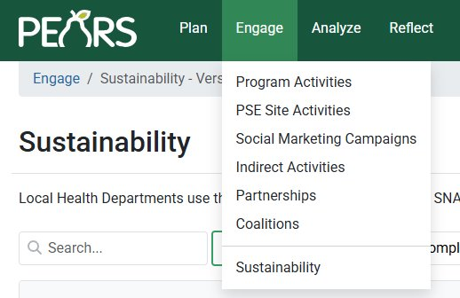
The module contains five sections:
- General info​rmation
- Collaborators​
- Train the Trainer​
- Identifying & applying for funding​
- General sustainability
Locate the Sustainability Module in PEARS by navigating to Engage > Sustainability.

- General information
Each LHD will submit only one entry in this module. For “Name,” please enter your jurisdiction (county or city).
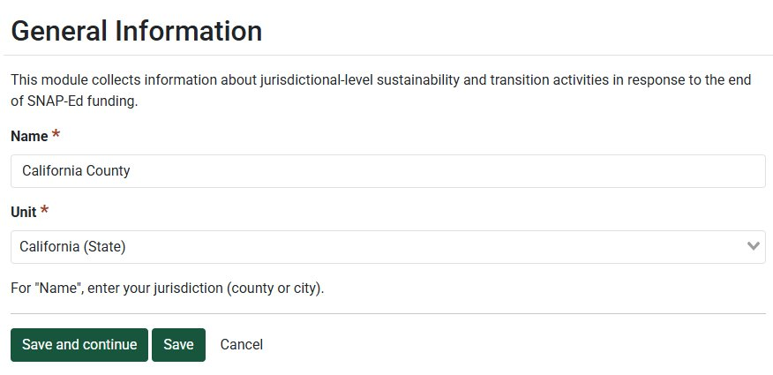

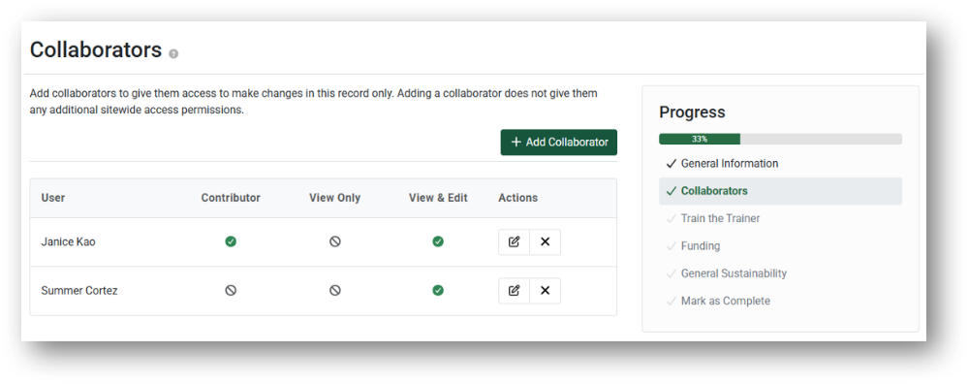
- Collaborators​
If applicable, add collaborators to give them access to view or make changes to your sustainability module entry. This feature may be helpful if your LHD will have more than one staff member contributing to this single entry.
Note: Because the Collaborators feature is currently not working, and Canopy is unable to provide an ETA for fixing the feature, we have provided text boxes throughout the document where your team can plan responses before entering data into PEARS.

- Train the Trainer​
There is one ‘required’ question in the Train the Trainer (TtT) section of this module. If you select ‘No,’ you can move on to the next section. If you select ‘Yes,’ you will be prompted to select one or more relevant intervention type.
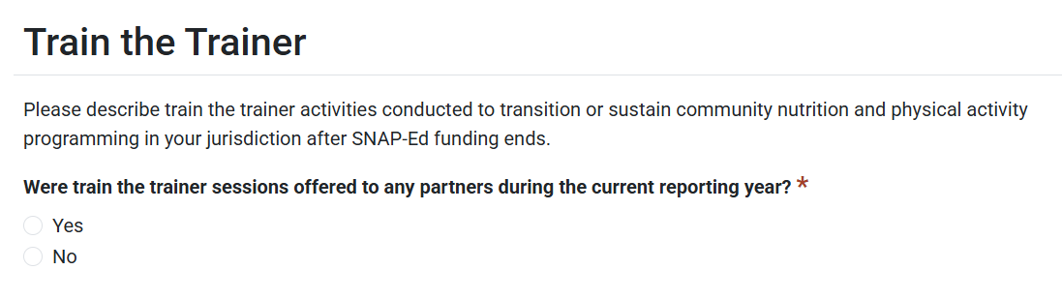



Complete follow-up questions only for the types of interventions relevant to the intervention type selected (PSE, Direct Education, or both). The screenshots below show the questions as they pertain to PSE TtT Activities; identical questions are asked for Direct Education TtT Activities. If you only select ‘Other’ as an intervention type, no further questions are asked.
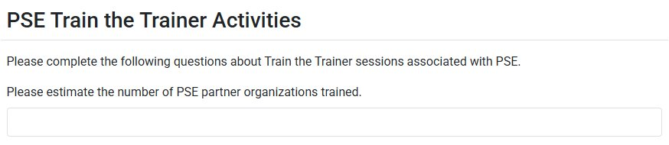

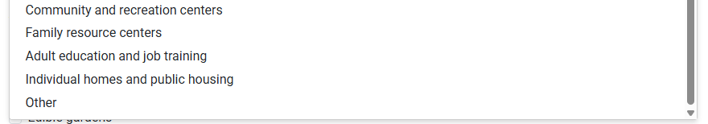
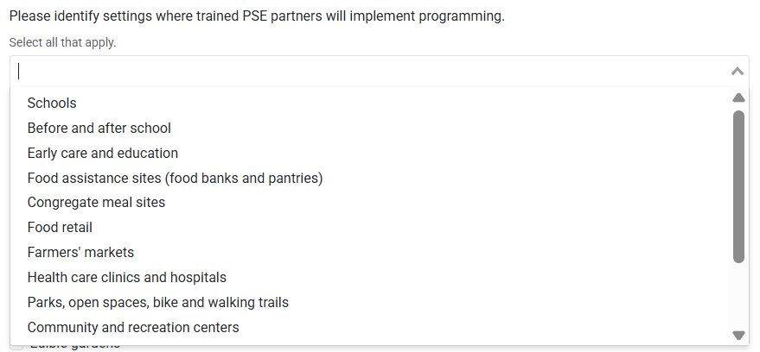

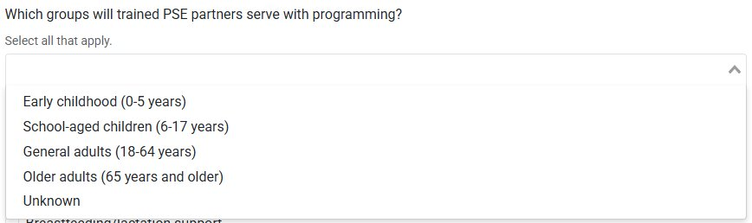

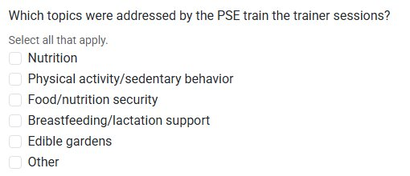

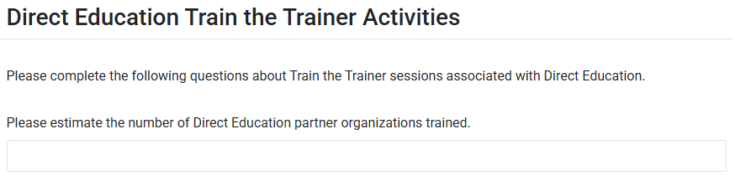
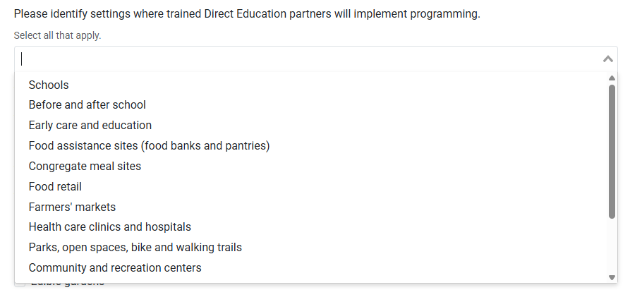

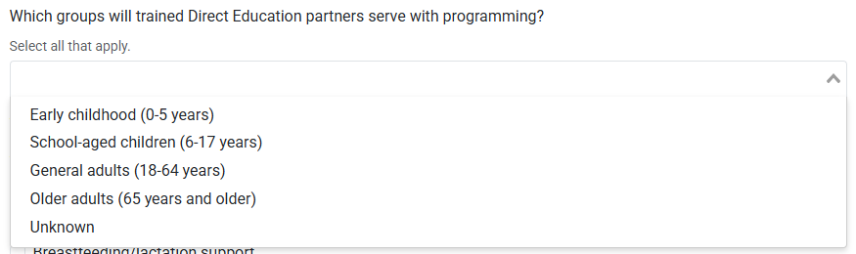

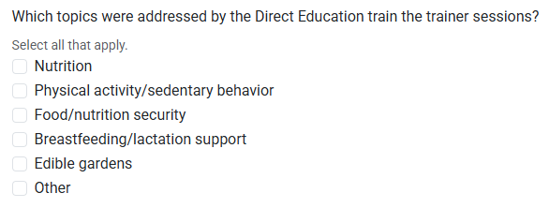

- Identifying & applying for funding​
There is one ‘required’ question in the funding section of this module. Teams should consider activities since July 1, 2025 when completing this section. If you select ‘No,’ you can move on to the next section. If you select ‘Yes,’ you will be prompted to provide additional information.
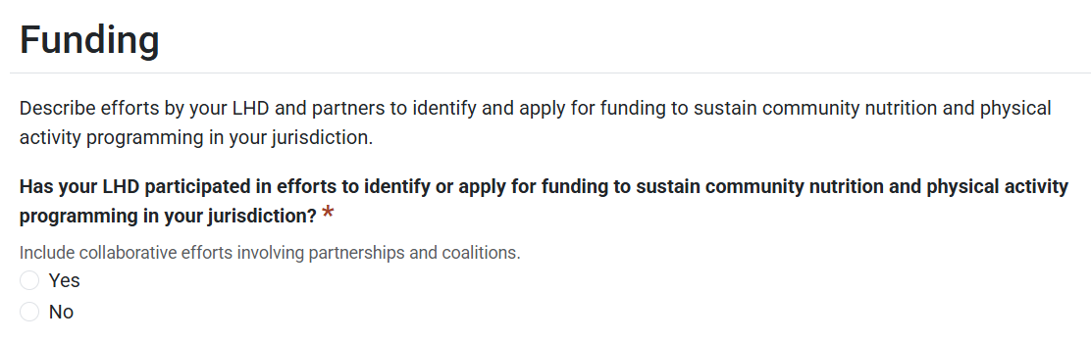

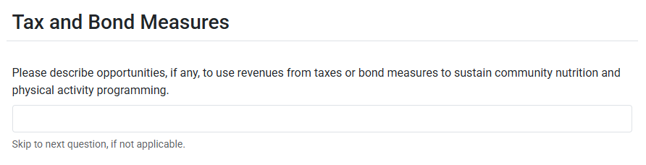
In the required question below, select the LHD staff roles that apply. If you select any of the listed roles, continue with the remaining questions about ‘Grants, Contracts, and Other Funding Mechanisms.’ If none apply to your LHD, select ‘Other,’ skip the remaining questions, and select ‘save and continue’ to progress to the next section.
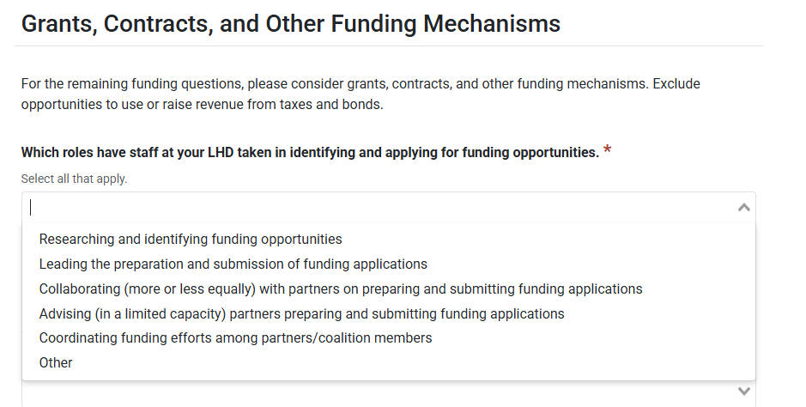

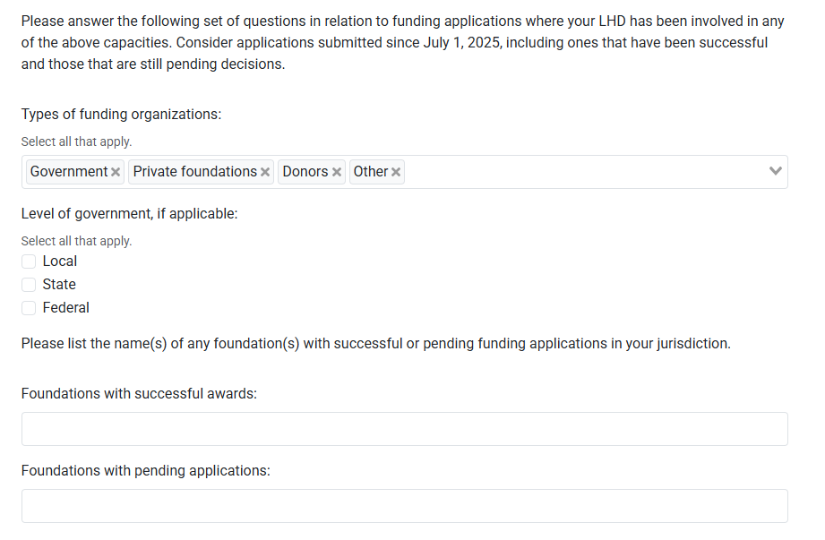

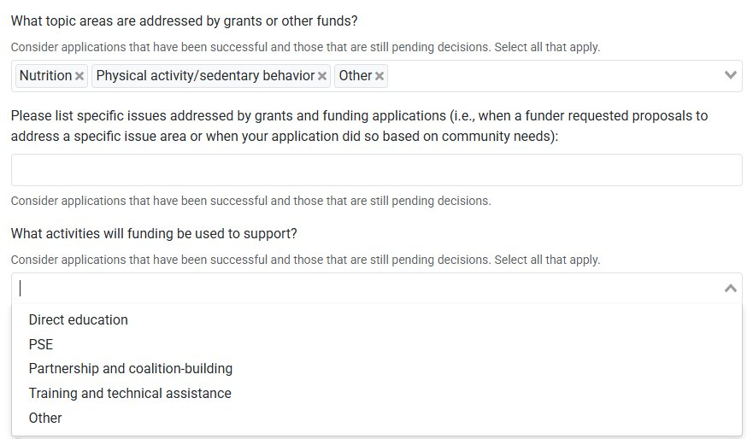

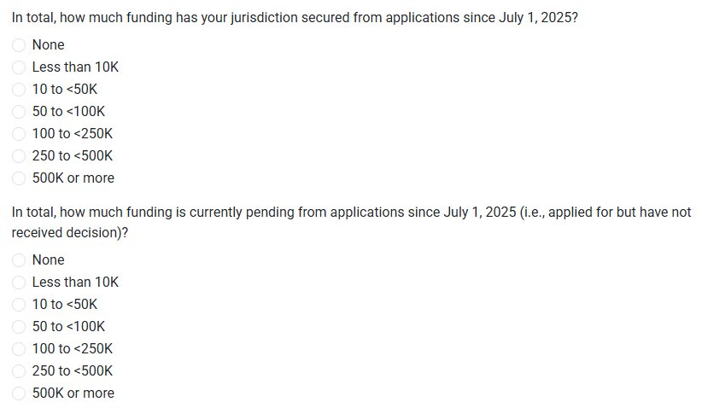

- General sustainability
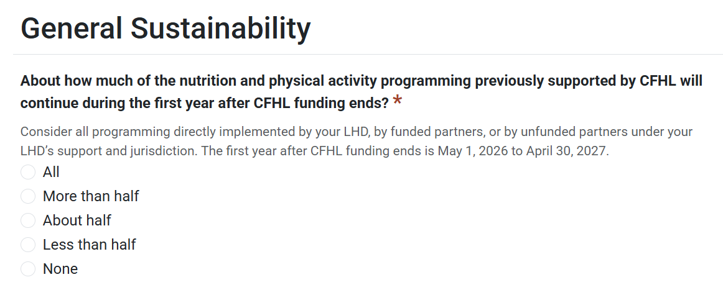
The general sustainability section of the module has one ‘required’ question, followed by a handful of optional questions.

