Drip Irrigation should be run for a long time. Think low, slow and soak. Drip systems are measured by gallons of water per hour. The deeper we can get the water, the better. Aim for getting the water into the soil to a depth of 12-18”. You will water less frequently and create a healthy environment for microorganisms, worms, and plant roots. Try to run your system for an hour or more, depending on the type and number of emitters you have installed.

To find out how much water your drip emitter produces.
Measure how many seconds it takes to fill a Tablespoon.
1 gallon emitter (gph) takes 14 seconds
2 gallon emitter (gph) takes 7 seconds
4 gallon emitter (gph) takes 4 seconds

Let’s measure how much water one plant is getting
1 gallon of water = 128oz
Irrigation controller is set for 15 minutes
You plant is getting 4 cups of water Example 128/4 = 32oz or 4 cups

Scenario 1
You have 2 emitters on one plant, they are 2 gallon emitters
Irrigation zone is set to run for 15 minutes
1/2 gallon (64oz) of water is used.

Scenario 2
You have 6 emitters on one tree, they are 1 gallon emitters
Irrigation zone is set to run for 15 minutes
3/4 gallon (96oz) of water is used.

Scenario 3
You have 2 emitters on one plant, they are 4 gallon emitters
Irrigation zone is set to run for 15 minutes
1 gallon (128oz) of water is used.

How Many Emitters Should I Have?
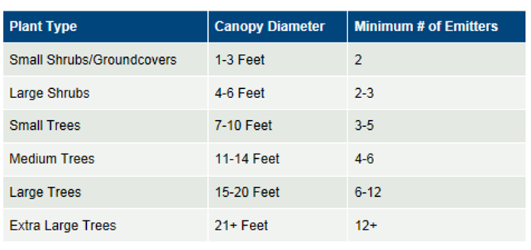

Lawn systems are measured in gallons of water per minute.
You’ll need set a timer, then run a valve, watch for any runoff of water, note the time it takes, then you’ll need to lessen the time.

Irrigation for the lawn should run for 2-3 cycles. With a minimum of 45 minutes in between each cycle. Example: Run a zone early in the morning (4am) and then run it again an hour later at 5am. This will ensure deep watering and make the roots chase the water down into the soil. The water should be 6-8 inches down into the soil. Most lawns need 1-1 ½ inches of water per week in order for the water to saturate. Use a screwdriver to test how far the water has infiltrated down into the soil. (Stick a screwdriver into the soil, if it comes out dry, it means its time to water)

Pop Up Spray Heads, run each valve for 3-6 minutes per cycle.
MP Rotator and multi stream sprinkler heads, each valve should run 15-20 minutes.
Impact and Rotary Heads, run for 7-10 minutes, per cycle

Variables – Look and see where they are in your garden
Wind, Microclimates (hotter or colder areas), Eto (Evaporation Transpiration Rate), Sunlight, Humidity, Type of plants, Soil Texture

Water Holding Capacity
Soil Texture | Plant Available -Water Holding Capacity
 | Inches of water per foot of soil
Very Coarse Sands | 0.4 - 0.75
Coarse Sands, Fine Sands, Loamy Sand | 0.75 - 1.25
Sandy Loams, Fine Sandy Loams | 1.25 - 1.75
Very Fine Sandy Loams, Loams, Silt Loams | 1.50 - 2.30
Clay Loams, Silty Clay Loams, Sandy Clay Loams | 1.75 - 2.50
Sandy Clays, Silty Clays, Clays | 1.60 - 2.50

