Workshop: Cottage Food for Small Farms
Thursday, Dec. 11 | 9:30 – 2 p.m.
4145 Branch Center Rd., Sacramento 95827
Detailed Agenda
Part 1: Establishing and operating a cottage food business
9:45 – 10:15 How to obtain a cottage food permit – Sac County EMD (30 minutes)
Sacramento County Environmental Management Department staff Monica Boatright will walk through the steps to successfully apply for a cottage food registration or permit.
10:15 – 10:30 Entrepreneurs’ perspectives – J Jordan and Jon Kupkowski (15 minutes)
Brown Rice Bakery’s J Jordan and The ReFarmery’s Jon Kupkowski will share their experiences obtaining cottage food licenses and complying with other regulations related to value-added food production.
10:30 – 10:40 Processing pathways, packaging and profitability (10 min)
UCCE Food Systems Advisor Olivia Henry will offer a brief presentation on alternate value-added food processing pathways and more.
10:40 – 10:55 Panel response (15 min)
Brown Rice Bakery’s J Jordan and The ReFarmery’s Jon Kupkowski will continue to reflect on cottage food operations, as well as tools and strategies related to financial tracking and profitability.
10:55 – 11:00 Break (5 min)
11:00 – 11:40 Marketing panel (40 min)
Lucía Plumb-Reyes of Moonbelly Bakery and Nova Wetherwax of the Sacramento Natural Foods Co-op will discuss marketing small-scale value-added food products in retail settings, including labeling, packaging and pricing.
11:40 – 12:10 Announcements and lunch (20)

Part 2: Techniques for producing safe, attractive food with UC Master Food Preservers
12:10 – 12:15 Orientation to station rotations (5 minutes)
Groups will be rotating between stations addressing food safety and visual presentation of foods eligible for cottage food production. Stations include:
    - Dehydrating and freeze-drying
    - Making jams and jellies
    - Crafting teas, herbs and salts

12:15 – 12:45 Rotation 1 (30 minutes)
12:45 – 1:15 Rotation 2 (30 minutes)
1:15 – 1:45 Rotation 3 (30 minutes)
1:45 – 2:00 Evaluations and drawing for equipment give-away (15 minutes)

Food Provided By:
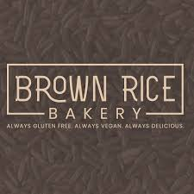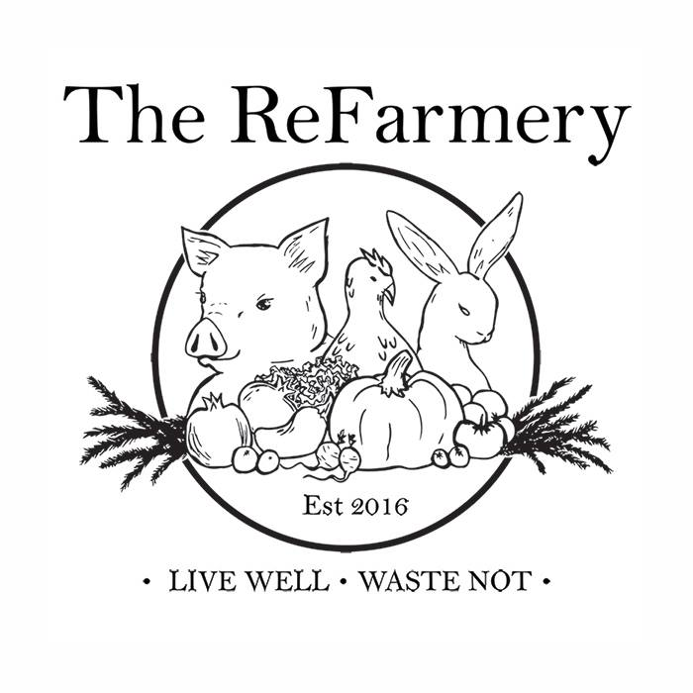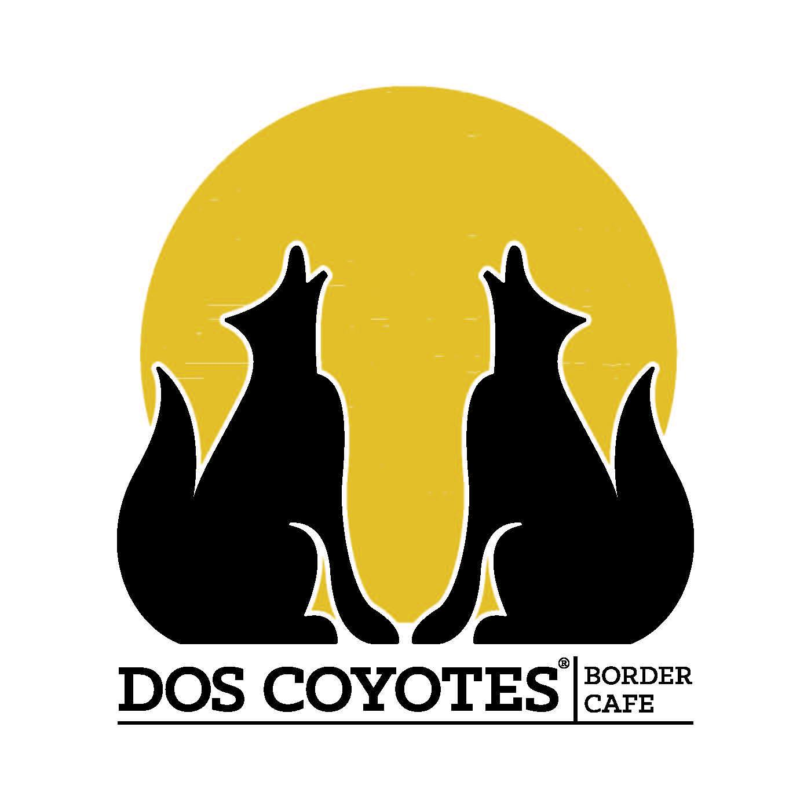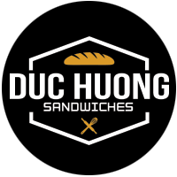
Program Contacts
Olivia Henry Margaret Lloyd Wendi Weston
Food Systems Advisor Small Farms Advisor Master Food Preserver Coordinator
omhenry@ucanr.edu mglloyd@ucanr.edu sacmfp@ucanr.edu




