UC ANR Parking Map
  - 2801 Second Street Davis, CA 95618
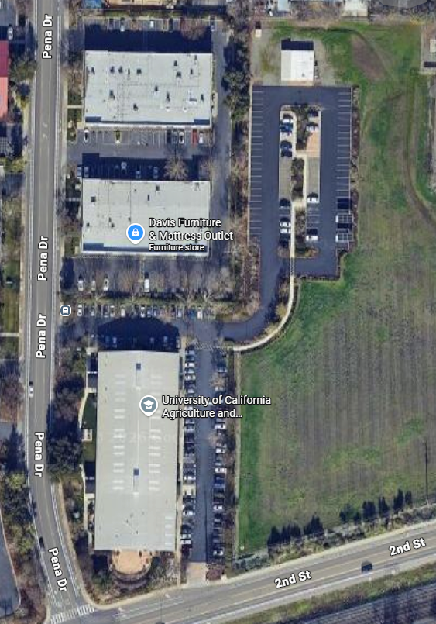

Please only park in the outlined parking lots. Do not park in adjacent businesses.

