SAN DIEGO COUNTY 4-H

ART & DESIGN DAY

2026

INFORMATION AND REGISTRATION PACKET



April 25, 2026

Check In: 9am
Start Time: 10am

Location:
San Diego Farm Bureau
420 S. Broadway
Escondido, CA 92025

For more information, contact:
Denise Barnes @ 56ranchers4h@gmail.com

Table of Contents

General Entry Guidelines and Information……………………… 3
Categories and Divisions…………………………………………. 6
Creative Arts and Crafts Category………………………………. 7
Engineering Design Category……………………………………. 8
Garden and Plant Design Category……………………………... 9
Food Category……………………………………………………. 10
Fashion Revue Category…………………………………………13
Judging Sheets…………………………………………………… 17

ART AND DESIGN DAY 2026
GENERAL ENTRY GUIDELINES AND INFORMATION

The purpose of Art and Design Day is to encourage hands on learning in project areas of interest for 4-H members. This event will encourage the utilization of composition and the design process for various projects. The emphasis throughout the event will be on learning. Please encourage members to share what they have learning and to learn from others.

Entry Guidelines and Criteria

All Divisions are open to all 4H members whether participating in that project or not, except Traditional Clothing Construction, Uniquely Upscaled Challenge, Favorite Decade Challenge and Needlework Challenge which requires participation in Clothing & Textile project which includes Sewing, Fiber Arts, Crocheting, Knitting, and Quilting.

All entries must have been started in the current 4-H program year. If item is not yet completed, it will be considered “in process” but will remain an entry in the appropriate category/division for the project, with the exception of a Fashion Revue entry not yet completed which will be moved to Creative Arts & Crafts, Sewing & Textiles division.

Members may enter items if they are not made in a 4-H project, however, school projects are not acceptable to enter.

All entries must be in good taste and suitable for family and public viewing. Entries
which are deemed vulgar, dangerous or offensive will be disqualified &/or removed.
Categories are open to all age classes, unless otherwise noted: Primary (ages 5-8),
Junior (ages 9-10), Intermediate (ages 11-13) and Senior (ages 14-18)

Categories are open to both Individual and Group entries, unless otherwise noted.
Group entries must list the name and age of each group member on registration form. The age of the oldest group member will determine the age class for entry, however groups with primaries may only earn participation and will not be judged. Each group member is expected to participate in the interview with each sharing at least one process of the project.

Electricity Availability: To ensure availability and access to electricity, please be sure to indicate your need on your registration form and please bring your own extension cord.

Members may enter a maximum of 6 entries (Any Division).

Dress Guidelines

Participants in judged events will be evaluated on how they present themselves as well as what they present. For this reason, it is important that members are dressed appropriately and neatly for the area they are involved in. The below guidelines for dress are recommended and encouraged.

Fashion Revue Show – participants model items created with (if needed) additional clothing and accessories that coordinate and enhance entry.

Other Categories and Divisions – for personal interviews in all areas, recommended dress is 4-H Uniform (white top and bottom with 4-H scarf or tie) or “Professional” attire (i.e. dress, skirt and blouse, slacks and dress shirt, etc. – shirts and blouses tucked in – suits, jackets, sweaters, ties and accessories optional). Please refer to the 4-H Dress guidelines - https://4h.ucanr.edu/files/210170.pdf

Safety, Supervision and Conduct

We want to advise participants and families who are attending that the event location is being offered for our use, with the agreement that it will be treated respectfully. Everyone must be on our most courteous behavior and respect facility rules that may be posted. Please take safety precautions and ensure younger children are always supervised, especially in the outdoor areas.

Evaluation and Judging Criteria

Entries will be judged interview style, by one or two judges, with an emphasis on what the member has learned and how the knowledge has been applied to their project. Members will be evaluated on their presentation skills, their knowledge of processes and technical skills for the specific project. Members’ age, years in project and complexity will be taken into consideration for evaluation. Members will also be evaluated on their interview skills and personal appearance (Well-groomed/dressed, speaks clearly, ability to verbalize all steps of project, etc.). Members will be evaluated on their display (neatness, representation of project and processes, etc.).

Primary members with entries in judged categories will be interviewed and evaluated but will not be competitively judged. Primary members will have a designated area where they can display all their work and where their interviews will take place. Primary members will receive a participation ribbon.

The Danish system of judging will be used for all entries. There will be potential for one County winner in each category/division: Junior, Intermediate and Senior age classes, however, it is up to the judges’ discretion if any entry in a category/division is in fact medalist quality. Therefore, there may be times when no medalist is selected for certain categories/divisions. The county winner will be chosen from the medalist category. The Planning Committee reserves the right to combine any Category/Division in which entries are insufficient to secure adequate competition or to further divide any Category/Division should entries exceed expectations.

** The Judging sheets are included in this packet. They illustrate what judges will be looking for. Please review to prepare for interviews.

Location:
San Diego Farm Bureau
420 S. Broadway
Escondido, CA 92025

Food Availability:

Water and soda will be available for purchase at the event.

Lunch will be available for pre-order purchase. An order form will be available before the event and payment can be made on the day the event in cash or check.

Otherwise, please pack your own snacks and lunch.

Registration:

Please complete the registration form that is available electronically. For participants of the Consumer Challenge, you will need to upload a copy of the receipts for your purchases.

ENTRY FORM: https://forms.gle/M4KyvcC98e1cWq6YA

DUE DATE: All entry forms must be submitted by Friday, April 13, 2026 by 5:00pm

Categories and Divisions
Below are the categories and divisions for your Art & Design Day entries. Information for each category and division is contained in this packet.

Category | Division
Creative Arts and Crafts | Textiles & Fibers
Creative Arts and Crafts | Photography
Creative Arts and Crafts | Paper Arts & Crafts
Creative Arts and Crafts | Drawings & Paintings
Creative Arts and Crafts | Comic Book
Creative Arts and Crafts | Jewelry
Creative Arts and Crafts | Wood and Metal Crafts
Creative Arts and Crafts | Ceramic/Clay
Creative Arts and Crafts | Painted Models & Figurines
Creative Arts and Crafts | Other Creative Arts and Crafts
Creative Arts and Crafts | Other Sewing & Textiles (in process)
Engineering Design | Engineering & Technology
Engineering Design | Lego Engineering
Garden and Plant Design | Garden and Landscape
Garden and Plant Design | Nest Boxes & Habitats
Garden and Plant Design | Container Plantings & Floral
Garden and Plant Design | Outdoor and Garden Art
Foods | Favorite Foods
Fashion Revue | Traditional Clothing Construction**
Fashion Revue | Consumer Science Purchased $50
Fashion Revue | Favorite decade challenge**
Fashion Revue | Uniquely upcycled challenge**
Fashion Revue | Softie Challenge
Fashion Revue | Leather Creations Challenge
Fashion Revue | Needlework Challenge**
**Entries in these categories require participation in Clothing & Textile project which includes Sewing, Fiber Arts, Crocheting, Knitting, and Quilting.

Creative Arts and Crafts Category

The Creative Arts and Crafts category is for projects where members utilize the process of design and/or art combined with any variety of mediums (fiber, paint, film, wood, paper, etc.) to create.

Divisions:

Textiles & Fibers – For projects where the member used material or fiber to create a project other than a sewn garment (i.e. home décor projects, knitting, crocheting, macramé, weaving, quilts, doll clothing, placemats, curtains, needlepoint, cross-stitch, etc.)

Photography - For projects where a member utilizes design and art principles combined with camera for non-verbal communication with a picture. Prints may be mounted or matted. One photo per entry.

Paper Arts and Crafts – For projects where member used paper/cardstock for primary medium. (Cards, Scrapbook pages/albums, Collage, Paper Folding art, Paper Maché, Decoupage, etc)

Drawings & Paintings – For projects where member used pencil, charcoal, pastels, crayon, acrylic, oil, watercolor, and any other types of 2-D sketching or painting.

Comic Book – For projects where members used any drawing, painting, or sketching of a comic book/graphic novel style. As small as you’d like but no more than six pages.

Jewelry- For projects where members created jewelry using beads, clay, wire, metal or other non-traditional items.

Wood & Metal Crafts – For projects where members created something with wood or metal items, sculptural, decorative, or functional items.

Note: Large wood or metal projects of a structural nature (furniture, cabinetry, etc.) should be entered in the Engineering Design category.

Ceramics & Clay- For projects where members created something using ceramics, pottery, polymer clay items, decorative or functional (beads and jewelry items will be judged under jewelry).

Painted Models and Figurines - For projects where members create models (cars, planes, trains, etc) and plastic or ceramic figurines that are purchased and then designed and painted.

Other- For projects where members create other arts & crafts projects that do not specifically fit under one of the other divisions. (Leather crafts, refinished items, lampshade).

Other Sewing and Textiles – For projects where members have an incomplete sewing project that is not ready for the fashion revue category.
Engineering Design Category

The Engineering Design category is for projects where members utilize the process of design to combine creative thinking with engineering principles and/or technology to turn ideas into reality.

Entries in this category may be from, but not limited to, the following 4-H project areas of interest:

- Aerospace and Rocketry
- Automotive
- Bicycles
- Electricity/Electronics
- General Engineering
- Farm Machinery
- Woodworking (Large projects)
- Metal Working/Welding
- Computers
- Computer Programming
- Robotics.

Note: Sculpture and small Home Furnishing projects should enter under the Creative Arts & Crafts category.

Divisions:

Engineering and Technology- For projects where the members designed and assembled a structure, machinery, system, component, etc.

Ideas: Structures such as a pen, fence, shed, etc.; rocket or aeronautical equipment/machinery; computer hardware devices or peripherals; farm equipment/machinery; furniture or cabinetry; circuit boards; computer networks; robotics; etc.

Lego Engineering – For projects where members design a structure, robot, or other moving or unmoving design of their choosing using Legos or similar toy brick construction.

Garden and Plant Design Category

The Garden and Plant Design category is for projects where members utilize the process of design and/or art combined with horticulture principles and practices. In addition to general guidelines: All plants on display must be free of insects.

Divisions:

Garden and Landscape Design –For projects where members design and implement a garden or landscaping of any type (i.e. vegetable, floral, evergreens, lighting, etc.).

- Display Method: Tri-fold display board

Nest Boxes and Habitats – For projects where members may create bird, bat, bee boxes or houses, or any other type of habitat for local fauna.

Container Plantings and Floral Design - For projects where members utilize design and art principles to combine any type of horticulture (live or artificial) and container.

Ideas: Potted Plants, flowers and/or vegetables; Topiaries; Terrariums; Floral arrangement; Bouquet arrangement; Hanging Basket; planted Patio Container; etc.

Outdoor and Garden Art– For projects where members design and create 3- dimensional art for use outdoors.

Foods Category

The Favorite Foods category is an opportunity for 4-H members to display their knowledge of food preparation, nutrition, menu planning, table setting and cost analysis.

Entries in this category may be from, but not limited to, the following 4-H project areas of interest:
- Foods and Nutrition
- Food Preservation
- Consumer Awareness

Divisions:

Favorite Foods- Members prepare a menu for a meal they might serve to family or friends and they make one item from the menu. The member must also prepare a table setting for their entry.

Guidelines for Favorite Food Entries:

Table Service:
Each entry will be assigned a table space to set up a table service display. The display must include a place setting for one person to include dishes, flatware, tablecloth or mat, napkin, glasses, and centerpiece that are appropriate for the menu and theme. Service items do not need to be made of glass. All items are brought at your own risk. Members are responsible for bringing all items to complete an appropriate display as planned.

REMEMBER: The 4-H member must set up their display themselves.

Menu:
Members should prepare a written or printed menu for a meal that they might serve to friends or family. Menus (including theme) should be written or printed on an 8½”x11” paper or cardstock that can be placed on the table for the judges to see. *Not required for primary members.

Food Item:
Members must prepare one item on the menu at home and then bring it to the event for the judges to sample. If you prepare a cold dish, KEEP IT COLD. If you prepare a hot dish, KEEP IT HOT. A dish wrapped in foil and towels and placed in a cardboard box or in an insulated container will help keep it hot or cold while transporting and before/after judging. A refrigerator or warm ovens may NOT be available for your entry.

- Primary members may prepare a snack instead of an entrée.

- For Group entries, each group member is expected to participate in the interview with each member preparing and sharing one item on the menu.

Please observe and follow food safety rules https://ucanr.edu/sites/safety/files/403272.pdf -

Day of the Event:
- Member must use the assigned table space to set up their table service display
- Prepared favorite food item should be included in an appropriate serving dish
- Place setting for one person including all flatware indicated in the menu.
- Your centerpiece for the table.
- Your menu card listing the theme and nutritionally balanced menu.

If you deviate from a traditional table setting, please be prepared to explain why you have a different display and the purpose or significance of your table setting/display.

Members should also bring small plate and service ware for at least two judges to sample the prepared food item (these can be disposable).
Remember to have fun!

Evaluation and Judging Criteria

In addition to the general guidelines:
Members will be expected to share the following information as it applies to their entry: Theme; menu explanation; nutritional balance; complementary food items; how (in general) to prepare all menu items; steps to prepare favorite food item; primary ingredients; cooking appliances and tools required; cost; time; new cooking skills learned; special circumstances and/or challenges (i.e. seasonal ingredient, weather/temperature conditions, etc.); safety issues; storage possibilities; etc.

Members will be judged on:
Taste
Visual appeal
Correct temperature

Members handling food must follow correct food handling and safety guidelines found here: https://ucanr.edu/sites/safety/files/403272.pdf -

Basic Table Setting Example:

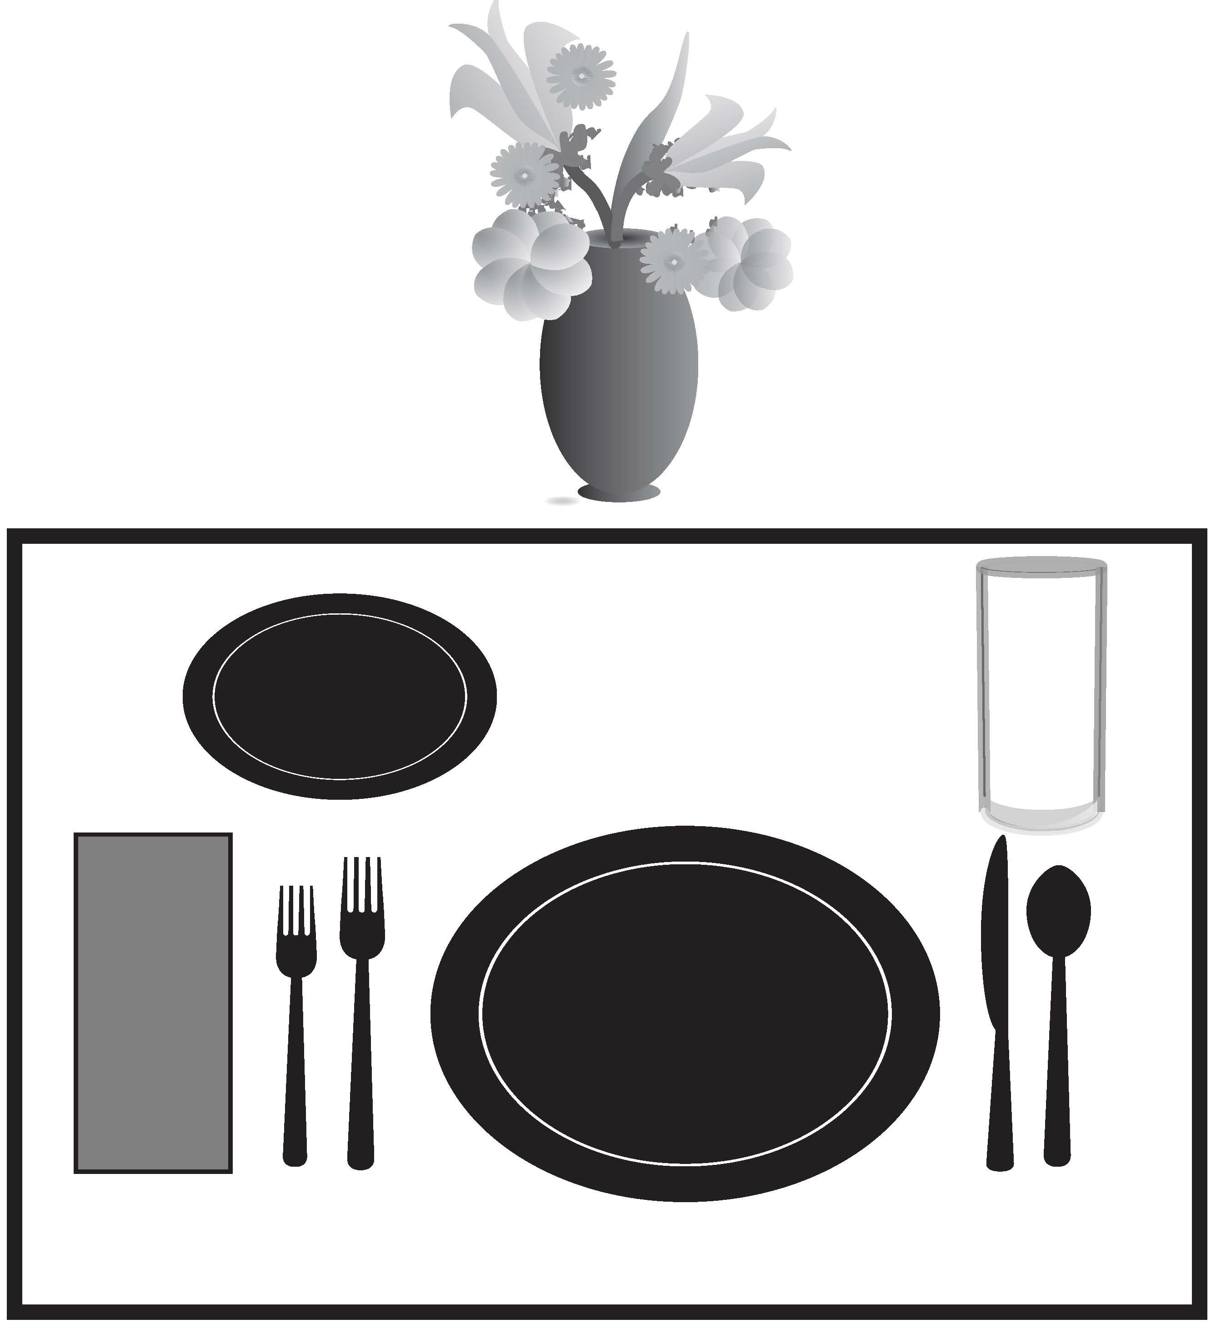
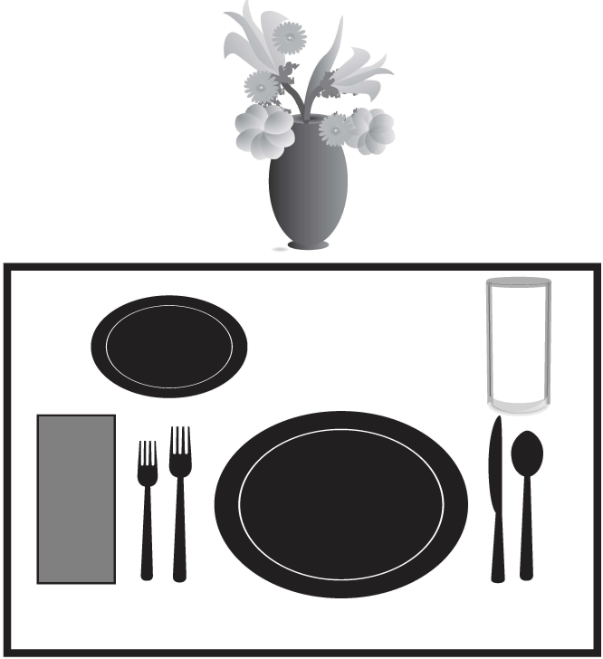
J
I
H
F
G
E
D
C
B
A
- Placemat
- Plate
- Salad Plate
- Glass
- Napkin
- Salad Fork
- Dinner Fork
- Knife
- Spoon
- Centerpiece

Fashion Revue Category

The Fashion Revue category is for clothing projects where members utilize the process of design and/or art to construct, create, or assemble a garment or outfit. Outfits must be suitable for public wear.

Entries in this category may be from, but not limited to the following 4-H project areas of interest:
- Clothing and Textiles
- Consumer Education
- Fashion Revue
- Creative Arts
- Crafts & Hobbies

Age Class Requirements:
- Primary: Primary members will not enter construction judging but will be interviewed on their projects. Primary members may participate in the Fashion Revue Modeling Show.
- Junior, Intermediate & Senior: Members may enter Wearable Art or garments made/ assembled in the Clothing project. County winners are eligible to enter the State Level Fashion Revue during State Field Day.

Divisions:

Garment(s) should be finished and ready for judging. Garment(s) should be clean, neat and well-pressed for presenting to the judges. Unfinished projects may enter in the category of Creative Arts & Crafts, Division of “Other Sewing and Textiles (in process)”

The outfit must meet 4-H Dress Guidelines: https://4h.ucanr.edu/files/210170.pdf

For more information about State Fashion Revue, go to: http://4h.ucanr.edu/4-H_Events/SFD/SFR/

Traditional - Participants in this category will construct a garment/s and assemble an outfit that showcases their sewing skills and ability to coordinate an outfit. The outfit must contain at least one constructed garment. Participants are encouraged to construct additional garments to complete the outfit but may wear clothing they purchased or already own. Accessories - such as shoes, hats, belts, jewelry, purses, backpacks, etc., - may be purchased, already owned, or made by the member. If items were sewn that cannot be worn - such as in a coordinating jacket, skirt, and pants set or in a pajama set with matching pillow or quilt - these additional items may be carried. Only garments sewn by the participant will be evaluated on construction, but all items worn will be evaluated on the outfit coordination.

**Entries in this category require participation in Clothing & Textile project which includes Sewing, Fiber Arts, Crocheting, Knitting, and Quilting.

Uniquely Upcycled: In the context of fashion, upcycling involves repurposing old clothing or textiles to create new and unique garments. This can include combining different pieces of a garment or other materials to create a fresh look. You can alter the items through sewing, embellishing, painting, dyeing, etc. An example would be combining sleeves from one garment to the bodice of another item to create your own, unique garment.

**Entries in this category require participation in Clothing & Textile project which includes Sewing, Fiber Arts, Crocheting, Knitting, and Quilting.

Pantone Color of the Year:
Participants in this challenge will create an outfit that uses the Pantone Color of the Year 2025: Mocha Mousse, a warming, soft brown that evokes comfort, thoughtfulness, and simple pleasures. It reflects a desire for ease and coziness and to nourish ourselves with life's simple pleasures, whether it's a quiet moment with a cup of tea or a peaceful walk in nature. Additional colors may be used to enhance the outfit. The outfit must feature at least one handmade garment made by the member
**Entries in this category require participation in Clothing & Textile project which includes Sewing, Fiber Arts, Crocheting, Knitting, and Quilting.

Softie: What is a softie? A stuffed animal, cloth doll, plush toy, soft sculpture, or fabric toy. In this challenge, the participant will sew, felt, knit, or crochet a softie using a pattern or their own design. Any type of fabric and any embellishment techniques (trims, embroidery, yarn hair, removeable clothing) may be used. Participants must present the entry themselves at the Fashion Revue event.

**This category has no 4-H project requirement and must be shown by the member at the Fashion Revue event.

Consumer Science Purchased: Participants in this category will shop for an entire outfit with the total cost not to exceed $50.00 not including sales tax. Receipts from the current 4-H year are required for any item that is visible. This includes but is not limited to shoes, stockings, jewelry, and hair accessories. Gifts, prior purchases, and items without receipts are not eligible for this category. Receipts from yard sales, etc. may be handwritten. The participant should consider value vs. cost, versatility, the shopping experience, and coordination of the outfit within the cost limit.

**This category has no 4-H project requirement and must be modeled by the member at the Fashion Revue event.

Costume Challenge: Participants in this category will create a costume for themselves or another person using any technique, materials, or pattern. It does not need to be sewn from fabric. The costume can be any theme and from any time, place, or country as long as it is 4-H appropriate. 70% of the costume must be handmade by the member; 30% can be handmade or purchased. The member must be able to move comfortably in the costume - sit, stand, walk, and go up and down stairs.

**This category has no 4-H project requirement. If it was sewn for the member, they must model it. If it was sewn for another person, that person may model it, or it may be shown on a hanger. The member must be present and participate at the Fashion Revue event if it was sewn for another person

Needlework: Participants in this category will create any type of needlework – embroidery, cross stitch, needlepoint, quilting, knitting, crochet, etc. You may use a kit. Participants must present the entry themselves at the Fashion Revue event.

**Entries in this category require participation in Clothing & Textile project which includes Sewing, Fiber Arts, Crocheting, Knitting, and Quilting.

Evaluation and Judging Criteria

Procedure for evaluation and judging of the Fashion Revue entries
- All projects will be evaluated during an “interview” or “presentation” in front of a panel of judges. The judges will evaluate what the members have learned, how the knowledge has been applied to their project and how they present themselves during the presentation and interview.
- Each member will wear their outfit or carry their softie, leather creation or needlework to the judge’s table
- The members will then give a short oral presentation about their entry
  - Primaries – 10-15 seconds (minimum of name, age and club)
  - Juniors and Intermediates – 30 seconds
  - Seniors – 1 minute
- Evaluators will then be able to ask questions and look at the outfit, garment or other items.

Members will be expected to share the following information as it applies to their entry during the oral presentation:
- Basic Information should include: Name, Club, Age, Description of the Project, Objective/desired use of item; Challenges (limited access to equipment, fabric challenges, pattern challenges); What they like best about the garment(s)
- Advanced information can include: Style or theme; Design factors and art concepts used (i.e. line, color, form, texture, composition, content, etc.); Options used in design; construction steps; cost; time involved; new skills learned; other techniques and skills used; safety issues; special circumstances or challenges; improvements required; future plans in the project; cleaning requirements and final observations.

Clothing Construction judging will include the following:
- How it Looks: Clean, ready for display; Well pressed (inside and out); Fabric is appropriate for style

- How it is Made: Cut “on grain”; Seams even and suitably finished; Quality of stitching (machine & or hand); Zipper or placket; Darts; Hem; Waistline; Neckline finish or collar; Sleeves or armholes; Buttonholes or fasteners; Belts; pockets, etc.; Interfacings; Lining; etc.

Purchased Ensemble judging will include the following:
How it Looks: Clean, ready for display; Well pressed (inside and out); Items of ensemble are consistent with selected style; use of design/art concepts (color, texture, line, etc.), use of accessories; etc.
How it was assembled: Creative shopping methods used; Total cost; Time required, use of hand-made accessories, etc.

Fashion Revue Modeling Show:
Members will be wear their garments or carry their softie, leather creation or needlework for the Fashion Revue Show. The Fashion Show is a way to show everyone (parents and other members) what the members made, but it is not included in the judging. All entries in the Fashion Revue Category are encouraged to also enter the Fashion Review Modeling Show.

Note: You must participate in the modeling show to advance to State Competitions.

Narration Card: If you are participating in the Fashion Revue Modeling Show, please bring with you a written narration card that includes your name, club name, age, experiences in 4-H, description of your entry. It will be read by the narrator as you are modeling.

ART & DESIGN DAY JUDGING SHEET (General)
Member Name: | Age Level:  Primary Junior Intermediate Senior
Category: | Division:
Placing: ☐ County Winner  ☐ Medalist: 95-100 ☐ Blue: 85-95 ☐ Red: 75-85 ☐ White: 14-74 |  | Possible Points | Points Earned | Totals
PRESENTATION (presentation of self and project)
Appearance: neat, well groomed, appropriate clothing, etc. |  | 1-10
Manner: friendly, poised, speaks clearly, appropriate eye contact with judges |  | 1-15
Display: meets display criteria, neat, organized, etc. |  | 1-5
Total Points for Presentation: |  | 3-30
KNOWLEDGE AND SKILLS
Objective: Describe desired effect, theme, objective, etc. |  | 1-10
Process: Describe steps, methods, skills and techniques to create project |  | 1-10
New Skills: Describe art and or design principles used in this project |  | 1-10
Consideration: Describe special challenges, circumstances, revisions, etc. |  | 1-5
Cost/Time: Describe cost of material and time required for project |  | 1-5
Analysis: Describe outcome, personal opinion, future use of project  &/or skills, maintenance requirements, etc. |  | 1-5
Questions: Ability to answer judge’s questions |  | 1-5
Total Points for Knowledge and Skills: |  | 7-50
WORKMANSHIP
Originality: creative use of art&/or design principles |  | 1-5
Objective: How well is desired effect, objective or goal achieved |  | 1-5
Complexity: Level of difficulty and number of steps/processes appropriate for age and years in project |  | 1-5
Quality: Neat, well finished, quality workmanship, etc. |  | 1-5
Total Points for Workmanship: |  | 4-20
Total Points (Sections 1-3): |  | 14-100
Judge’s Comments (use back of form if needed)

For Group Entries:
Complete judging sheet for each member. Total points will be added and divided by the number of group members.

ART & DESIGN DAY JUDGING SHEET (General)
Member Name: | Age Level:  Primary Junior Intermediate Senior
Category:  FOODS | Division:  FAVORITE FOODS
Placing: ☐ County Winner  ☐ Medalist: 95-100 ☐ Blue: 85-95 ☐ Red: 75-85 ☐ White: 13-74 |  | Possible Points | Points Earned | Totals
TABLE SETTING
Appropriate style for food |  | 1-5
Correctly placed |  | 1-10
Eye catching / Creativity |  | 1-10
Total Points for Table Setting |  | 3-25
MENU
Nutritionally balanced |  | 1-5
Items complement each other |  | 1-5
Understanding, in general, of how to prepare all menu items |  | 1-5
Understanding of how/why menu is nutritionally balanced |  | 1-10
Completeness/Creativity of menu poster |  | 1-5
Total Points for Menu: |  | 5-30
PREPARED FOOD ITEM
Taste |  | 1-10
Visual appearance |  | 1-10
Correct temperature |  | 1-5
Able to describe steps in preparation of item |  | 1-10
Poise in interview |  | 1-10
Total Points for Prepared Food Item |  | 5-45
Total Points (Sections 1-3): |  | 13-100
Judge’s Comments (use back of form if needed)

For Group Entries:
Complete judging sheet for each member. Total points will be added and divided by the number of group members.

4-H Art & Design Day Scorecard (Primary)

Name: _____________________________________________
Primary Member (5-8 Years)

Category ___________________Division________________

Comments
Technical Aspects
(Appearance, Neatness, Quality of Work)

Design
(Complexity, Usefulness for Intended Purpose)

Visual Impact/Appeal
(Creativity, Impression on Viewer)

Use of Materials
(Appropriate for Purpose)

Comments: ______________________________________________________
______________________________________________________
______________________________________________________
______________________________________________________

4-H Fashion Revue Scorecard (Primary)

Name: _____________________________________________
Primary Member (5-8 Years)

Category __________________ Division_________________

Comments
Member
(Appearance, Self Esteem, Interaction with Judges)

Garment
(Choice of style, Usefulness for Intended Purpose)

Visual Impact/Appeal
(Creativity, Impression on Viewer)

Fashion Revue
(Workmanship, Coordination of the look)

Comments: ______________________________________________________
______________________________________________________
______________________________________________________
______________________________________________________

