Looking for something fun and educational to do with the kids?
Schedule an Adventure Day at UC Elkus Ranch in beautiful
Half Moon Bay.
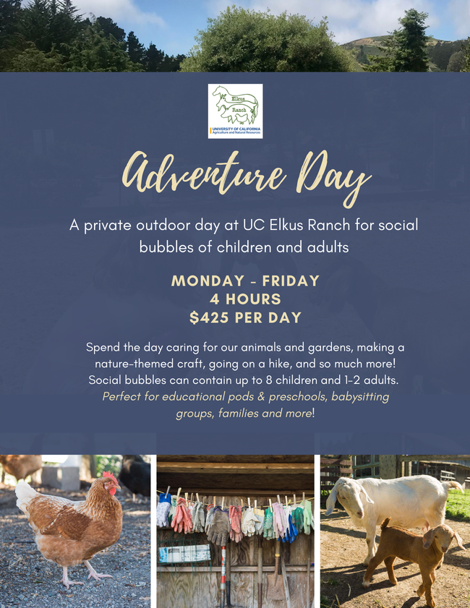

Contact Leslie Jensen to Sign Up!
LKJensen@ucanr.edu | (650) 712-3151

Important Notes
*Social Bubbles (from the San Mateo County Health Department): A social bubble is a group of twelve or fewer people from different households or living units who have agreed to socialize only with members of their group. A social bubble must be maintained for a minimum of three weeks, and people can only be members of one social bubble at a time. Click here for the full San Mateo County Health Order. At Elkus Ranch, all participants will be required to wear masks.
**Adults are required to attend with children to assist with any issues that require close contact so that our educators can remain socially distant. Please let us know if the children you are registering are younger than 5 years old.

