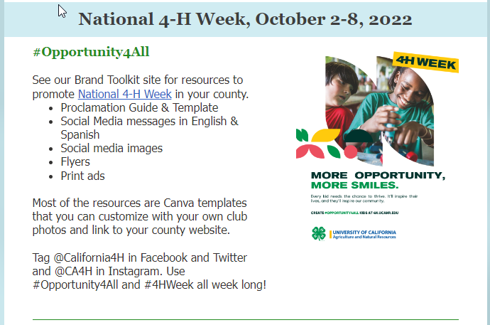

Link:

<https://ucanr.edu/sites/CA_4-H_Brand_Toolkit/Toolkits/National_4-H_Week/>