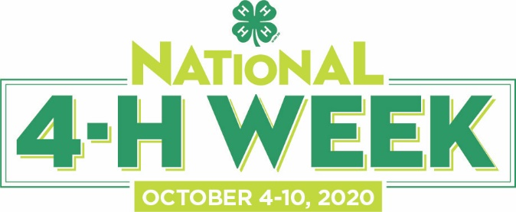

[Insert name of county] Youth to Celebrate
National 4-H Week: October 4-10

City, State (Month, Day, Year) — Every year, National 4-H Week sees millions of youth, parents, volunteers and alumni come together to celebrate the many positive youth development opportunities offered by 4-H. The theme for this year’s National 4-H Week, Opportunity4All, is a campaign that was created by National 4-H Council to rally support for Cooperative Extension’s 4-H program and identify solutions to eliminate the opportunity gap that affects 55 million kids across America.

With so many children struggling to reach their full potential, 4-H believes that young people, in partnership with adults, can play a key role in creating a more promising and equitable future for youth, families and communities across the country. In 4-H, we believe every child should have an equal opportunity to succeed. We believe every child should have the skills they need to make a difference in the world.

[Name of county] 4-H will observe National 4-H Week this year by highlighting some of the inspirational 4-H youth in our community who are working tirelessly to support each other and their communities.

“We believe youth perspectives are so important and a solution to eliminating the opportunity gap, because young people come with new ideas and new ways of seeing the world,” explains Jennifer Sirangelo, President and CEO of National 4-H Council. By encouraging diverse voices and innovative actions, 4-H believes that solutions can be found to address the educational, economic and health issues that have created the opportunity gap.

[Insert a paragraph detailing how your program will be celebrating 4-H Week here]

“[Place quote from a local 4-H staff member about the value of the 4-H experience and how the youth have contributed to the community],” said [Individual's name and title]. "[Highlight a specific project related to Opportunity4All and the effect it will have on the community]."

In [name of county], more than [number] 4-H youth and [number] volunteers from the community are involved in 4-H. [Insert a paragraph highlighting some of the 4-H programs offered in your county related to Opportunity4All.]

One of the most anticipated events of National 4-H Week every year is the 4-H STEM Challenge, formerly known as National Youth Science Day. The theme of this year’s event, which is expected to see hundreds of thousands of youth across the nation taking part throughout October, is Mars Base Camp. Developed by Google and Virginia Cooperative Extension, Mars Base Camp is a collection of activities that teaches kids ages 8-14 STEM skills, including mechanical engineering, physics, computer science and agriculture.

To learn more about how you can get involved, visit http://www.4-h.org/.

About 4-H
4-H, the nation’s largest youth development and empowerment organization, cultivates confident kids who tackle the issues that matter most in their communities right now. In the United States, 4-H programs empower six million young people through the 110 land-grant universities and Cooperative Extension in more than 3,000 local offices serving every county and parish in the country. Outside the United States, independent, country-led 4-H organizations empower one million young people in more than 50 countries. National 4-H Council is the private sector, non-profit partner of the Cooperative Extension System and 4-H National Headquarters located at the National Institute of Food and Agriculture (NIFA) within the United States Department of Agriculture (USDA).
Learn more about 4-H at www.4-H.org, find us on Facebook at www.facebook.com/4-H and on Twitter at https://twitter.com/4H.

About the University of California 4-H Youth Development Program:
The University of California 4-H Youth Development Program is open to all youth age 5 through 19 years. More than 155,000 youth and over 14,000 adult volunteers participate in 4-H throughout California. The program is delivered through the Cooperative Extension offices of the University of California Division of Agriculture and Natural Resources (UC ANR), a statewide network of the University of California. UC ANR researchers and educators draw on local expertise to conduct agricultural, environmental, economic, youth development and nutrition research that helps California thrive. Learn more at ucanr.edu.

Learn more about California 4-H at 4H.ucanr.edu, on Facebook and Twitter.

###

Contact: [insert name], [insert title]
[insert telephone number], [insert E-mail address]

