From: EvaluateSNAPEd [mailto:evaluatesnaped@ucanr.edu]
Sent:
Cc: NEOP Evaluation Unit <neopevaluationunit@ucdavis365.onmicrosoft.com>
Subject: April PEARS User Newsletter

Greetings CDPH PEARS users! Each month we will share news, updates from KSU, and resources that you may find helpful as you conduct your PEARS reporting.

New! A recent update to the PEARS Partnerships Module allows you to track the jurisdiction of your partnerships, like you can already do for Coalitions. You will find this new field on the "General Information" section of the Partnerships Module. For any existing partnerships, the field has been left blank; however, you can edit the partnership and add it.
v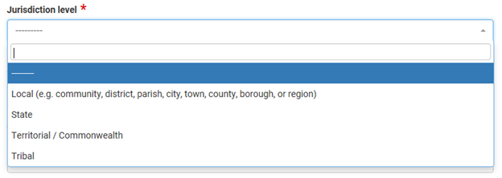

Under Development! Your California PEARS team is currently developing brief, topical webinars on PEARS questions and features that LHDs have expressed an interest in learning more about. If there is a topic you are especially interested in, it is not too late to submit your idea to us at EvaluateSNAPEd@ucanr.edu. Stay tuned for more information soon!

The California PEARS team holds Q&A sessions for LHDs every third Thursday from 1:30-2:30 pm PST. We’ll answer any programmatic questions you have about PEARS, such as “What is the difference between unique and new individuals?” or “Do parents at schools need to fill out data cards?” The April Q&A session will be held on the April 19th. See below for instructions on how to join.
- Questions and answers from the March 22 Q&A session are attached for your reference.

The KSU PEARS team holds Q&A sessions every other Wednesday at 1:00 pm PST. The next call is April 18th. They’ll answer any technical questions and problems you have about using PEARS, such as “After I enter a survey instrument I can’t select it in a program activity,” or “When I try to use the search bar, nothing happens when I hit enter.” See below for instructions on how to join.

The CDSS PEARS User Resources and Reference webpage has a list of training and TA resources, including links to webinar recordings. Bookmark this for easy access and check back often, as more resources will continually be added.

If you or someone you work with need a PEARS user account, please fill out this form. If you need help with any other PEARS questions, please contact the SNAP-Ed evaluation team at NPI using this email.

We strive to respond to your questions in a timely manner. Please know that all your feedback is welcome and helpful as we continue to make improvements to the system.

PEARS Programmatic Q&A Sessions led by the CA SNAP-Ed Evaluation Team:
Thursday, April 19th
Thursday, May 17th
1:30-2:30 pm PST

To join:
On a PC, Mac, Linux, iOS or Android device, click this link: https://ucanr.zoom.us/j/260319270
OR... Dial in on your phone by calling +1-646-558-8656 (US Toll) or +1 669 900 6833 (US Toll) and entering Meeting ID: 260 319 270.

PEARS Technical Q&A Sessions led by Kansas State University:
Wednesday, April 18th
Wednesday, May 2nd
Wednesday, May 16th
Wednesday, May 30th
at 1:00 pm PST
To join:
On a PC, Mac, Linux, iOS or Android device, click this link: https://ksu.zoom.us/j/543214262
OR... Dial in on your phone by calling +1-646-558-8656 (US Toll) or +1-408-638-0968 (US Toll) and entering 543 214 262 as the Meeting ID.

