Program Activities naming - PEARS Program Activity Module
For review or additional reporting, Program Activity entries can be filtered by a number of the data fields included in the activity entry: 1) start date, 2) end date, 3) delivery person, 4) delivery site, 5) SNAP-Ed curriculum, and 6) unit. In addition, the “Program activity name” is a flexible field programs can use to identify a program activity entry (see PEARS excerpt below).
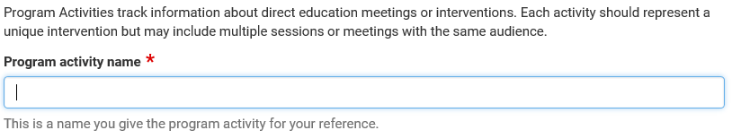
Program Activity Name
Based on the FFY2017 piloting of the Program Activity module, please use the following naming conventions for the “program activity name”. Programs can also choose to add additional information to the name based on their specific needs and interests.
Focus Audience and single vs. series format
Most programs deliver direct education focused on specific audiences – youth, adult and/or family – and either in a single or multi-session format. See below for short-form program activity names based on these common types of direct education.
Type of Direct Education | Short-form name to be entered
- Youth Education – series  - Youth Education – single session/workshop | - YE – series  - YE – single
- Adult Education – series  - Adult Education – single session/workshop | - AE – series  - AE – single
- Senior Education –series  - Senior Education – single session/workshop | - SE – series  - SE - single
- Family Education – series  - Family Education – single session/workshop | - FE – series  - FE – single
- General/All ages Education – series  - General/All ages – single session/workshop | - GE – series  - GE - single

Additionally, programs might want to include other specific information in the program activity name that is not already available as one of the filtering options e.g. subcontractor or educator that delivered intervention, language session delivered in, classroom number or volunteer teacher’s name, other education formats such as garden-based or store tours or topic focus such as physical activity.

