**Reporting Organization-Level Activities in the PSE Module**

PEARS PSE Activities – organizational vs. site level reporting

The PEARS PSE Activities module is set up to capture work with a site or organization to make PSE changes – see excerpt below. This job aid was developed to help clarify when and how to report **organization-level** PSE activities.

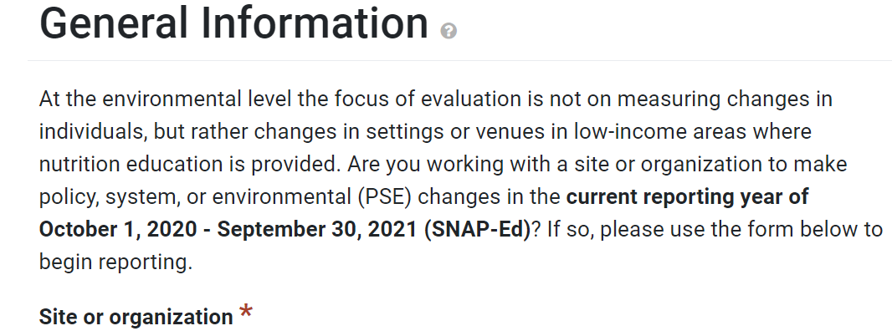

Working at the organization-level to plan, assess, design, implement and/or monitor PSE changes can have many benefits especially in terms of reach and efficient use of resources. State Implementing Agencies (SIAs) typically encourage their Local Implementing Agencies (LIA) to seek partnerships that make this type of strategic and broader impact possible.

Examples of organization-level PSE work for a School District may include the following:

* School District Wellness committee triennial assessment of the district school wellness policy
* In collaboration with the District Food Service Director, adoption of new district-wide school foodservice practices (e.g., serving a variety of fruits and vegetables, new standardized recipes, etc.)
* In collaboration with the District Physical Education and Activity Specialist, plan and implement professional development training and materials distribution to Physical Education Specialists throughout the school district.

Examples of organization-level PSE work outside of K-12 school settings may similarly include nutrition and wellness policies, trainings, standardizing recipes, food procurement or donation specifications, etc.

Organization-level activity and effort is distinct from, but certainly supportive of, any additional PSE work that occurs at the individual sites within the same organization. PEARS PSE reporting combines both organization-level and site-level reporting into the PSE Site Activities module. The objective of this additional guidance is to help the PEARS user accurately determine at what level the PSE related work occurred (site vs organizational) and complete the PSE reports, including custom questions, accordingly.

**When should you report PSE activities at the organization level?**

* When the PSE changeoccurs at the “parent” organization which governs or provides direction for multiple sites (e.g., a school district, a grocery association, a food bank, etc.)

**When should you report PSE activities at the site level?**

* When PSEchanges are implemented directly at the site level (e.g., an individual school, store, ECE site, food pantry, etc. that an LIA partners with to plan and implement PSE work).
* This PSE activity is reported into PEARS separately for each site
* *Note for LHDs: This reflects a change in our guidance – LHDs no longer have to create PSE entries for sites they aren’t working directly in.*

**Examples:**

*Organization-level PSEs:*

* Change to a school district wellness policy
* Change to procurement standards for a food bank governing multiple food pantries
* Change to marketing policy for a chain of grocery stores
* CATCH training for a group of ECE providers coordinated through the county referral and resource center
* CATCH training at the district level with all PE specialists in order to roll out CATCH PE at all schools

***Not*** *organization-level PSEs:*

* Making the same change at multiple sites, by working with the sites one-by-one, such as implementing Smarter Lunchroom practices at several sites in a school district
* Conducting separate CATCH trainings at multiple ECE or school sites, each one intended to benefit that individual site only
* Working with individual stores to improve the placement or display of healthy foods

Examples of common PSE activity categories that happen at the organization level are:

1. **written** **policies (policy adoption or revision) and policy related activities (e.g. wellness committees, systems to monitor or evaluate policy implementation)**
2. **food procurement and/or changes to menus and recipes developed at the organization level**
3. **professional development**

*Examples of the specific changes adopted, possible PSE implementation scenarios, and additional guidance on reporting reach and site-level PSE implementation are presented below for some common organization-level PSE categories.*

**Category: Written Policies**

|  |  |  |
| --- | --- | --- |
| **Types of changes adopted** | **Reporting reach** | **Additional reporting** |
| * Established or improved food/beverage or nutrition related policy (childcare wellness, school wellness, workplace wellness, etc.) * Established or improved physical activity policy (childcare wellness, school wellness, workplace wellness, etc.) * Other changes that involved creating new or improving existing written policies | Per the [reach support documentation in PEARS](https://support.pears.oeie.org/document-reach/), written policies that have not yet been implemented have a reach of 0. Once implemented, the reach is the number who come in direct contact with the practice, program, or environmental change this year that resulted from the policy. | * Custom questions regarding organization-level PSEs * Separate PSE Activity reports for each SNAP-Ed eligible site that the LIA works with directly to plan and implement PSE changes intended to benefit that site specifically |

**Example:** A school district adds language to the district wellness policy specifying a minimum number of minutes of PE for each grade level and that PE must be taught by credentialed PE teachers.

**What to report for the organization:**

|  |  |  |
| --- | --- | --- |
| **Site** | **Change adopted:** | **Reach:** |
| Name of school district | Established or improved physical activity policy (childcare wellness, school wellness, workplace wellness, etc.) | **If there is a mechanism to confirm the policy change was implemented at the site-level:**  The unduplicated number of students affected by the policy at SNAP-Ed eligible school sites  **If there is NOT a mechanism to confirm the policy change was implemented at the site-level:** 0 |

**Category: Food-Related Practices**

|  |  |  |
| --- | --- | --- |
| **Types of changes adopted** | **Reporting reach** | **Additional reporting** |
| * Improved food purchasing/donation specifications or vendor agreements towards healthier food(s)/beverages * Initiated or expanded farm-to-table/use of fresh or local produce * Improved menus/recipes (variety, quality, etc.) | Report the total unduplicated reach of those affected by the food procurement change this year.  If this is unknown, specify “unknown” for the reach and characteristics of those reached. | * Custom questions regarding organization-level PSEs * Separate PSE Activity reports for each SNAP-Ed eligible site that the LIA works with directly to plan and implement PSE changes intended to benefit that site specifically |

**Example:** A food bank changes their donation specifications and no longer accepts sugar-sweetened beverages or candy. Clients that visit food pantries that receive food from this food bank are reached by this change, since member agency pantries receive fewer or no SSBs or candy.

**What to report for the organization:**

|  |  |  |
| --- | --- | --- |
| **Site** | **Change adopted:** | **Reach:** |
| Name of food bank | Improved food purchasing/donation specifications or vendor agreements towards healthier food(s)/beverages | The unduplicated number of clients who receive food from the food pantries who are member agencies of the food bank |

**Category: Professional Development**

The PEARS PSE changes list includes two professional development related PSE changes – see first column of the table below. These are categorized as *Systems* changes and should **only** be reported when the following are true:

1. Professional development is a central and intentional focus for this PSE activity and partnership,
2. Implementing professional development that has defined learning objectives, training/resource materials and is a structured training or capacity building effort linked to an evidence-based PSE change or intervention, and
3. Multiple sites or multiple staff or community members at a single site were involved in the professional development.

If the above conditions are not true, the training should instead be reported in the *Strategy* section of the PSE module. Select “Staff training on continuous program and policy implementation” under *complementary activities*.

|  |  |  |
| --- | --- | --- |
| **Types of changes adopted** | **Reporting reach** | **Additional reporting** |
| * Initiated, improved or expanded professional development opportunities on nutrition * Initiated, improved or expanded professional development opportunities on physical activity | Include the reach of the SNAP-Ed eligible sites governed by this organization and affected by this change this year, if a mechanism exists to confirm PSE changes were adopted at the site level due to this professional development. Otherwise, report reach as 0 or unknown. | * Custom questions regarding organization-level PSEs * Separate PSE Activity reports for each SNAP-Ed eligible site that the LIA works with directly to plan and implement PSE changes intended to benefit that site specifically |

**Professional Development Continued…**

**Example:** In coordination with the School District Physical Education and Activity Specialist, a half day CATCH training is provided to all of the Physical Education (PE) Specialists working at schools in the school district. Materials and resources from the CATCH physical activity toolbox are also provided to all the PE Specialists for use with their PE classes at schools in the district.

**What to report for the organization:**

|  |  |  |
| --- | --- | --- |
| **Site** | **Change adopted:** | **Reach:** |
| Name of school district | Initiated, improved, or expanded professional development opportunities on physical activity | **If there is a mechanism to confirm that PE specialists adopted new CATCH activities and techniques to improve the quality of physical education (PE) at the school site:**  The unduplicated number of students affected by the change that are enrolled at SNAP-Ed eligible schools in the school district  **If there is NOT a mechanism to confirm that PE specialists adopted new CATCH activities and techniques to improve the quality of physical education (PE) at the school site:** 0 |