Indirect Education:

Reporting Sites and Approved Non-site-specific Activities

Starting in FFY23, it will be mandatory to report the site of all Indirect Education (IE) channels in PEARS.
- Most IE is associated with a physical location (i.e. an approved site). This could be:
  - Where an activity is delivered
  - Where participants are recruited
  - Any activity where you can link an approved site
- Occasionally, approved IE happens without a specific site. This could be:
  - Virtual, when recruitment is not tied to an approved site
  - Covering an area that is wider than a specific site (e.g. a billboard)
  - IE where reach cannot be allocated to a specific site
NOTE: Regardless of physical location, all activities must be approved by a CFHL Project Officer.
For a refresher on entering indirect activities in general, refer to the Indirect Education Participant Guide. This job aid is a supplement to help you with reporting site information.
Reporting Physical Sites in Indirect Activities
Any time your IE is associated with an approved site or sites, you must report that site(s). Site is reported for each “intervention channel”. This means you could report multiple sites within one IE report by reporting more than one channel.
- If you cannot locate an approved site in PEARS, please contact EvaluateSNAPEd@ucanr.edu.
In the hypothetical example below, the LHD distributes a monthly newsletter to after-school participants at all the after-school sites where they conduct PSE activities. They created a single Indirect Activity report, then added one Intervention Channel for each site. This allows them to report each related site.
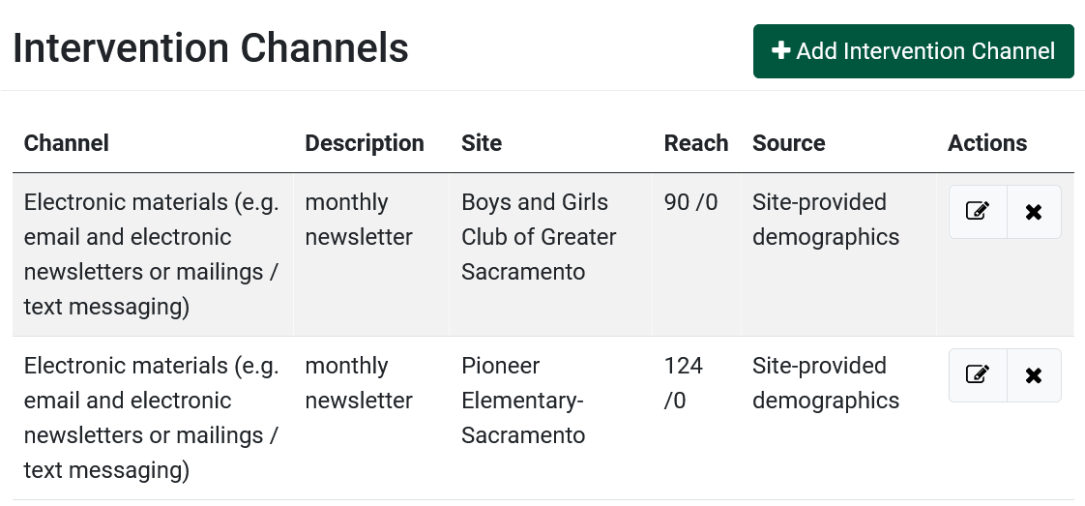
Reporting non-site-specific Indirect Activities
When IE cannot be tied to an approved site, you can select a site from the PEARS list titled called “Approved non-site specific Indirect Education (IE)”.
- This site can be found by searching ‘approved’ or ‘indirect education’, as shown below.
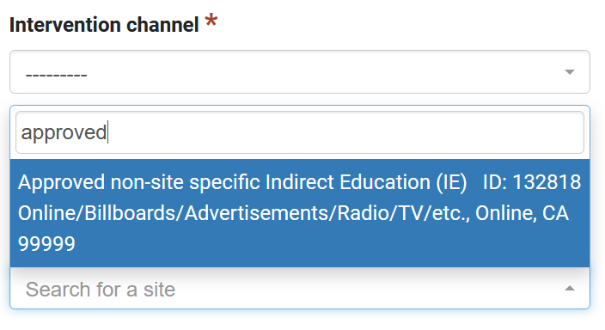
When is it appropriate to use “Approved non-site specific Indirect Education (IE)” as a site?
“Approved non-site specific Indirect Education (IE)” may only be used for IE that cannot be assigned to a physical location. Do not use this site when you have one or more sites relevant to the IE being reported.
Here are a few situations when you might need to use “Approved non-site specific Indirect Education (IE)” as a site:
- Reach cannot be allocated to specific site. For example, if your organization has been adding newsletter recipients over the course of many years, it may be impossible to allocate the reach to specific sites. Note: if you can allocate some of reach to specific sites, you should create an intervention channel for each site with allocated reach, then report the remainder of the reach under a non-site-specific channel.
- Nutrition education websites, blogs, social media, or videos on a website like YouTube
- Text messaging with recruitment from billboards, radio ads, or other non-site-specific methods
- Radio or television interviews
- Recipe cards as part of a food pantry delivery when the delivery is not associated with a walk-in food pantry
Choose the appropriate channel for your non-site-specific IE entry. The channel should be limited to the following:

- Electronic Materials
- Podcast
- Radio Interview
- Radio Public Service Announcement
- Social Media
- Television Interview
- Text Messaging
- TV public service announcements
- Videos from online sites like YouTube
- Websites

Example of non-site-specific IE in PEARS

