How to Capture Community-Level PSE Interventions

What are community-level PSE interventions?
A community-level PSE intervention covers a geographic area of land and is not confined to a single location. An example would be an active transportation policy for a city or a capital improvement project for the sidewalks and/or bike lanes in a neighborhood. Another example might be working to include a health element in the county general plan. Community-level PSE efforts are planned and implemented with a geographic area in mind, rather than changing a single building, site, park, school, etc.

What to enter in your PEARS PSE report
All LHDs working on community-level PSE activities should complete both a PEARS PSE report and a supplementary survey to describe the geographic area the PSE work covers and indicate which jurisdiction-level policies (if any) they are working on enacting. This survey is referred to as the ‘Community Level PSE Questionnaire’ and can also be found here: https://tinyurl.com/CommunityPSE.
Before beginning this survey, a PSE activity entry must already be started in PEARS. Beginning in FFY 24, all LHDs should select the following LHD-specific site for their community-level PSE reports:
“[Name of LHD] LHD Community-Level PSE”
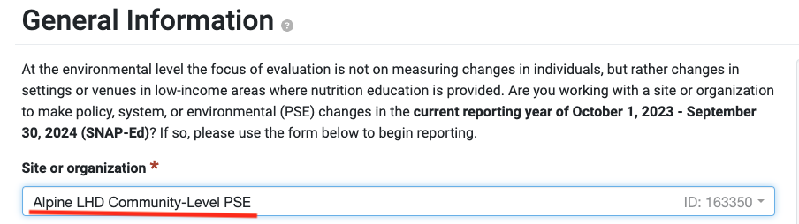
Example of community-level PSE site selected in the PSE module:
You can choose the setting that is most relevant to your community-level PSE work, following the same guidance for selecting the setting for site-level PSE activities. For example, if you are working on active transportation policies and/or sidewalk improvements, the most appropriate PSE setting would be “bicycle and walking paths”. If you are working on something more general, select the “Other neighborhood settings where people ‘live’ or live nearby” setting. This will then give you an open text field where you can explain a bit more about your setting. The setting field is also found on the “General Information” page in the PSE module.

Example of “Other neighborhood settings where people ‘live’ or live nearby” setting selected with a description of the PSE work in open text field: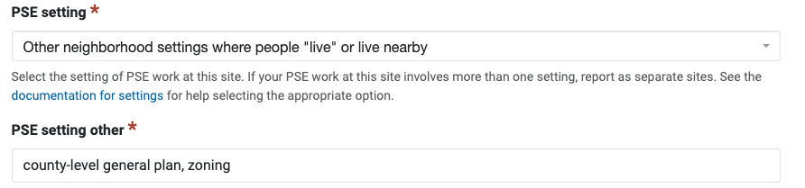
In the “Custom Data” section of the PSE module, there are two questions:
- Is this report for community-level PSE activities (not an organization)? Yes / No
- If this report is for community-level PSE activities, please provide more information using the survey linked here: Community Level PSE Questionnaire
Has the survey been completed? Yes / No
Answer “yes” to the first question. Then, to complete the survey, copy and paste the survey link into your browser or click on the hyperlink in this job aid. If you are unable to fill out the survey at the time you are working on your PEARS PSE entry, mark “No” temporarily. Be sure to complete the survey at a later time and update this response to "Yes." We will send out reminders if we see a “Yes” response for the first question and a “No” response for the second.

Gathering the relevant PSE information for the supplemental survey
Before you begin the supplemental community-level PSE survey, you will need the PSE activity ID and the PSE project field from PEARS. If you are working on your PSE report and the supplemental survey simultaneously, the PSE activity ID is the 5-digit number in the URL after “…track/pse/”:
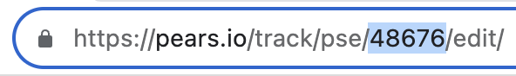

The PSE project field is a brief name or description of your PSE work that you designate. It appears right under the “site or organization name” on the “General Information” page:
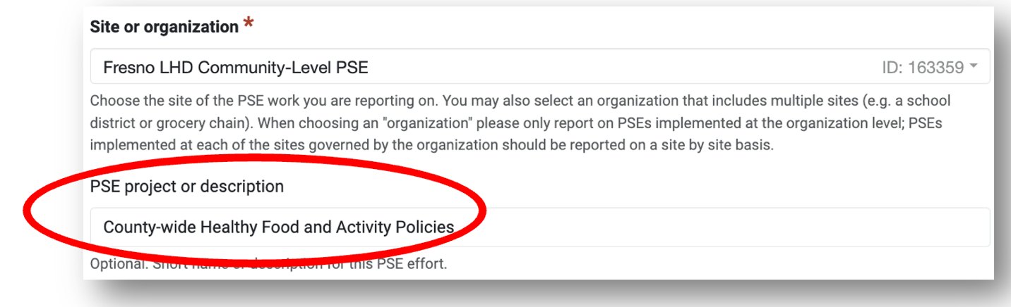
If you created a PEARS PSE entry for your community-level PSE work earlier in the year, go to the end of this document for instructions on where to find your previously created report, the PSE Activity ID, and PSE Project Name.

Completing the supplemental community-level PSE survey
Once you have the necessary PSE report information, access the survey using this link: Community Level PSE Questionnaire
The first part of the survey has fields to enter the corresponding PEARS PSE report information so that we can correctly link your supplemental survey entry with your community-level PSE report. These fields include: current federal fiscal year (FFY), PSE activity ID, site name, and PSE project description.
Next, you will capture the geographic area that the community-level PSE change covers using the map tool. Search for the general location using the map's search bar or using Ctrl+scroll to zoom. To mark the PSE coverage area, use the 2nd or 3rd buttons on the right.
Location of search bar and insert area buttons:
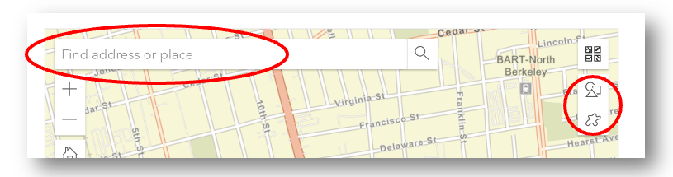
Here is more information about how to use the mapping tools from the makers of Survey 123.
The Sketch button is like a freehand drawing tool which is best used when the area has a lot of curves or small sections. The Smart Shapes button takes your freehand sketch and converts it into an ellipse, rectangle, or triangle.
The next survey question asks about the type of geographic area or administrative boundary that this community-level PSE work covers:
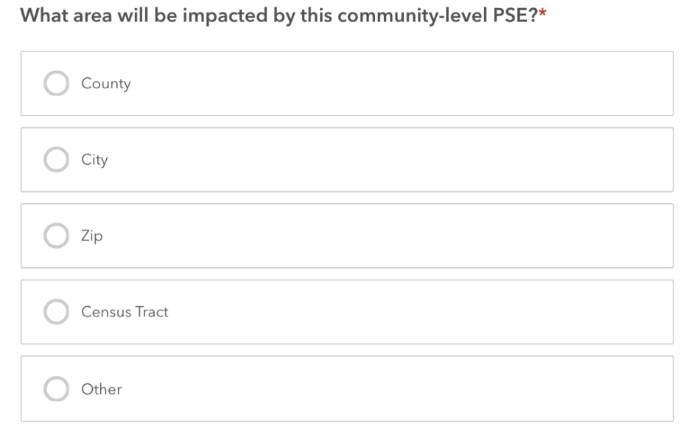
Choose the type that corresponds the best. For example, if the PSE work covers most of the county except for a small, unpopulated portion, choose “County”. If the PSE work is limited to CalFresh Healthy Living eligible census tracts, choose “Census Tract”. If the PSE work does not follow administrative boundaries, choose “Other”. The next question is a text box that allows you to actually name or describe the area (e.g., “Sacramento County” or “Sidewalks between Main St and 2nd St, and between Park Ave and Lakeview Ave”).
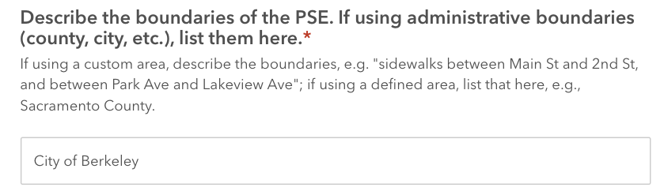

The next question asks whether work was done towards informing, improving, or adopting community-level policies during this federal fiscal year that would impact the specific geographic area selected for the report:
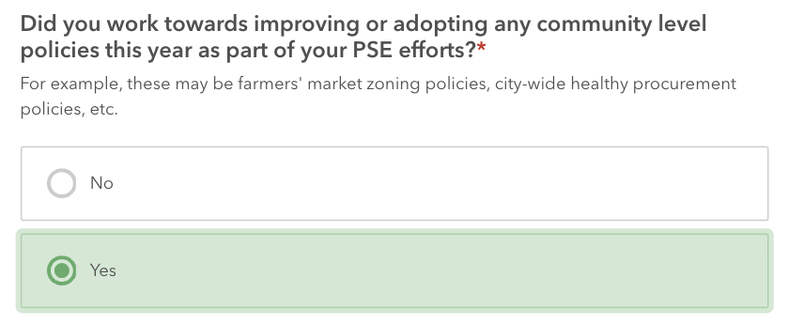
These may be zoning policies, city-wide healthy procurement policies, and other community-level policy changes, many of which are described in the SNAP-Ed evaluation framework under MT7 and MT10.
If you select yes, this will bring up another question where you will be able to specify the types of policies worked on this year. Include all policy-related efforts, whether or not the policy change has been adopted yet.
Here is a list of the types of policies to choose from. If you choose other, please provide more information about the policy.
- Local Food Production/Distribution
- Healthy Food and Beverage Procurement/Vending
- Physical Activity Policies and Supports
- Nutrition/Health Element in General Plan
- Access/safety to parks/open space
- Complete Streets and/or active living
- Community design and/or safety
- Zoning for food/beverage outlets and/or physical activity facilities
- Other
The final survey field is a comment box. Please feel free to use this space to comment on anything else that you would like to note about your community-level PSE work.
Once you hit the “Submit” button at the bottom, you will be done! Please don’t forget to return to PEARS and complete the rest of the PSE report, if you haven’t already and mark “yes” to the second custom question.
Thank you!

Gathering information from a previously entered PSE report
- Go to the “Track” PSE section of PEARS and find the community-level PSE report for which you will be completing a supplemental survey. Click on the Site/Org Name to open the PSE summary.
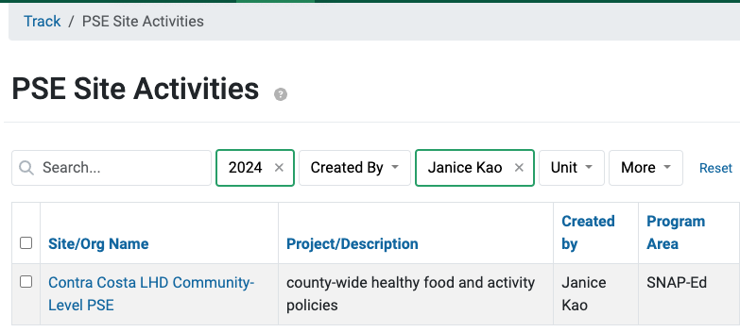
- A report summary will open and the PSE Site Activity ID will appear at the end of your URL.
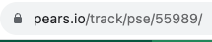

- On the PSE report summary page, you will find the Site Name, PSE Project Description, Reporting period (for the FFY field):
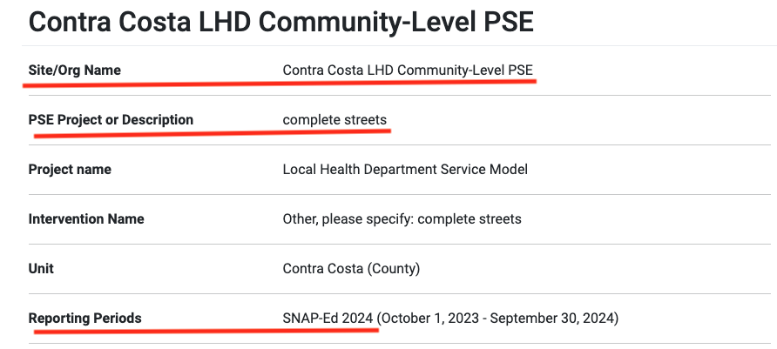

- You’ll also find an additional place with the PSE Site Activity ID:
