Community-Level PSE Questionnaire
Developed by the
University of California Nutrition Policy Institute for the California Department of Public Health

FFY (Federal Fiscal Year): ___________________

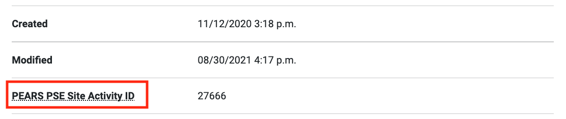
PSE report IDs can be found by opening the PSE report and scrolling down to "PEARS PSE Site Activity ID."
_________________________
Input the PSE Site name: ___________________ Community-Level PSE
(i.e., Alameda Community-Level PSE)
Project name: ___________________________

1. Please complete the survey using the survey123 link to trace the shape of the PSE coverage area:
2. What area will be impacted by this community-level PSE?
- County
- City
- Zip
- Census Tract
- Other Specify Other: ________________________

3. Describe the boundaries of the PSE. If using administrative boundaries (county, city, etc.), list them here.
If using a custom area, describe the boundaries, e.g. “sidewalks between Main St and 2nd St, and between Park Ave and Lakeview Ave”; if using a defined area, list that here, e.g. “Sacramento County”.
__________________________________________________________________________________________________________________________________________________________________________

4. Did you work towards improving or adopting any community level policies this year as part of your PSE efforts?
For example, these may be farmers’ market zoning policies, city-wide healthy procurement policies, etc.
- No

- Yes Complete Q5

5. Please select all of the types of policies that you worked on this year for the geographic area described above, whether or not the policy change has been adopted yet.
□ Local Food Production/Distribution
□ Healthy Food and Beverage Procurement/Vending
□ Physical Activity Policies and Supports
□ Nutrition/Health Element in General Plan
□ Access/safety to parks/open space
□ Complete Streets and/or active living
□ Community design and/or safety
□ Zoning for food/beverage outlets and/or physical activity facilities
□ Other

6. Comments:
__________________________________________________________________________________________________________________________________________________________________________________________________________________________________________

