**What should I work on? You will likely be faced with a number of possible issues and identified clientele needs to resolve in your community. Consider the importance of each of the following in helping you set your priorities.**

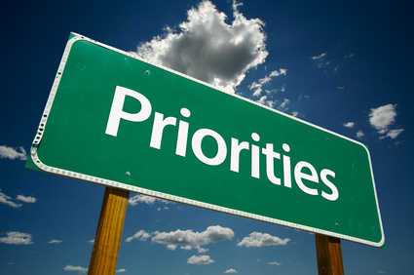

**UC ANR Considerations**

* [Strategic Vision 2025](http://ucanr.edu/files/907.pdf)
* [Public Values](http://ucanr.edu/sites/anrstaff/2016-2020_Strategic_Plan/Goal_5__Prioritize_programs_and_services/Public_values_statement/) and [Condition Changes](http://ucanr.edu/sites/anrstaff/2016-2020_Strategic_Plan/Goal_5__Prioritize_programs_and_services/Condition_changes/)

**Individual’s Considerations**

* Your job description
* Your expertise/something you can be the expert in
* Collaborations
* Quick, relevant results that can promote your visibility
* Funding and resources available

**Other Organization Considerations**

* Level of support from political and other local leaders and organizations
* Local perspectives, dynamics and priorities
* Comparative advantage of UC ANR or potential synergies with other organizations

**Clientele (Audience) Considerations**

* Clientele awareness and perceptions of the issues
* Percent audience affected
* Extent of the problem - catastrophic, low loss, etc.
* Frequency of the problem

**“Solution” Considerations**

* Type of problem - technical, economic, or political

i.e., do you need to address a technical issue, a political issue, or an economic issue? The appropriate solution will look very different and may or may not have a feasible solution.

* What’s the state of the science? Is there enough known for you to make progress?
* Probability of successful resolution (i.e., probability of an economically feasible solution)
* Potential for impact?
* Other…..?