Measuring Outcomes for Urban Water Quality Program
Darren L. Haver, Water Resources Advisor, Orange County
October 2018

Background
Beginning in 2001 I initiated work with Orange County Watersheds, a County of Orange department tasked with administering the National Pollutant Discharge Elimination System allowing discharges into urban storm drain systems, to improve water quality countywide through the adoption of pesticide and fertilizer management practices. A component of the Permit is a requirement to begin tracking pesticide and fertilizer use on city and county-owned properties. In most jurisdictions, pesticides and fertilizers are applied to parks, medians, and around city-owned facilities, such as city halls, libraries, and community centers.

Measuring Outcomes Approach
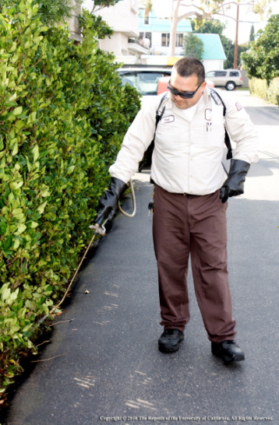
Each year jurisdictions submit a list of pesticides and fertilizers along with the quantities applied to all their properties. I utilize this data to complete an analysis to determine trends in use patterns between jurisdictions and among reporting years. The analysis must consider the quality of the data submitted by each jurisdiction as well as changes in pest pressure, especially control of invasive pests or considerable rainfall resulting in higher than normal weed populations.

The results of the analysis have provided important feedback to me on the success of my extension efforts to reduce the impacts of pesticides and fertilizers on local streams, creeks, and the ocean. For example, we created a targeted effort to reduce use of two organophosphate pesticides available to landscape professionals. Annual extension trainings for the personnel who maintain city-owned properties focused on an integrated pest management program approach and its link to protecting water quality. The annual pesticide use data provided secondary data source documentation on the continued use or reduced use of the pesticides of concern. Additionally, we can use data from a county-wide water quality monitoring program (OC Watersheds) and, if available, the California Department of Pesticide Regulation’s Surface Water Protection Program to assist us in determining if monitored pesticides are increasing or decreasing in runoff.

Outcome
City and county landscape professionals adopted an integrated pest program as part of their maintenance activities, which has reduced unnecessary pesticide and fertilizer applications as documented in submitted use records, contributing to reduced water quality degradation.

Lessons Learned
We learned to focus our effort and measuring outcomes approach. Since 2001 we have attempted to improve the quality of the data collected by each jurisdiction by reducing the number of pesticides of concern and providing a specific training on how to collect pesticide and fertilizer use records. In recent years, the analysis has focused significantly more on those pesticides and fertilizers with the greatest potential for negative impacts on water quality.

