Ripple Effect Mapping: Zoom Adaptation

Background
Ripple Effect Mapping (REM) is a participatory method that combines mind mapping and appreciative inquiry to evaluate short term outcomes and long term impact of a particular program, event, or organization (Kollog, Flage, Chazdon, Paine, & Higgins, 2012). It has been utilized by Extension academics across the country, including Washington State University, University of Idaho, University of Minnesota, North Dakota State University, and South Dakota State University.

Purpose
The purpose of using REM is to visually document the outcomes of an event, program, or organization on individual participants, groups, communities, or regions involved. It is especially helpful for capturing rich detail that cannot be easily measured with numbers or collected from other data collection methods.

What is it?
Ripple Effect Mapping is:
A participatory group method that engages program and community stakeholders to retrospectively and visually map the chain of effects resulting from a program or complex collaboration. The REM process combines elements of Appreciative Inquiry, mind mapping, group interviewing, and qualitative data analysis. It is a powerful tool for documenting both the intended and unintended results of a program. It is also a way to engage and reenergize program participants and stakeholders around shared goals. (Chazdon, 2015).

Appreciative Inquiry is “a process that inquires into, identifies, and further develops the best of what is in organizations in order to create a better future” (Coghlan, A. T., Preskill, H., & Tzavaras Catsambas, T, (2003), p. 5). It is also described as a “one on one dialogue among organization or community members and stakeholders using questions on highpoint experiences, valuing and what gives life to the organization or community at its best” (Cooperrider & Whitney, 2006, p. 275).

Benefits
- Relationship building and opportunity for celebration and reflection.
- Capturing unintended outcomes and outcomes that may not feasibly measured through other methods.
- The mix of participants creates an insider-outsider dynamic that can lead to game-changing insights about past and future programs, making REM a possible developmental evaluation tool (Chazdon, 2015).

Deliverables
- A visual outcomes map.
- Data that demonstrates outcomes and impacts.
- Report and other publications as desired.

Participant Recruitment
Recommended to have 8-16 people with the goal of having half direct participants and half non-participant stakeholders.
- Examples of direct participants include current and former event/program participants, staff, volunteers, program/organization leaders
- Examples of non-participant stakeholders: Relatives, coworkers, and supervisors of the event/program participants, community members, neighbors, legislators, and funders. These stakeholders should have some familiarity with the program and likely have heard stories or seen outcomes of the program that they can share.

Roles
- Interviewer (welcome, agenda, ground rules, activity instruction, facilitates pair share out, asks probing questions to get to outcomes)
- Mapper (prepares XMind, shares screen and develops a live map during pair share out). (XMind is a software that can be used to create the visual map. It is available as free download for iOS and Windows versions).
- Zoom host (manages waiting room and pair breakout rooms, must be flexible and able to quickly change breakout rooms if there are no shows)
- Welcome and concluding presentations
- Program staff/volunteers involved in planning as well as participate in REM

Figure 1. Gallery mode in Zoom.
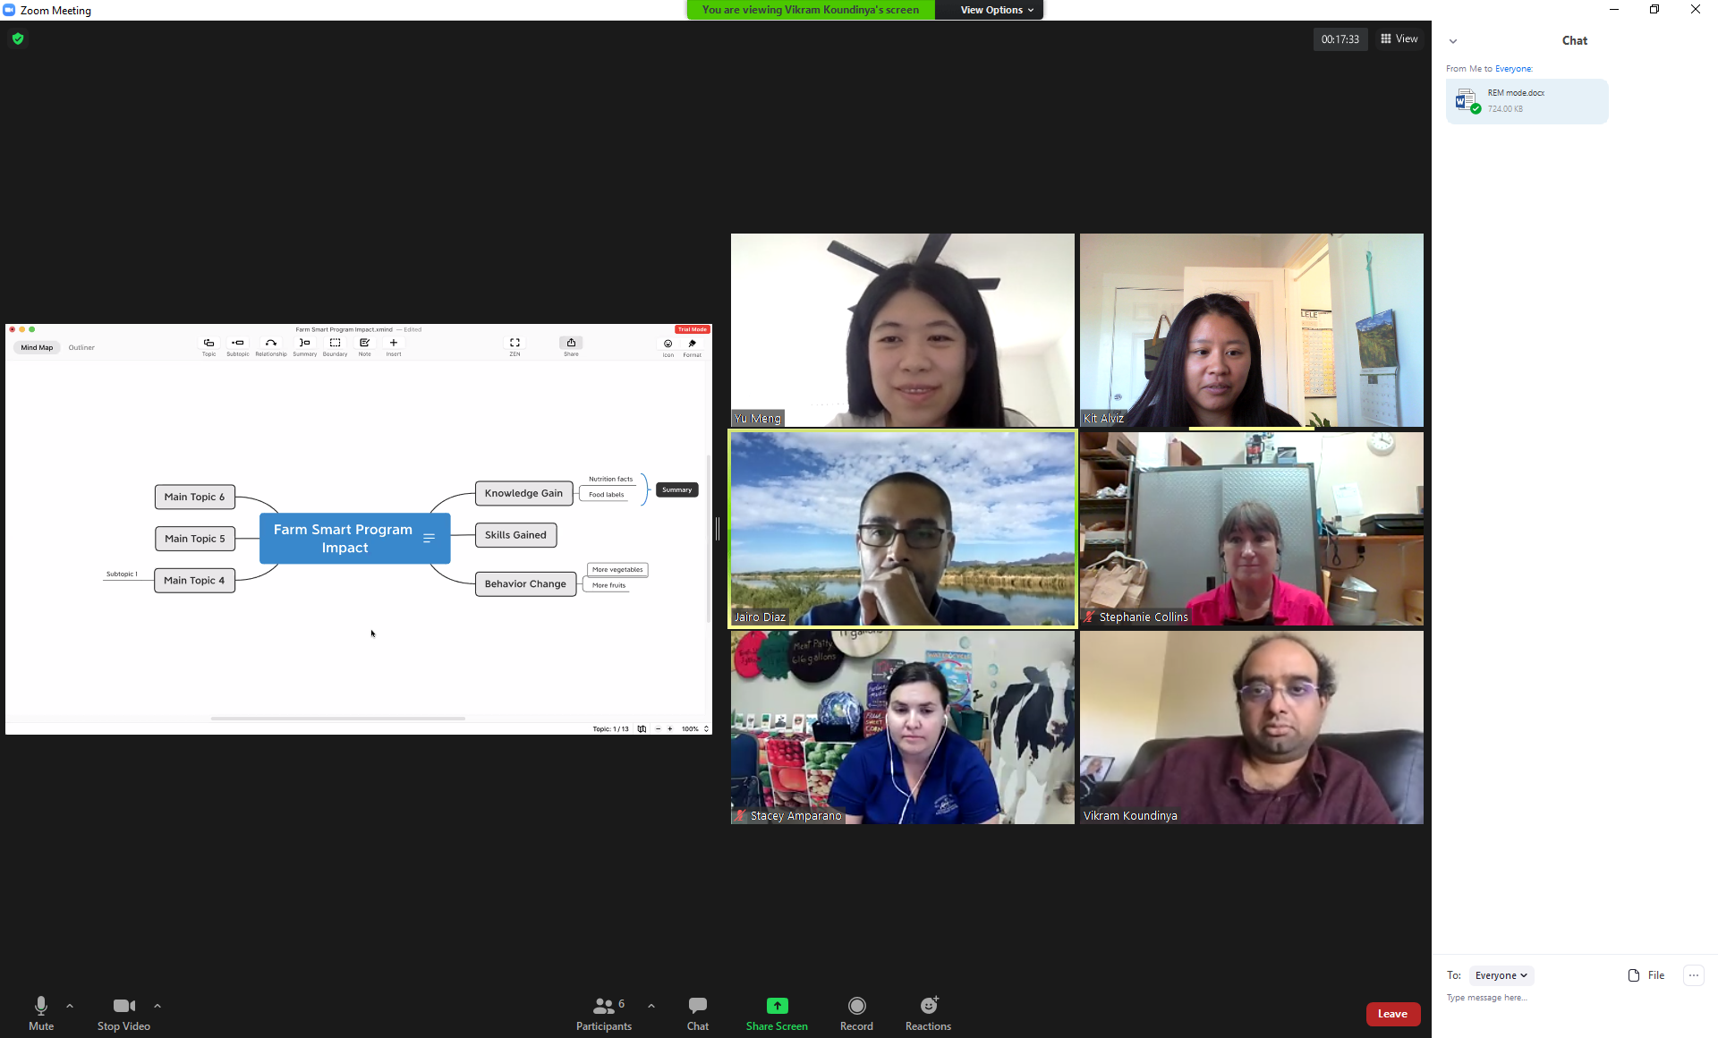

REM Session with Zoom Adaptation:

Time required: 60-120 minutes

Event set up
- Designate a greeter (e.g., program staff who knows most people) to say hello, chat with participants that join before the event begins, let them know we are starting in a few minutes, etc.
- To save time, ask individuals to introduce themselves in the chat and have a fun icebreaker trivia question about the program.
- Zoom host manages waiting room, pairs for breakout rooms, logistics, and starts the recording.
- As participants arrive, do not use the share screen feature so that the emphasis is on the participants. Encourage participants to turn on their cameras if they are able.

Introduction (15 minutes)
- Provide an overview of the session and objectives. Also cover ground rules and let them know the meeting is being recorded for the purposes of having notes to add to the analysis.

Appreciative Inquiry Interview (10 minutes)
- Let participants know that they’ve been paired with a partner and will be put in breakout rooms for 10 minutes. Once in breakout rooms, partners should introduce themselves and then use the Appreciative Inquiry questions. Provide your participants multiple questions for all types of direct and indirect participants. Examples:

“Describe a time in your organization/community that you consider a highpoint experience, a time when you were most engaged and felt alive and vibrant.” (Cooperrider & Whitney, 2006, p. 275).

Think about a time when you worked with the program over the past 5 years and experienced or observed a meaningful, significant outcome.

(For Farm Smart students, teachers, and staff/interns), Please share a story about memorable experience from farm smart that positively impacted you. How has the Farm Smart program helped participants connect to agriculture & Food? How does Farm Smart program help you connect to food & agriculture?

(For parents, community members, and stakeholders) Please share one memorable story you have heard from folks participating in Farm Smart? Describe any positive impacts that you have seen in our community by the children participating in Farm Smart?

- Recommend participants take down a few key words about their partner’s story to help them remember. Each person will be asked to share their partner’s story to the larger group.

- Zoom host can set 10 minute timer and broadcast a message at 5 minutes letting them know they are halfway through.

Mapping (45-70 minutes)
- For this part of the meeting, recommend participants set up their computer monitor to allow for viewing the map, other participants’ faces, and the chat. An example is in Figure 1, Gallery mode in Zoom.

- Ask each pair to share one story. Mapper screenshares XMind application. Mapper creates one ripple per participant and takes shorthand notes on the map. Minimize the amount of text on the screen so that it is easy for participants to see the map. The mapper should write very little text on the methods and write more text about the outcomes and impacts.

- Interviewer and mapper can ask probing questions as needed. Then what happened? Who was involved? How many people were there? What is different in the community as a result (people, organizations, community)?

- Continue until everyone has shared one story.

Reflection (10 minutes)
- Ask group to discuss to take a look at the map and share if there is anything striking, what stands out, any commonalities between what people said, etc.

Closing (5 minutes)
- Thank participants for engaging in REM exercise.

- Explain map will be digitized and coded, and how it will be shared.

After REM session

Clean up the live map
- Use participant responses to reflection (step 7) as a starting place to organize the map into common themes.
- Add additional themes as needed.
- Spell out acronyms, shorthand, etc. Add minimal but critical information from the Zoom recording that might help tell the ripple effect stories. But do not add lengthy text in order to keep the map visually appealing.
- Somehow highlight or visually differentiate short, medium, and long term outcomes so that they stand out.

Conduct follow-up interviews
- May need to follow up with ripple effect mapping participants to collect additional details and confirm accuracy.
- May need to collect additional information for others who were unable to attend the session by scheduling follow-up phone interviews or Zoom meetings. The same appreciate inquiry questions can be asked.

Analysis
- Select-all in XMind then paste in Excel.
- Add rich details in Excel file from the Zoom recording and any follow up interviews.
- Clean, code, analyze. One recommended way to code the data is into short, medium, and long-term outcomes.
Report
- For reports, consider adding the whole map and/or screenshots of certain sections of the map.
- Consider having report sections for short, medium, and long term outcomes.
- Add photos
- Give participants the opportunity to review and provide feedback before finalizing the report.

This document was developed by University of California Agriculture and Natural Resources:
Katherine Webb-Martinez¹, Kit Alviz¹, Vikram Koundinya², Yu Meng³, Jairo Diaz³, Stephanie Collins³, and Stacey Amparano³.
¹: Program Planning and Evaluation, UC ANR
²: Department of Human Ecology, UC Davis & UC Cooperative Extension
³: Desert Research and Extension Center & Imperial County Cooperative Extension, UC ANR
References
Chazdon, S. (2015, June 16). EEE Week: Scott Chazdon on Ripple Effect Mapping. AEA365 Blog. https://aea365.org/blog/eee-week-scott-chazdon-on-ripple-effect-mapping/
Coghlan, A. T., Preskill, H., & Tzavaras Catsambas, T. (2003). An overview of appreciative inquiry in evaluation. New Directions for Evaluation, Winter 2003 (100), 5-22. Available at: https://onlinelibrary.wiley.com/doi/epdf/10.1002/ev.96

Cooperrider, D. L., & Whitney, D. (2006). Appreciative inquiry: A positive revolution in change. Pp. 275-289 in P. Holman & T. Devane (eds.), The Change Handbook. San Francisco: Berrett-Koehler Publishers, Inc.
Kollock, D.H., Flage, L., Chazdon, S., Paine, N., & Higgins, L. (2012). Ripple Effect Mapping: A "Radiant" Way to Capture Program Impacts. Journal of Extension, 50(5). Available at: https://archives.joe.org/joe/2012october/tt6.php

