**Ripple Effect Map Example:**

**University of California Sustainable Agricultural Research and Extension Program**

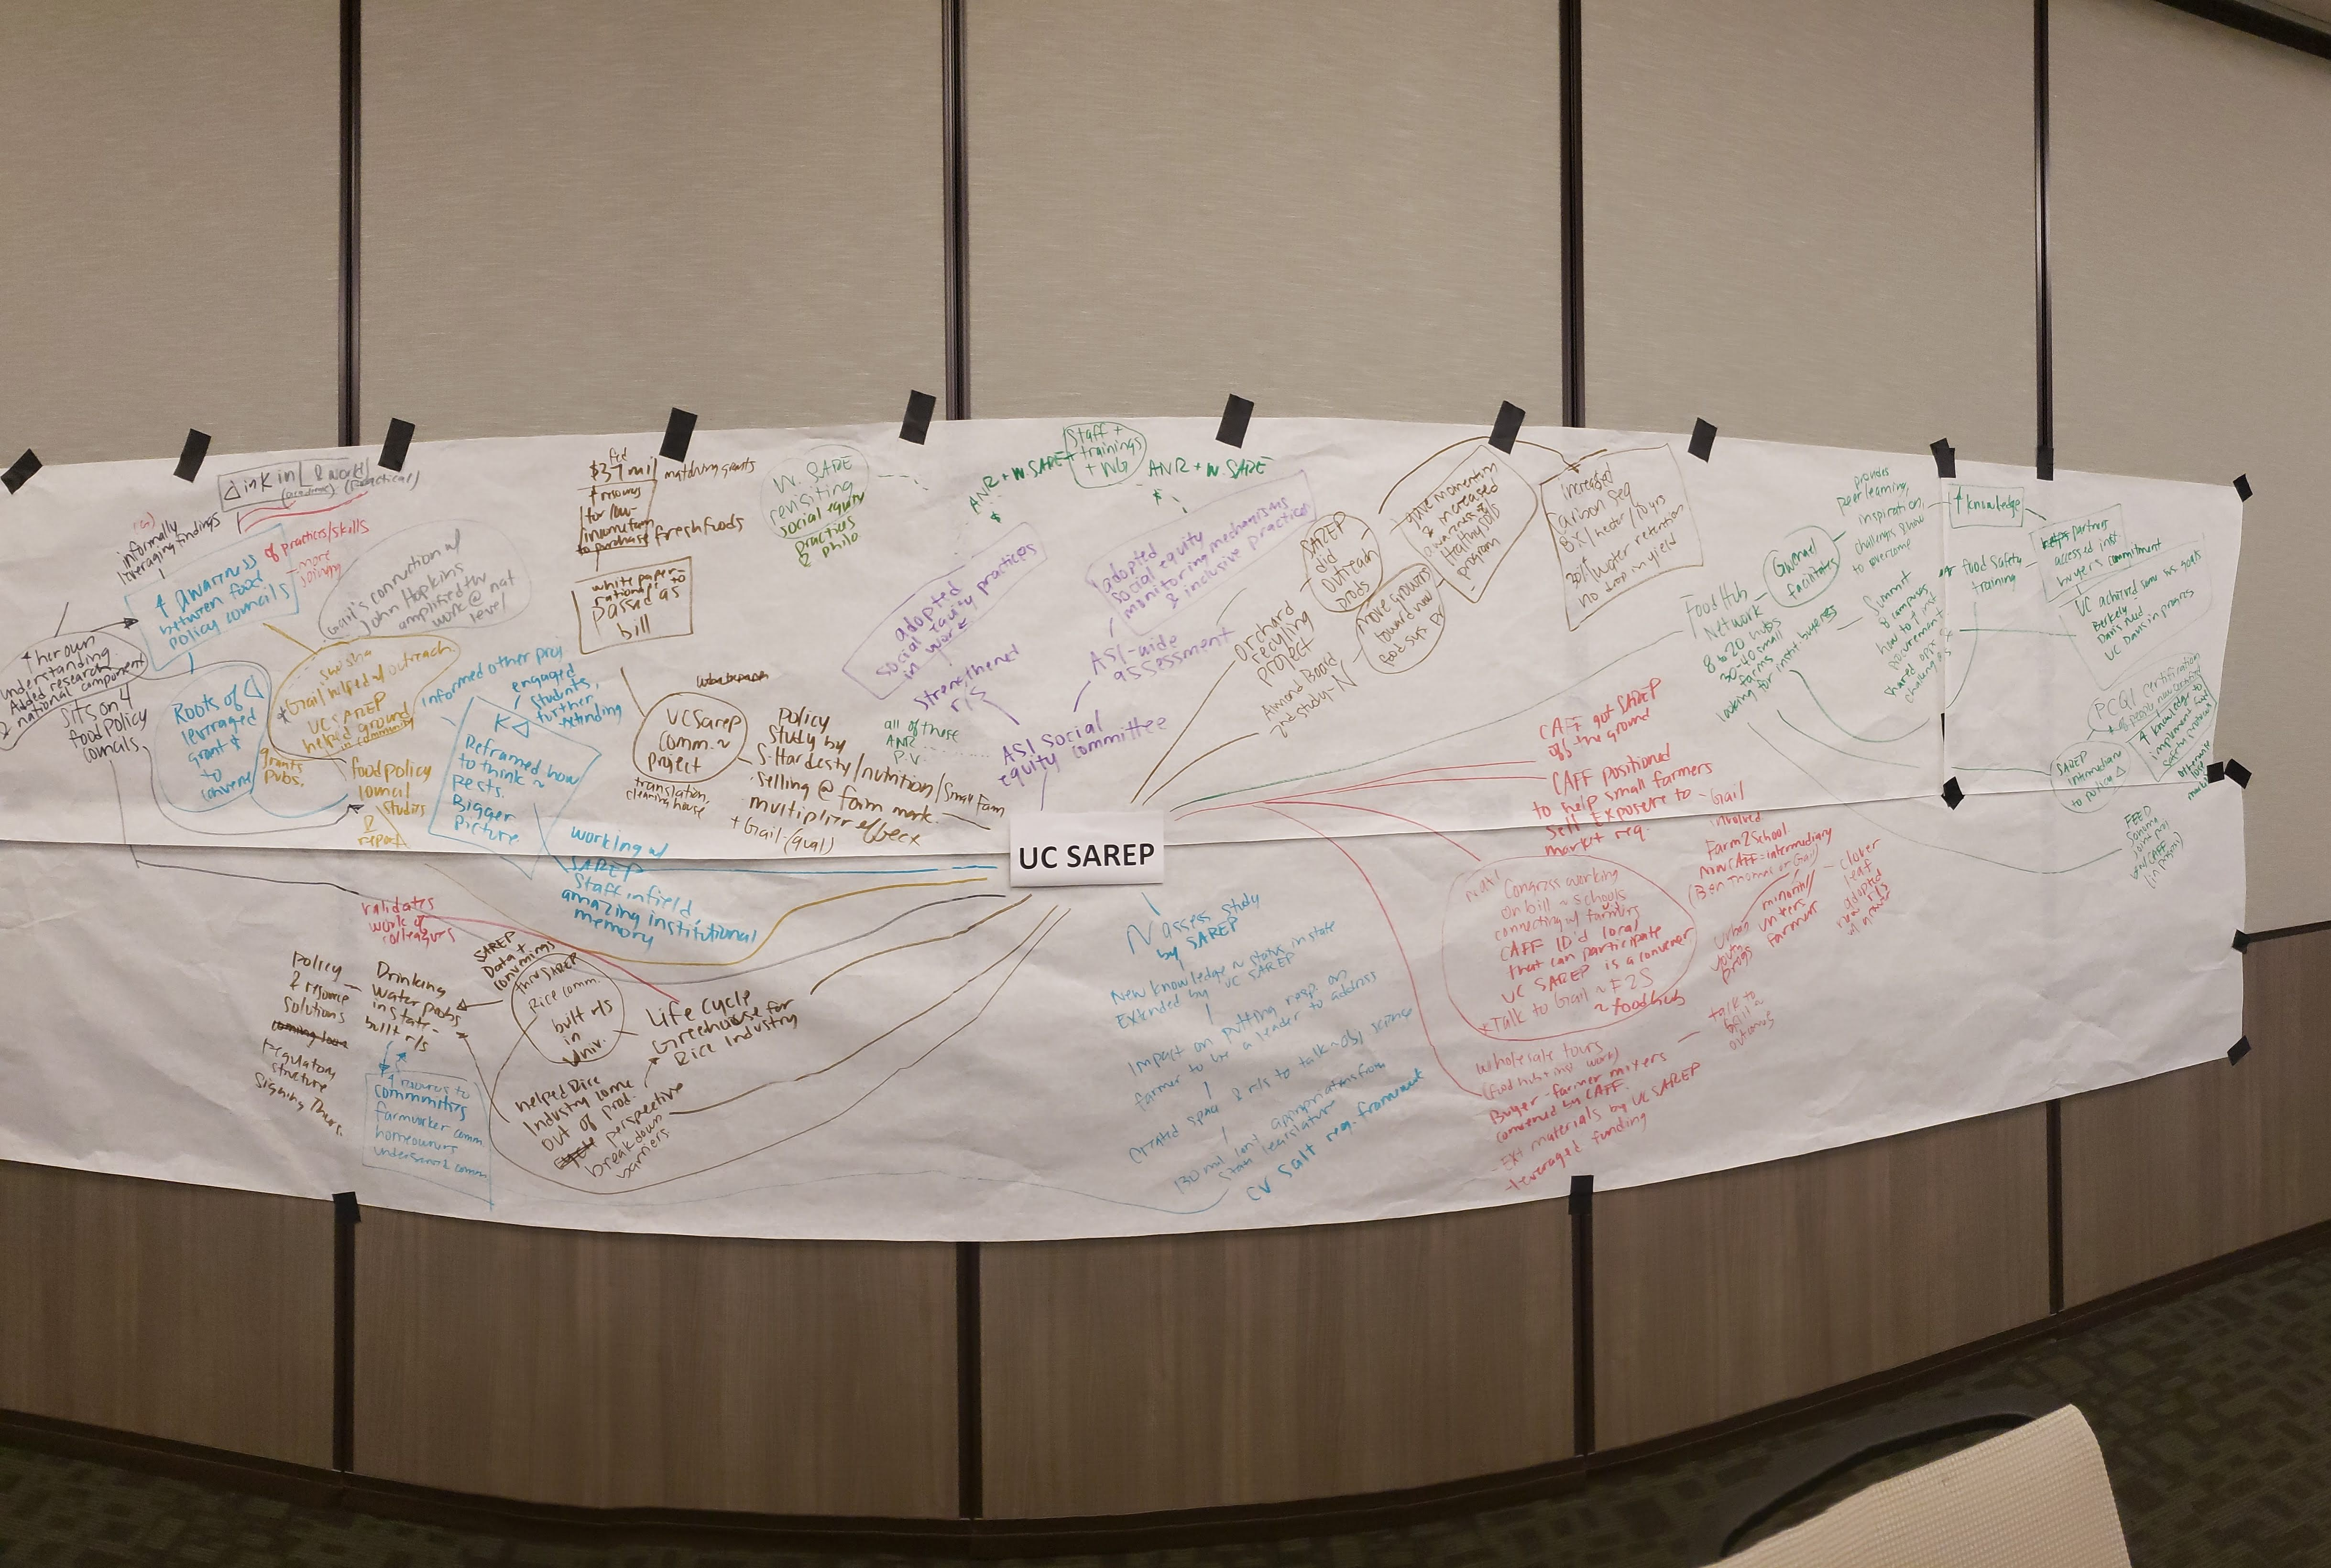

**Example: Table of Ripples by Outcome Type**

*After the Ripple Effect Mapping session, the map can be transcribed into a table for easier reading. Each participant’s response is illustrated in a row. A short description of the action or activity is provided, followed by the ripple effects organized into outcome columns: changes in learning, changes in behavior, and changes in policy. High-level themes were assigned to each row, which can be sorted for further analysis.*

| **#** | **Theme** | **Description of Action / Activity** | **Short-term Outcomes: Changes in Learning, Attitude, and Skills** | **Mid-Term Outcomes: Changes in Behavior** | **Further Behavior Change Ripples** | **Mid:Term Outcomes: Changes in Policy** |
| --- | --- | --- | --- | --- | --- | --- |
| 2 | Environmental | Amelie is the PI for an ongoing project on orchard recycling funded by almond board. Sonja is a key member of the 10 person interdisciplinary team. The goal is to understand how grinding up of trees improves sustainability of orchard. SAREP catalyzed the outreach by surveying growers to identify barriers to adoption, developing a website and fact sheets. SAREP set up opportunities for presenters to present. SAREP did fact sheets, talked to members, synthesized information in non-jargon way.  The project comes from the CARB greenhouse gas fund, so the project must demonstrate that there is carbon capture. | Knowledge gained by growers, is moving them to a new system to make conditions better. | As a result of growers adopting practices: There is a measured increase of 8 tons/hectare of carbon sequestered over 10 years. There is also a 37% increase in water retention with no drop in yields, and after 10 years, yields begin to increase. | Almond Board was motivated by results of first project to invest more money for 2nd study on how to ensure there is enough Nitrogen in the soil to break everything up. | Impact on policy-makers- The CDFA Healthy Soils Program is being influenced by it, because it provides one possibility for a proven, effective methodology to improve soil health. |
| 3 | Economic | Clare was a PI for a massive study and report on Food Policy Councils. SAREP (Gail and Shosha) instrumental in grounding information so it was applicable to communities, helping identify collaborators, developing interview questions, and assisting with technical report development. They kept the project from being too theoretical and academic, and instead focused on useful questions. Gail was able to leverage connections from her food systems study in Kern county.   Effective practices for food councils were shared at different convenings | Increased awareness of Food Policy Councils for ANR and external audiences.   SAREP- able to bring it to national level as a result of Gail's connection to John's Hopkins. Helped amplify statewide work at national level.   Communicated information through Journal of Agriculture Food Systems and Community Development. Rose Hayden Smith- blogged about it, and made front page of ANR website | Regional food policy assessments are becoming annual and the 8 most powerful food councils in the state have participated. More councils are joining the network and several councils have expressed interest in having SAREP come in. | The same grant provided Roots of Change with money to help convene people. Were doing work on policy that became law. Chance for different counsels to coalesce learning. |  |
| 4 | Social | Julia is an advisor in 4 counties and sits on 4 food policy councils. Connections with SAREP, helped her work on 4 councils to connect with statewide research project that connected to national research project, broadening the reach of the research. | SAREP helps county based farm advisors make statewide and national connections that might not otherwise happen for a county based person. | 4 food policy councils are informally leveraging findings. |  | Formally- working on change in knowledge and awareness of statewide food policy councils. |
| 5 | Environmental/Social | Gail and Shosha worked on food system assessments for Kern Food Policy Council. Unsure how to extend preliminary data related to agricultural chemicals, so met with CE colleagues. | CE and SAREP colleagues gained understanding of each other’s perspectives, and came to agreement on how to frame report. | CE academics shared commodity contacts who had sustainability plans.  Assessment plan has been posted on website, and used by others who saw it posted. | Created a bridge between the food policy council and people working agriculture |  |
| 6 | Economic | CAFF helped get SAREP off the ground and funded. SAREP help and assistance to position CAFF to assist farmers to meet needs in local markets and how to sell to whole sale food market. Help farmers get exposure to what their markets would be. Now act as intermediaries between farmers and schools like Ben Thomas' programs.  SAREP helped create network and type of activity, so can provide examples to reps (proof of concept of what can be done). SAREP role- using research knowledge and implanting it in new and emerging model of food hubs. Research would be baseline and progress.   SAREP- were able to provide more materials that were research based. | Run program that keeps expanding, due to collaboration with SAREP and Gail's program.   SAREP's role led to information gained that might not have otherwise happened. | Buyers that were visited started buying Cook Co., Clover Leaf Farm sold to Cook. There are other examples. |  | Trying to introduce bill in congress to allow more geographic preference. Co-sponsored by Josh Harder from Turloc. Agreed to support bill. There are a dozen school districts in his district part of network that do this, and identified a half dozen farms in district selling to local schools. |
| 7 | Social | Joanna co-founded a social equity committee within ASI. Sonja contributed by developing a checklist that takes into account equalizing partners. | As a result, there was an ASI- wide social equity assessment.   Working relationships strengthened.   Sonja and Gail thought about ways to incorporate social equity into their work. | Sonja and Gail adopted ways to incorporate social equity into their work. They adopted social equity monitoring mechanisms and inclusive practices.   UC ANR gave temporary funding to SAREP support staff to focus on social equity internally.  The Collaborative Tools work group around diversity equity and inclusion has been revived as a result of workshop, so people can continue to communicate about practices | Sonja sparked internal discussion within western SARE which are ongoing. From infast ?, ASI to SAREP. Sonja having voice with western SARE. Bringing forth social inequality.   Western SARE providing funding for an upcoming training for ANR. |  |
| 8 | Economic | Study done by nutrition team and Shermaine Hardesty- small farm on local products sold at farmers market. Roots of Change asked SAREP to educate farmers- value of local vs. imported products. Shermaine PI (Gail co-pi doing qualitative interviews with farmers) | SAREP communicated to Food policy council |  | Led to a grant program that gave low income households coupons to use at farmers markets to double their purchasing power. | Data used in white paper and testimony presented by Gail became rationale for bill that passed in California. Up to $37 million in matching grants (so far $15 million matched) to provide to low income households coupons to buy food at farmers markets. |
| 9 | Environmental/ Social | Working with SAREP staff, going out in the field. Staff were experienced and had institutional knowledge and memory that they shared. Incredible knowledge with SAREP and connected to ASI.SAREP had the ability to create a bigger picture point of view. | Reframing about how she thought about pest management. Instead of microlevel, but thinking about entire landscape influence on beneficial and pest insects. | Research now takes that approach. Beyond that- networking, engaging students to engage in projects. Have worked with a number of students have mentored them and they have done internships. Have further extended information from SAREP. |  |  |
| 10 | Environmental | Led California N assessment project. Review of field, and new knowledge. Shared findings. Held Workshop in central valley to share results. Presentations from farm advisors, panel discussions. | Contentious issue. Farmer/Board member: "We can fix this problem". Science had direct impact on farmer being willing to take responsibility.   Led to relationship building. Issue wasn't that science was ground breaking issue. Convening of relationships a place to talk about neutral science and discussions that resulted in actual solutions being applied. | Can draw a straight line from N study early meetings to a regulatory framework: Central Valley SALTS (Salinity Alternatives for Long-Term Sustainability) - umbrella organization- basin plan amendments prescribe what people can do if impacting groundwater and practices to impact less over time. |  | Thursday Budget will be signed by Governor, including $130 million per year to help solve drinking water problem in state. Driven around relationship that convened Ag and env communities building relationships, understanding issues. Help farmers comply. On complex issues multiple institutions, but SAREP's work has been part of the mix. |
| 11 | Economic/ Environmental/ Social | SAREP project Gwenael mentioned about Food hub network. She facilitated it the last 4 years. Started with 8, now over 20. Food hubs source from about 30-40 small farms. Effectively trying to find markets for smaller farms who might struggle to access markets on their own. | Convenings enable information sharing, inspiration to learn from others, share out challenges and strategies to overcome challenges. | Convening might not seem like a direct impact, but a lot going on in terms of ideas to put into practice.  Recent food hub network summit, brought dining services from 8 campuses, and Cal State campuses and UCOP. All working on securing procurement of locally grown food from food hubs | Hubs are enabling farmers to access large buyers like UC dining. Interest from campuses to purchase from food hubs. Consistent with UC's food and society work. Helps UCOP achieve their sustainability goals. UCB, UC Davis Med Center, UCD working on it. |  |
| 12 | Economic | Did a survey of food service directors and whether or not they knew about food hubs. As part of a grant, set up farm to school community extension hubs. |  | K-12 schools in 3 school districts (Oakland, Winters, Redding) increased their local food procurement as a result. |  |  |
| 13 | Social | One challenge over the years- food safety- SAREP secured grant to do food safety training for farmers and food hubs and institutional knowledge from specialist Erin Dicaprio. | Definitely an increase in knowledge of managers to increase practice of protocols. SAREP key intermediary for food hubs to be aware of food policies- and help get them to tools and resources they need to be in compliance with regulations. | Direct impact PCQI certification. A number of food hub managers are now certified. | Led to joint project CAFF has with Sonoma county FEED Sonoma- food hub to help people get certified and feed people locally. In progress. |  |
| 14 | Environmental | Through existing connections between Rice Commodity Board, ASI and ANR Rice Advisor, SAREP approached the Rice Board requesting to do a life cycle study of green house gases. | SAREP's collaboration and study broadened the Rice Commodity Board's perspective beyond production ag. Normally just worked with rice advisor on agronomy, but was approached by SAREP to do study. Ag and env groups tend to have antagonistic relationship. helped convene and bring people together. Helped solve problems that were un-overcome-able.   Life cycle assessment of rice- validates work of other CE scientists- can show where key impact is coming from and helps prioritize work of ANR colleagues. | . |  |  |
| 15 | Environmental/ Social | Worked with ASI/SAREP, specifically Tom and Sonja, on various life cycle assessment projects such as conducting research, developing a webpage that ASI/SAREP, presenting talk at a nutrition conference, and publishing research findings. |  | Collaborating with Sonja created connections that never happened before. Companies have reached out to her and asked her to do research for them.   Almond industry has used research findings in their advertisements.  Bioenergy industry contacts her about innovating around the use of byproducts like almond hulls. | There is definitely policy relevance. Growers care because It is a way to reduce their costs. Government and agencies care because they see the climate change mitigation. |  |
| 16 | Social | Work Directly with SAREP academics through Advisory Board | Used information learned through interactions with UC SAREP when presenting at National Urban Extension Conference in Seattle | SAREP builds connections with people who are then able to advocate for urban agriculture |  |  |
| 17 | Social | Through the Social Justice Learning Institute, working on urban agriculture and food production with young people. Applied for grant jointly with ASI which led to food system tours by youth. |  | Students who participated were able to demonstrate leadership with a host of stakeholders centered in LA as well as people interested food systems work. | Tours brought in new partners, and deepened relationships |  |
| 18 | Social | Part of the ASI advisory board. Connected an intern that had worked with Intertribal Agricultural Council before as an intern to an internship with SAREP. |  | This led to a new research opportunity and stipend for the youth. The internship will start in July, but the intent is that SAREP will benefit by the intern’s work in doing research on key points of consideration that can be included in extension materials. | This experience has shown that SAREP has the ability to take in new idea and turn them into opportunities, which include research opportunities for youth in underserved communities and extension opportunities that include tribal communities input and cultural context. |  |
| 19 | Environmental | Utilized SAREP’s cover crop database to develop an organic nitrogen budget and extension materials. | Delivered the information through workshops to over 250 people and through one-one-one technical assistance to about 30 people. | 5-10 people that received the information have informally talked to Margaret and mentioned that they changed the way they think about nitrogen and have changed their nitrogen budget. These outcomes lead to helping farmers with complying with new California nitrogen regulations, reducing input costs for organic farmers, and lastly, better projections of available Nitrogen that will be become available. Aligns with PVS about environment the most. |  |  |
| 20 | Environmental | SAREP’s work in organic agriculture and healthy soils |  | SAREP broke the ice and got people interested in organic agriculture and healthy soils programs | Led to organizations like CDFA and DPR providing funding for projects for healthy soils, improved groundwater quality, and |  |
| 21 | Economic/ Environmental | As an organic farmer, I collaborate with UC SAREP to help UC SAREP gain insight and information on grower techniques and being less chemical driven. UC SAREP’s sustainable ag outreach usually just confirms what I already know, but It is important to get the information out to other farmers about farm impact on the environment. | UC SAREP is one of many resources I use to get specific information to inform my systems approach to sustainable farming. I might get information on cover crops, soil types, irrigation systems. It is hard to say specifically what I got from UC SAREP; It is kind of a blur when there is so much going on my farm. | I developed a pretty good system so the common issues that farmers who dabble in organic farming experience are practically nonexistent on my farm. I enjoy it and getting unbelievable results from an organic system that is working. Not going broke on it. | If your system is better than the year before, then you’re having positive effect in the environment. It is important since soil’s a natural resource |  |