|  |
| --- |
| **UC Cooperative Extension Central Sierra** |
| *Serving El Dorado, Amador, Calaveras and Tuolumne counties* |
| Contact: Susie Kocher, 1061 3rd Street  South Lake Tahoe, CA 96150 (530) 542-2571 [sdkocher@ucanr.edu](mailto:sdkocher@ucanr.edu)  [http://cecentralsierra.ucanr.edu/Forestry/](http://cecentralsierra.ucanr.edu/Forestry/%20) |

**Press Release – for immediate release**

**New El Dorado / Amador Prescribed Burn Association conducts first private landowner burns**

**Placerville, CA, July 12th, 2022:**

***The new El Dorado / Amador Prescribed Burn association, formed in August 2021, has conducted several burns with private landowners and received funding for a part time coordinator.***

A new group of local residents dedicated to helping private landowners conduct prescribed burns on their own properties has formed in El Dorado and Amador Counties. The group was convened by Susie Kocher, Forestry Advisor for the University of California Cooperative Extension in the central Sierra Nevada. *“Prescribed Burn Associations or PBAs are groups of landowners helping each other to both learn how to use prescribed fire to manage their properties and to help each other carry it out. They have been common in other states in the Midwest and Southeast United States but are relatively new to California*,” said Kocher. The first PBA was formed in Humboldt County and now there are at least 20 in various stages of development throughout the state.

***New El Dorado / Amador PBA holds first burns***

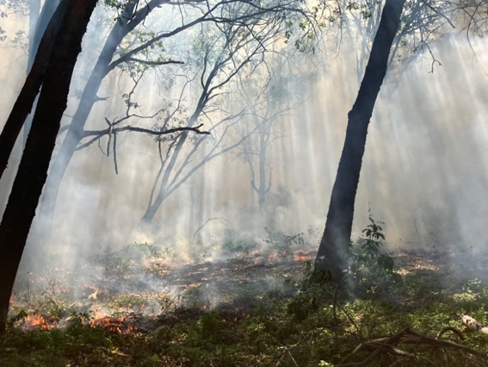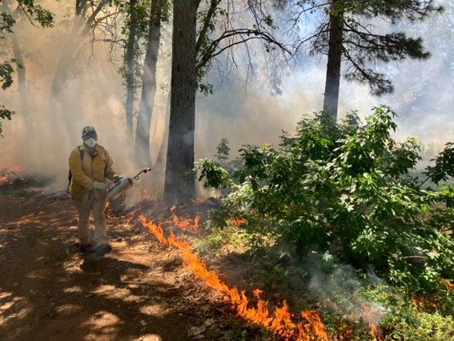To date, the local group has held workshops on prescribed burn use, planning, and integration with targeted grazing for fuels reduction. The group held their first broadcast burn on May 15th, 2022 at LBS Ranch in Placerville. Due to rain in April, the group was able to take advantage of the tail end of the spring burning window. The event served as an educational opportunity for members to get more live fire experience and discuss the planning and implementation process.

*Photos from spring 2022 prescribed burn. Left: After igniting low-intensity strip along control line, volunteer walks adjacent to small flame lengths monitoring fire behavior. Right: Smoke lingers amongst oaks and conifers while pockets of fuel continue to smolder after ignitions.*

Those who attended were landowners, volunteer fire department members, foresters, and community members with varying degrees of experience. Together they reduced fuels and resprouting shrubs by burning an acre of forested land that had previously been thinned and masticated. Fire behavior and effects occurred as planned, with low flame lengths and good consumption of live and dead vegetation.

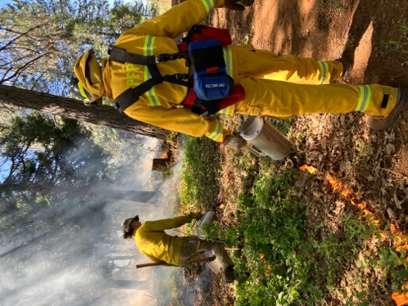

***Funding received for part time coordinator***

In April, the University of California Cooperative Extension was awarded funding through a Regional Forest and Fire Capacity subaward from the Watershed Research and Training Center, by a grant awarded by the California Department of Conservation to hire a part-time PBA coordinator. A total of nine PBAs across the state received subawards to fund leadership, peer mentorship, and training and travel. The El Dorado / Amador PBA was awarded funding for a half time coordinator for the next two years. The new coordinator, Kestrel Grevatt, is based at UC Berkeley’s Blodgett Forest Research Station and will be splitting her time between the PBA and her role as Intern Forester at Blodgett. She has a background in fire suppression, prescribed burning, and implementing and overseeing fuels reduction work.

*Above: Newly appointed coordinator Kestrel leads volunteer from local fire department during ignitions on spring prescribed burn. Below: Low fire intensity with smoldering in larger material met desired burn effects.*

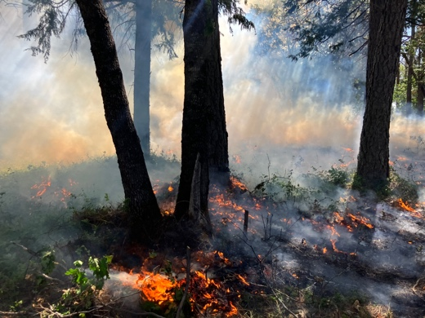

Looking forward, the group is planning a burn plan writing workshop for August. This workshop will be intended to help landowners understand the prescribed fire planning process, necessary burn plan components and help them walk away at the end of the day with a drafted burn plan. Attendees will have the opportunity to download and create maps, plan burn units, discuss permits needed and smoke considerations, and write a weather/fuels prescription, all with guidance from PBA leaders and agency representatives. Through the fall and winter, the group’s priorities will be to implement burns and make local and regional training opportunities available to members.

*“The overall goal of the group is to give community members the support to safely and effectively put good fire on the ground. By starting small, with a few acres at a time, members can learn how to use this tool and develop comfort with fire as a process. Over time, with many landowners’ involvement, we can continue to increase the pace and scale of prescribed fire,”* said Grevatt.

For more information, please contact Kestrel Grevatt [kestrelgrevatt@berkeley.edu](mailto:kestrelgrevatt@berkeley.edu).

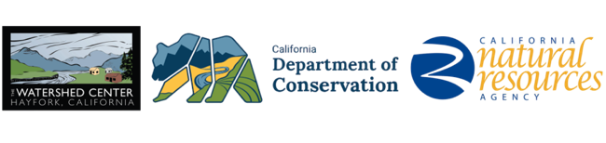

*The work upon which this publication is based was funded in whole or in part through a Regional Forest and Fire Capacity subaward from the Watershed Research and Training Center, by a grant awarded by the California Department of Conservation. The El Dorado / Amador PBA is also supported by UC ANR.*