**UC CalFresh Monthly Time Reporting and Mileage Procedures**

**Reporting Hours Worked and Claiming Mileage:**

The work week is Sunday – Saturday, work hours are 40 hours per week, M-F 7-5, with some evenings and weekends. Flexing your work time when you are required to work weekends or additional hours during the week is a priority, as compensatory time (CTO) is only given in rare instances and with prior approval since we are grant funded. CTO must be approved prior to accrual.

***University of California – Policy PPSM-30*** [***http://policy.ucop.edu/doc/4010400/PPSM-30***](http://policy.ucop.edu/doc/4010400/PPSM-30)

***C. Hours of Work; 2. Non-Exempt Employees; D. Travel Time.***

* *Assigned travel during an employee's normal working hours, including travel on his/her scheduled days off, is counted as time worked. Travel time between home and the work place is not time worked.*
* *Time spent by an employee traveling from work site to work site during the workday counts as time worked.*
* *For travel that does not keep an employee away from home overnight, travel time to the first destination and from the final destination, except for the time the employee normally would spend traveling to and from the work place, counts as time worked.*
* *Travel that keeps an employee away from home overnight is counted as time worked when it occurs during an employee’s normal working hours, including on his/her scheduled days off.*

**Example 1—Weekday travel, within normal working hours:** It is a Wednesday and a member of the UC CalFresh staff is responsible for delivering direct nutrition education at a Jobs site location.

**MILEAGE:** This staff member will travel from the office to the site, recording mileage from the office to the site.

**HOURS:** Hours worked will be reported as the time this staff member left the UCCE office to travel to the site.

Note: If the class ends by 5pm, and the staff person travels directly home from the location that is not paid time. Mileage in excess of the distance from the office to home location can be claimed.

**Example 2—Weekday travel, from home to site:** It is a Thursday and a member of the UC CalFresh staff is responsible for delivering direct nutrition education at an Elementary site location all day. This staff member will travel directly to the site from home as it is an 8am event and close to their home.

**MILEAGE:**

* This staff member will travel directly to the site from home as the distance is approximate to the normal commute to their home, thus no mileage would be reported to this site as it is considered normal work commute.
* Only mileage in excess of the typical mileage they accrue from their home to the UCCE office should be claimed.

**HOURS:** hours worked will be reported as the time this staff member arrived at the school site.

Note: If the class ends by 5pm, and the staff person travels directly home from the location that is not paid time. Mileage in excess of the distance for the regular commute location can be claimed.

**Example 3—Weekday travel, work day ending after normal working hours:** It is a Tuesday and a member of the UC CalFresh staff is responsible for recruiting an Elementary site location for adult direct delivery, then traveling to another site for a family centered activity (evening event), not returning to the office.

**MILEAGE:**

* This staff member will begin travel from the office to the site, recording that mileage.
* When they continue on to a secondary site, the mileage between sites will be recorded as well.
* Since the event ended after normal working hours, any mileage greater than the distance of the normal commute from work to home can be recorded.

**HOURS:**

* Time from the UC office to the first site can be counted.
* The event was a work day that exceeded the normal working hours, travel from jobsite to home is not counted as overtime or time worked, if it is within the normal commute time from work to home.
* Travel time in excess of normal commute time will be counted as hours worked.

**Example 4—Weekend Travel, outside normal working hours:** It is a Saturday and a member of the UC CalFresh staff is responsible for attending a family centered event at school partner’s location.

**MILEAGE:**

This staff member will count mileage to and from their home to the site.

**HOURS:**

This staff member will travel directly to the site from their home, thus they will be on paid time during their travel to and from the site. This is the case because it is on a weekend outside of normal working time.

**Claiming Mileage:**

1. Maintain written monthly mileage log when traveling.
2. At the end of the month type your UC CalFresh mileage log, run and attach calculator tape confirming total mileage, and turn it in to your direct supervisor for approval and processing.
3. Your direct supervisor will compare the timesheet with approved calendars for accuracy. Once approved they will be turned into the Fiscal Manager.
4. The Fiscal Manager will compare typed mileage log with timesheets for additional accuracy. Fiscal Manager will provide final approval and process.
5. Overnight travel will be submitted to Fiscal Manager.

**Making Corrections**

1. All paperwork is auditable.
2. If you make an error made a single line, note correction, and initial. (Both you and your supervisor initials).
3. Do not use white out, correction tape, or scribble out errors.

**How to Use AggieTravel @ UC Davis**

Launch your internet browser. Please note that Mozilla Firefox works best for accessing this system. Obtain your free download from ANR Communication Services web site http://anrcs.ucdavis.edu/computers/Software_--_How_and_Where_to_Get_It.htm.

Type in [http://aggietravel.ucdavis.edu](http://aggietravel.ucdavis.edu/) on the address bar.

Type in your User ID (UCD Login ID) and Password (Kerberos password) and click Login.

**Completing the User Profile**

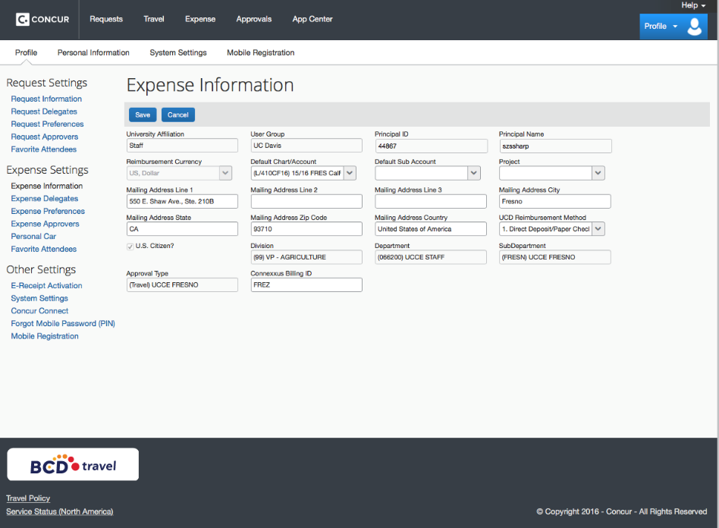

You must complete the User Profile Section (Profile button , then profile settings in the upper right corner) before you may request reimbursements.

Click on the Request Information link (left panel, first item under heading).

Confirm the employee information has been imported correctly.

The first row of cells should automatically populate with your information.

Add Default/Chart Account: Our current FY 17 account will be found by typing in L/410CF16. You may change/update accounts when you prepare your expense reimbursement if needed later.

Default sub-account and Project field are to be left blank.

Mailing Address1 field enter the office address: 550 E. Shaw Avenue, Suite 210-B.

Mailing Address2 & 3 fields are to be left blank.

Mailing Address City field enter Fresno.

Mailing Address State field enter CA.

Mailing Address Zip code field enter 93710.

Mailing Address Country field enter United States of America.

UCD Reimbursement Method drop down, select 1. Direct Deposit/Paper Check.

US Citizen checkbox should have auto-populated.

Division field should have auto-populated.

Department field should have auto-populated.

Sub Department field should have auto-populated.

Approval Type field should have auto-populated.

Connexxus Billing ID field enter: FREZ

Click save to update your profile.

Click on the Request Delegates (left panel, second item under heading).

Click on Delegates.

This page displays the employees allowed to perform work on behalf of this selected employee. Click **Add** to add a new delegate.

In the Search by employee name, email address, employee id or logon id search for the following:

Stephanie Sharp, click can prepare box, can review receipt images

Gloria Gonzalez (email is TGONZ@ucdavis.edu), click can prepare box, can review receipt images

Yolonda Murillo, click can prepare box, can review receipt images

Click Save.

Ignore the Request Preferences as these have been auto-populated (left panel, third item under heading).

Ignore the Request Approvers as these have been auto-populated (left panel, fourth item under heading).

Ignore the Favorite Attendees as these have not yet been established/identified (left panel, fifth item under heading).

Click on the Expense Information link (left panel, first item under heading). This is the same information entered under Requested Information above.

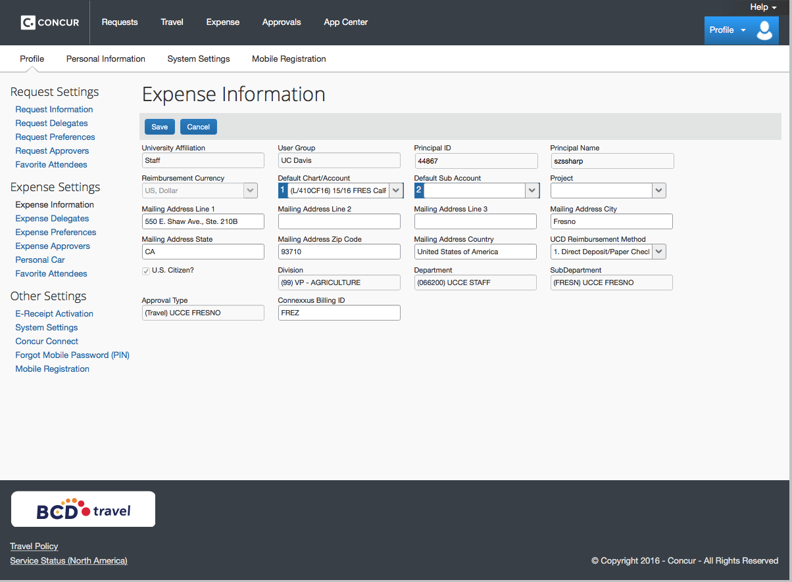

Click Save.

Click on the Expense Delegates link (left panel, second item under heading). This is the same information entered under Requested Information above.

Click Save.

Click on the Expense Preferences link (left panel, third item under heading). This information has been auto-populated and needs no updating.

Click Save.

Click on the Expense Approvers link (left panel, fourth item under heading). This information has been auto-populated and needs no updating.

Click Personal Car link (left panel, fifth item under heading).

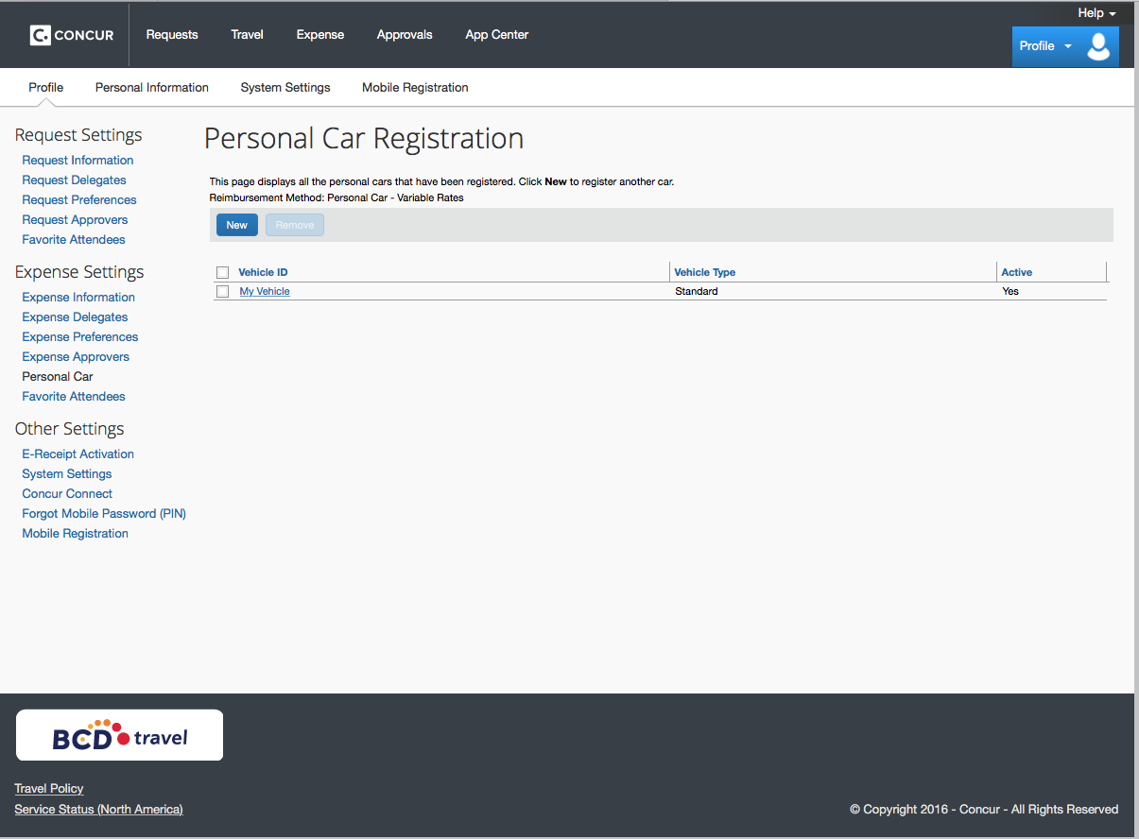

Click on New.

Vehicle ID: Enter a general descriptor.

Vehicle Type: Click the drop-down box and select Standard.

Click Save.

Ignore the Favorite Attendees as these have not yet been established/identified (left panel, sixth item under heading).

Ignore the E-Receipt link (left panel, first item under Other Settings heading). This has been automatically activated for you.

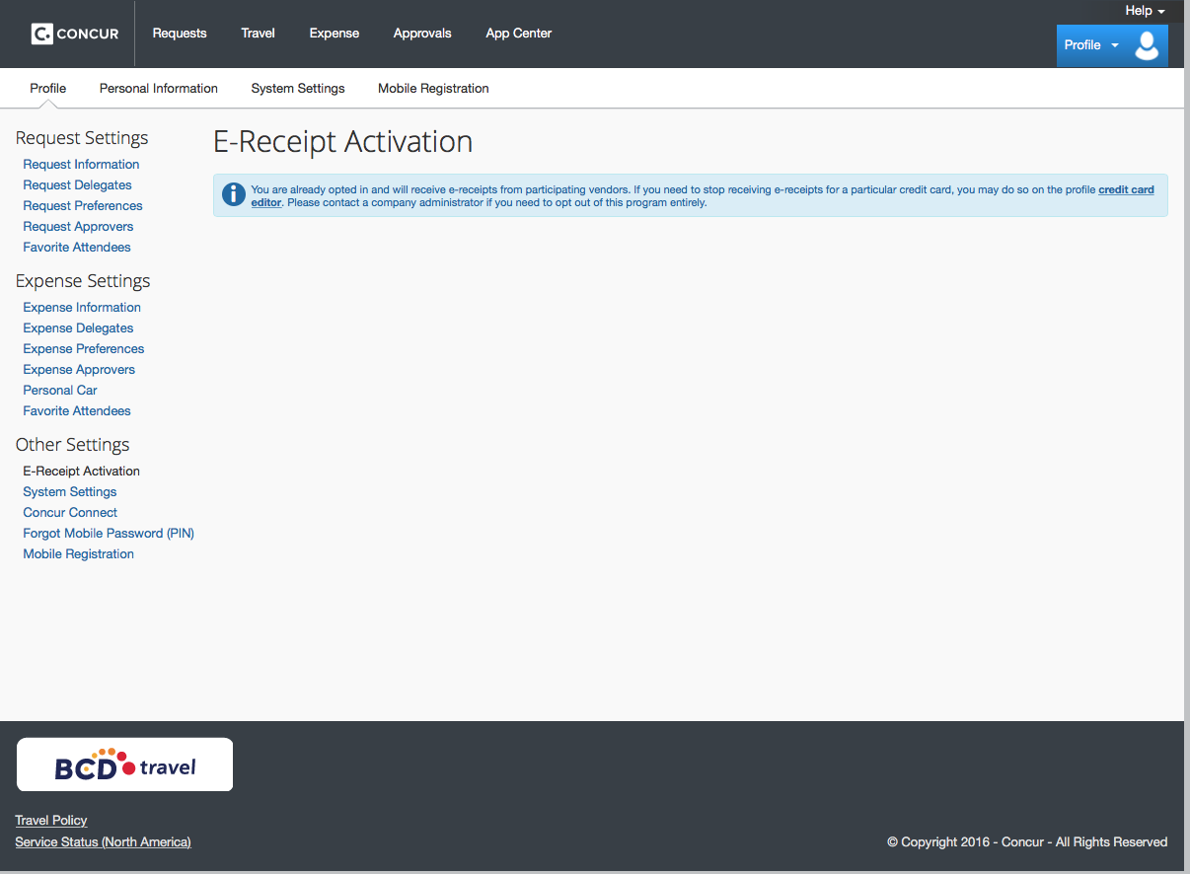

Review the System Settings link (left panel, second item under Other Settings heading). No changes are necessary as these are default settings.

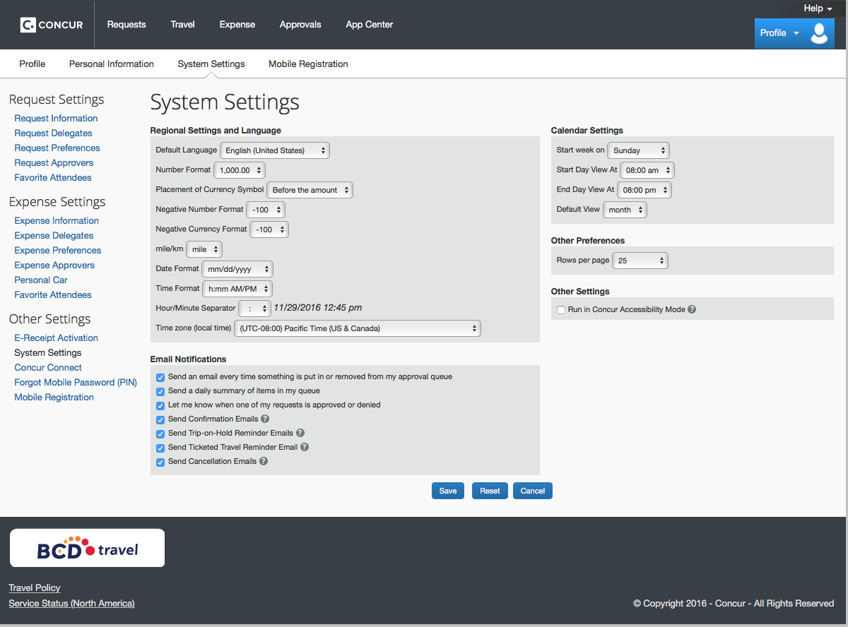

Review the Concur Connect link (left panel, third item under Other Settings heading). No changes are necessary as these are default settings. This allows capability for uploading of receipts taken with your cell phone to account for purchases made. This by no means makes any changes to the traveler having to maintain hard copy receipts for travel documentation maintained by the Fiscal Manager.

Ignore the Forgot Mobile Password (PIN) link (left panel, fourth item under Other Settings heading). We do not have a mobile only password.

Review the Mobile Registration link (left panel, fifth item under Other Settings heading). Download the app to your cell phone and you are ready to begin uploading receipts into AggieTravel.

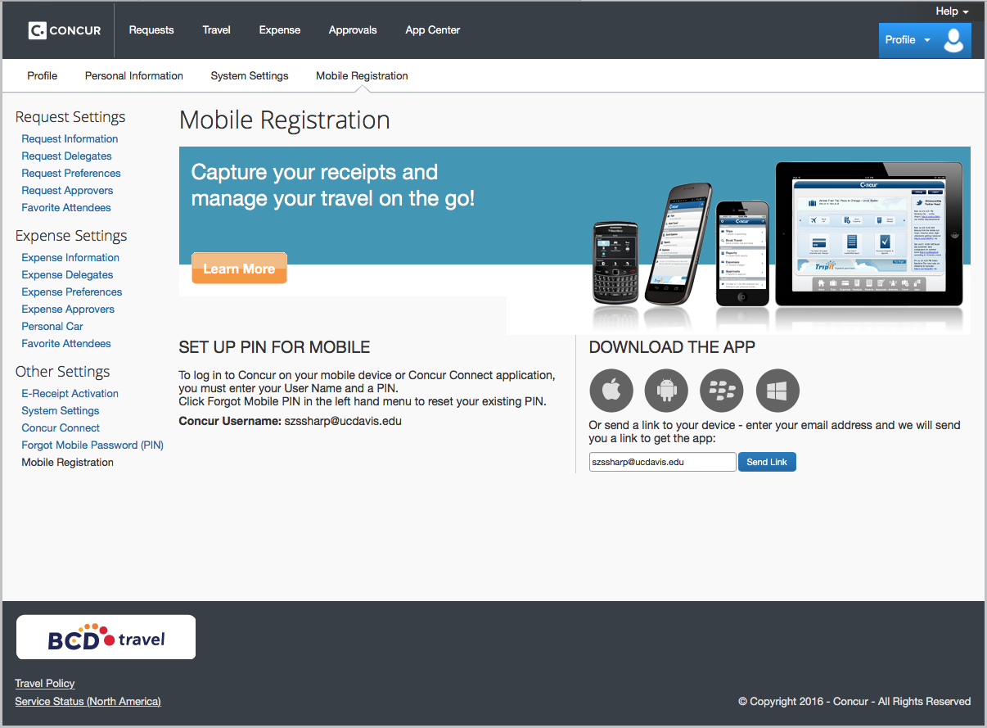

We are all done with that and can move on to processing a reimbursement! (coming soon)

**To be updated - Submitting a Reimbursement in MyTravel.ucdavis.edu**

Complete and submit a monthly mileage log to your immediate supervisor. The mileage log will be compared to staff’s timesheet and calendar for accuracy. Supervisor will sign off approval of mileage log.

The approved mileage log will then be submitted to the Fiscal Manager for processing

Once the travel has been processed, you will receive an email from the MyTravel system that says you have a travel report ready for submission.

Click the link in the email and it will take you to the login page. Enter your Login ID and Kerberos password.

The Main Travel Center page will load.

On the left-hand side of the page under MyTravel Forms and Processes, click on edit and review expense reports.

The Expense Report List page will load.

Scroll down the Active Reports to submit your report.

In the Actions Column click on Submit Report.

You are all done and can logout of MyTravel door icon upper right corner.

**Your Reimbursements can be directly deposited:** <http://afs.ucdavis.edu/our_services/travel-e-entertainment/direct-deposit-text.html>

**Advantages**

* Safe & secure method of payment
* Improves service delivery
* Funds are available upon deposit

**How to Enroll**

1. Go to [directdeposit.ucdavis.edu](http://directdeposit.ucdavis.edu/)
2. Click on the link "**Employment Reimbursement and Student Refunds Sign up to Direct Deposit HERE"**
3. Get your bank information ready. You will need:
   1. The bank number
   2. ﻿The bank routing number
   3. The bank account number
4. Click on **"Go to the Enroll/Change Info page to set up your account information"**
   1. Enter your bank information
   2. Click on the submit button
5. ﻿You will receive a confirmation email.

It takes about 2-3 weeks for your direct deposit to become effective.