
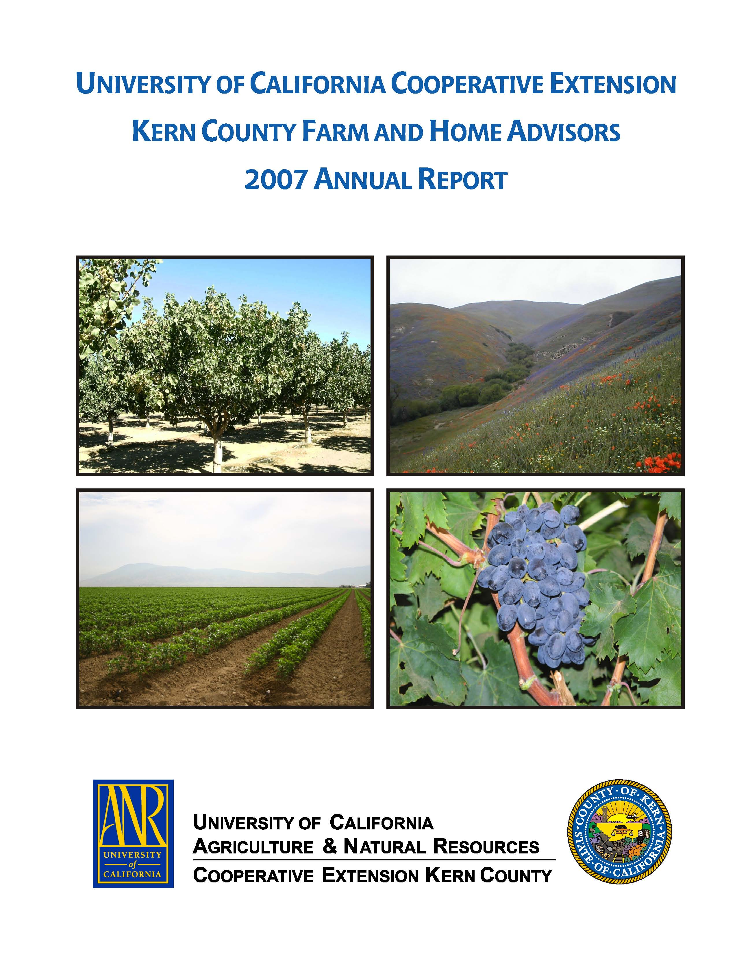
University of California Cooperative Extension – Kern County
NEWS RELEASE
1031 S. Mt. Vernon Avenue • Bakersfield, CA 93307 • 661-868-6200 • http://cekern.ucdavis.edu

June 12, 2009 Blake Sanden, Irrigation & Agronomy Farm Advisor
(661) 868-6218
Summer Irrigation Cutoff Saves Money and Will Not Harm
Alfalfa Stand in Central Valley

It’s bad. The season started with 0% allocation of water to districts receiving federal water on the Westside of the San Joaquin Valley and State Water Project users to receive 15%. Well, we finally ended up with 15% to federal districts and 40% to state water project districts, and folks felt lucky to get it. This is still just about 1 foot of water for almond, grape, pistachio and alfalfa growers that need 3 to 4.5 feet of water to make optimal yields. Growers are scrambling to make up the difference through groundwater pumping and buying water where they can find it. Groundwater pumping levels in Kern County have declined 50 to 180 feet compared to 3 years ago. The result of all this is water costs ranging from $90 to $500/ac-ft in the southern San Joaquin Valley. So what’s this got to do with the price of hay and the condition of my alfalfa stand?
Everything. Forage growers enjoyed some of the best prices ever during 2007 and 2008 – with dry cow hay going for over $200/ton. Since it takes about 5 to 6 inches of crop water use to make one ton of alfalfa you could still make money using $100/ac-ft water. Now, in 2009, milk prices have been slashed and dairy operators are struggling to stay profitable and keep their herds intact. Demand for milk cow hay is down. Dry cow hay is selling for $100/ton if you can find a buyer. From June to September the quality drops and water use peaks. The smart thing to do is fallow the field and use the precious water on other profitable crops, but you’re concerned you’ll hurt the stand.
Field trials show fallowing does not hurt stand. This is one small bit of good news in the face of all the other problems. A 4 year study by UC Cooperative Extension (2005-2008) looked at summer irrigation cutoff in alfalfa fields from Imperial Valley to Tule Lake to determine the amount of real water savings, yield loss and the viability of the stand over 3 years. Since vegetative forage production is a straightline relationship between crop water use (evapotranspiration, ET) and yield we initially figured that if we cutoff water mid to late summer for 45 to 60 days we would lose a couple ton/ac of hay and have a real savings of 10 to 12 inches of water to use on other fields or sell to the “water market”. Depending on location, the actual cutoff times ranged from 36 to 118 days with yield losses running from 0.85 to 3.15 ton/ac. On most fields there was very little regrowth, as expected, during the cutoff period, but the stressed hay continued to slowly extract water out of the rootzone so that the actual water “savings” was only 30 to 45% of what we would have predicted from the yield loss. So as a means to truly reduce water use over California’s 1,000,000 acres of alfalfa, summer fallowing does not deliver as much as we thought it would.
The good news is that you can walk away from the field in July, if you’re not making money due to poor price and expensive water, and water it back the end of September for an October cutting and not lose stand integrity or yield for the following year. For low elevation, non-dormant alfalfa we do recommend that you water the field going into the fall so the plant has enough carbohydrates and cover to hold back winter weeds and start regrowth in the spring. In the Imperial Valley it is essential to have some growth shading the soil before hard stress sets in. If the field is cut, and no regrowth occurs, the extreme heat and direct sunlight on unshaded soil in the southern desert will create soil temperatures that can literally cook the crowns.
So if you are going in the red on your summer alfalfa cuttings we can say that fallowing, followed by at least one watering in the fall, will be a safe strategy to cut costs and save your stand for next year.
♦ ♦ ♦

