
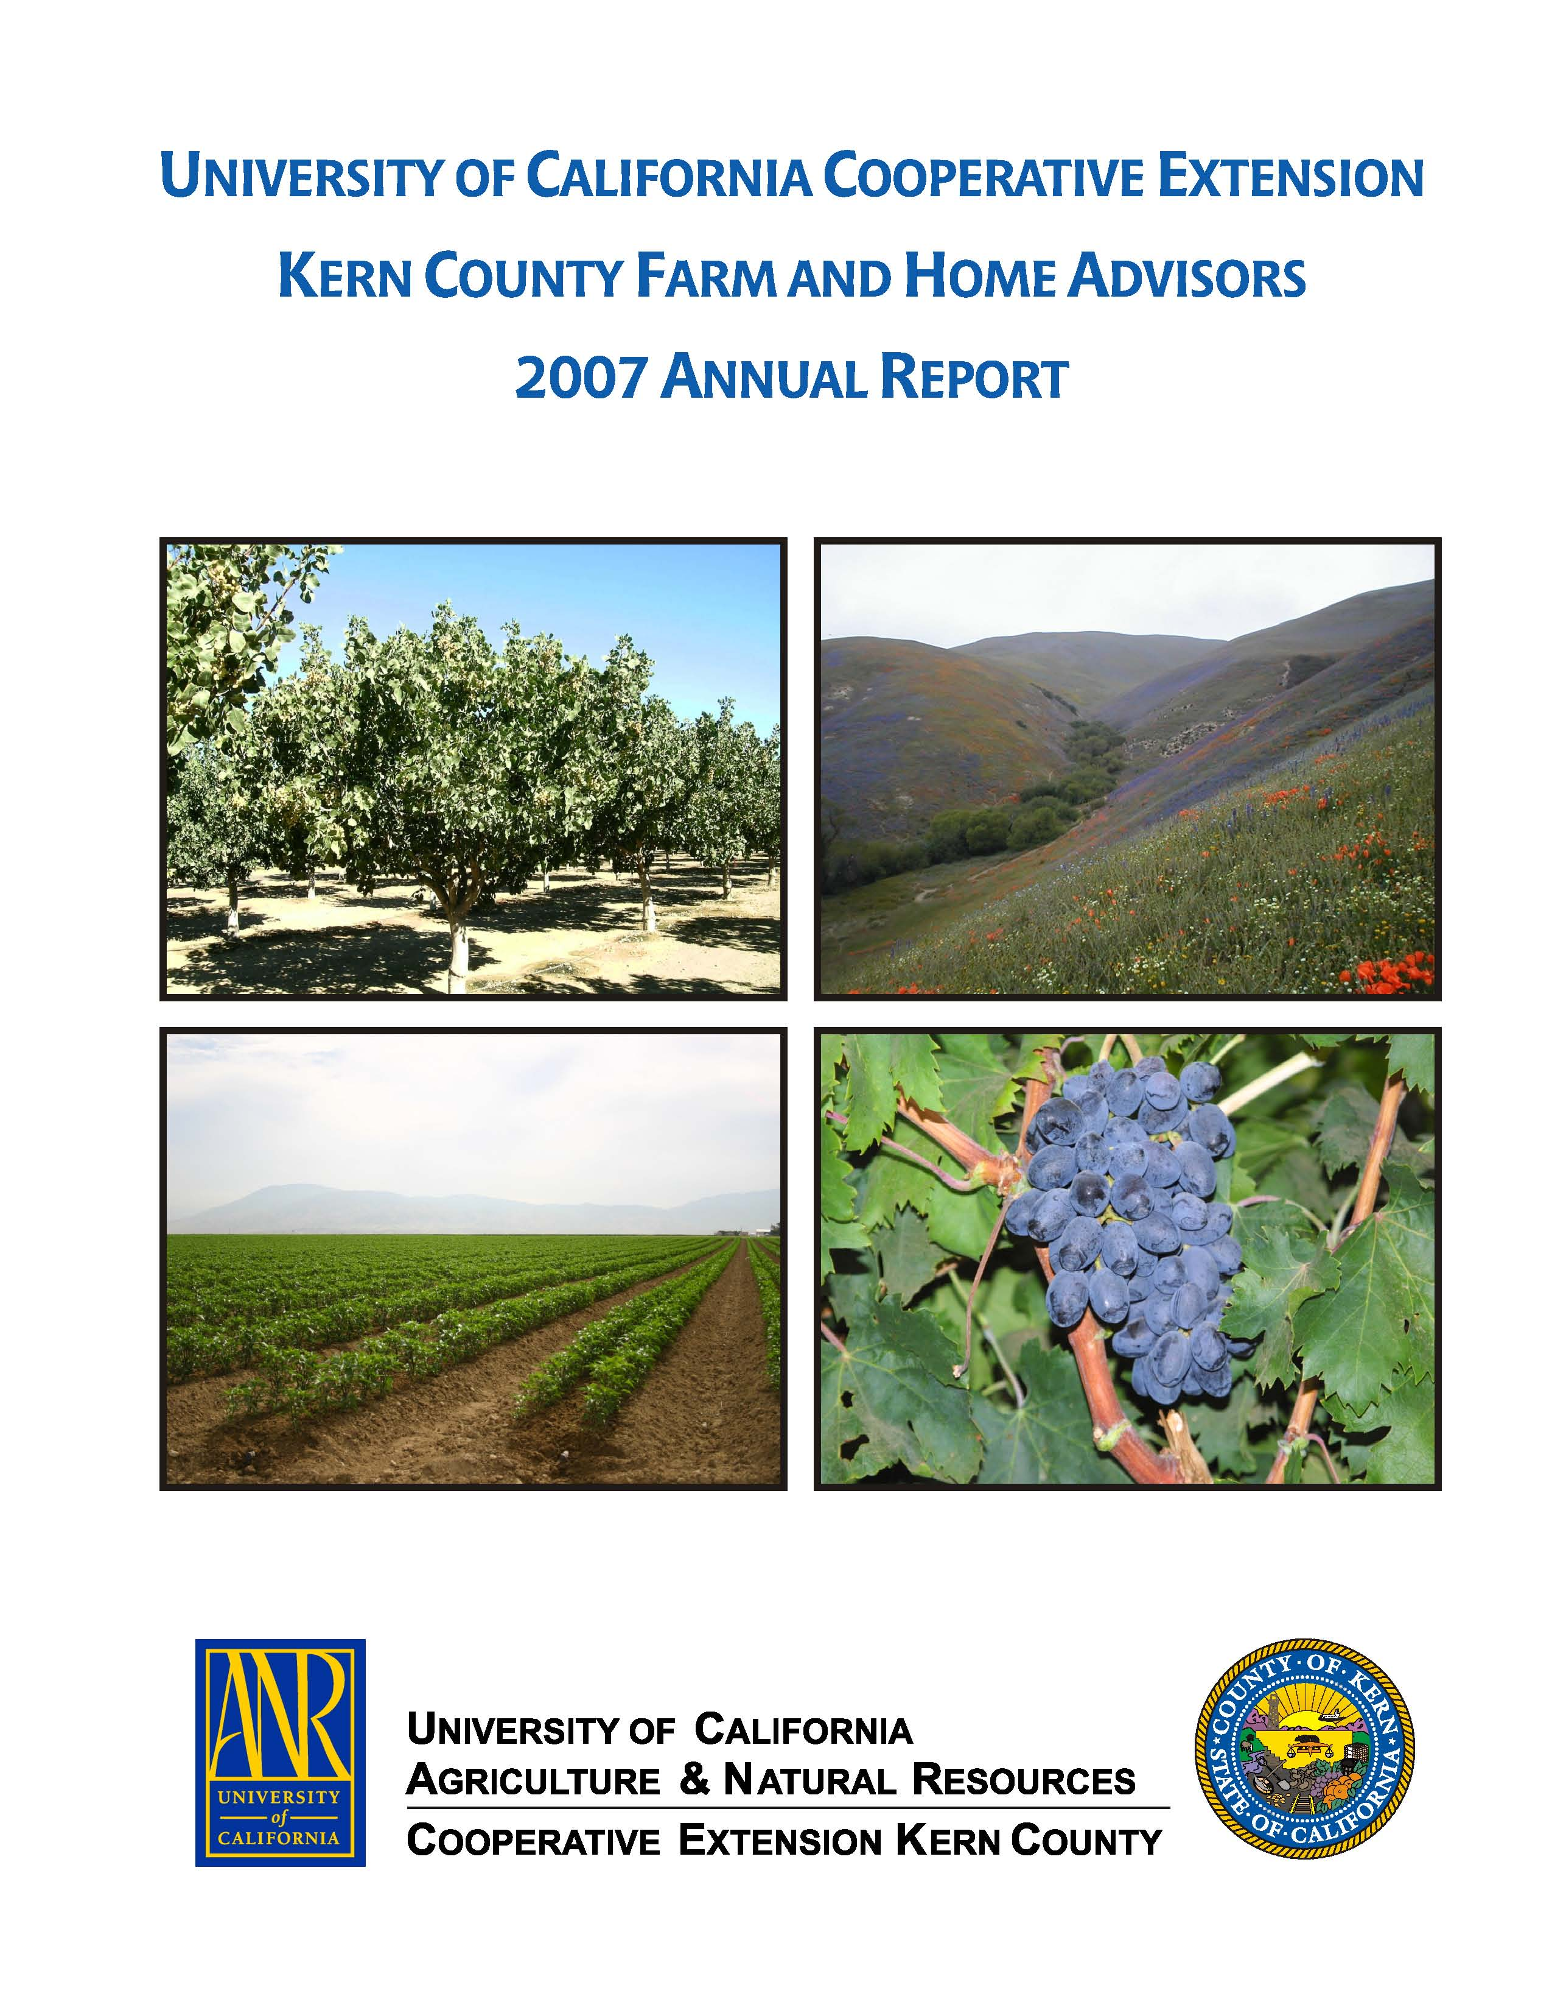
University of California Cooperative Extension – Kern County
NEWS RELEASE
1031 S. Mt. Vernon Avenue • Bakersfield, CA 93307 • 661-868-6200 • http://cekern.ucdavis.edu

July 12, 2010 Craig Kallsen, Farm Advisor

Citrus, Subtropical Horticulture, Pistachios
(661) 868-6221
August Important for Successful Pistachio Harvest

The fruit of the pistachio tree, what we normally call the nut, is composed of a hull (made up of the epicarp and mesocarp of the fruit), a shell (botanically called the endocarp) and a kernel (also called the embryo). The hull is removed shortly after harvest at the huller and most pistachios are sold as a split shell nut containing an edible kernel or nutmeat. Pistachio growers are paid for nuts based on weight and the only way a California pistachio grower gets paid for the weight of the shell is if that shell is split and encloses an edible nutmeat. The shell averages about 45% of the combined weight of the shell and nutmeat, and so non-split nuts that require mechanical processing to release the nutmeat, and shells that fall apart prematurely during processing represent a substantial financial loss to the grower. Forty-five percent of the potential paycheck for a nut disappears with each loose nutmeat or with each non-split shell. Typically, when blank nuts are included in the calculation, Kerman, by far the most commonly planted pistachio variety, will produce about 70% edible split nuts most years.
Although the harvest typically begins in early September, the relative success of that harvest depends on botanically important events occurring from mid-June through early July. The shell of pistachio nuts tends to get ahead of what is happening in the kernel. The shell and its protective hull grow first. Cut a pistachio nut open in early-June and what will be seen is a green hull stuck tightly to an empty shell. A white structure will be visible within the shell but almost nothing of what will become the kernel is visible to the unaided eye. At this time, the shell will cut easily and can actually be flattened with the pressure of thumb and forefinger. Beginning in mid June, two things happen to most of the nuts on the tree. The kernel within begins to grow and the shell begins to harden. In June the tree is still adjusting its crop load. The tree normally produces many more nuts in the spring than can be expected to reach maturity. The tree normally drops a percentage of the small developing nuts during May and June, damaged or not, in response to the amount of carbohydrate stored in the tree that is available to produce nuts or in response to weather, irrigation and other variables. Nuts that are damaged by insects or disease before mid June will generally fall from the tree and not adversely affect crop yield at harvest. There are many other nuts on the tree to compensate for this loss.
Cutting into nuts before July 1 is not going to provide much information on how the pistachio crop is developing. Many nuts on the tree will not necessarily mean that a bumper crop is on the way. Pistachio fruit can develop parthenocarpically, which means fruits will stay on the tree even though they may not contain a seed (i.e. an embryo or kernel). Even if fertilization does take place and a kernel begins growing, a harvestable nut is not guaranteed. The embryo can also abort at some point during its later development, which will also result in a blank, although a messier blank. Again, weather variables and insufficient irrigation can cause a high degree of blanking, and many of the blanks that are on the tree in September can trace their failure to produce a viable kernel to events in May or June.
Through July and into August those empty shells should be filling with developing kernels and cutting nuts during this time period will be more meaningful. Although the feeding of small plant bugs like lygus or phytocoris prior to shell hardening may not adversely affect harvest yield before the tree has adjusted its crop load, big plant bugs, like stink bugs and leaf-footed bugs, can severely impact harvest by their activities after shell hardening in July and August. These bugs have the ability to penetrate hardened shells resulting in destruction of the kernel inside.
Sufficient irrigation in mid-June, July and most of August will ensure that those kernels keep growing and exert sufficient force on the shell to split it. Pistachio has the ability to survive extreme drought but Dr. Goldhamer, recently retired University of California Irrigation Specialist, has shown that irrigating to meet the full evapotranspiration requirement of pistachio in July and August is necessary to insure maximum shell split. Splitting appears to be largely a mechanical process, and to produce a nutmeat large enough to split the shell requires that the nutmeat continue to grow through August.
Soil water should be carefully monitored during the summer to avoid poor nut splitting traceable to either inadequate or excessive irrigation that may result in slow growth of the edible nutmeat. In late July 2010, despite out our cool spring, harvest is still probably only 7 weeks or so away in the San Joaquin Valley of California but they are important weeks for a successful harvest.
⧫  

