Seasonal Spring: Spring Cleaning, Vegetable Pickles, Soup, and Peas

We are in a time of transition--days are getting longer, the sun is feeling warmer, and the threat of frost is still present. There are many chores to do this time of the year, so it’s a great time to refresh the pantry. You might want to add soup and vegetable pickles to your larder. Carrots, beets, and asparagus from the garden make great pickles. Peas are glorious this time of the year, and they can be enjoyed throughout the year once preserved.
Spring Cleaning
Ready to tackle your food cupboards during spring cleaning? Stored-product pests are usually brought into the home in an infested package of food. The most common insects infesting food in the home are meal moths or pantry beetles. Consult a food storage chart to see when it might be time to throw out some staples and start fresh.
(see Preserving Food at Home brought to you by the National Center for Home Food Preservation, hosted by the University of Georgia ® https://www.foodsafety.gov/keep-food-safe/foodkeeper-app)
(see Pantry Pests: Pest Notes for Home and Landscape (PDF 174k) - Cleaning and Sanitizing the Kitchen)

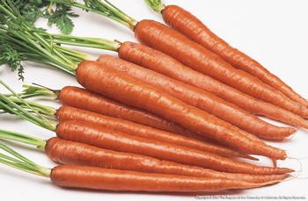

Vegetable Pickles: Carrots, Beets, Asparagus
Pickles are acidified vegetables--vinegar or other sources of acid are key ingredients. Remember to follow tested recipes for vegetable pickles. Omitting or skimping on the amount of acid or not following the directions exactly can lead to illness.
(see How Do I . . . Pickle - National Center for Home Food ...)
(see March veggie happenings Crunchy Mixed Refrigerator Pickles)
(see March veggie happenings Sweet Pickled Radish)
(see Preparing and Canning Pickles Vegetables. How Do I Pickle Carrots nchfp.uga.edu)
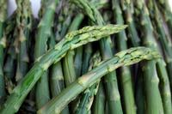
(Preparing and Canning Pickles Vegetables. How Do I Pickle Asparagus nchfp.uga.edu)

Soup: Canning and Freezing
Freezing soup is a little easier and less time consuming than canning.
(see Soups- National Center for Home Food Preservation How Do I www.Canning and Freezing Soup nchfp.uga.edu)

Peas
With careful processing, peas can be preserved to be enjoyed throughout the year. It is recommended that sugar snap and Chinese edible pods be frozen for best quality.
(see Selecting, Preparing and Canning Vegetables: Peas Green or English Shelled nchfp.uga.edu)
(see Freezing Vegetables information)

