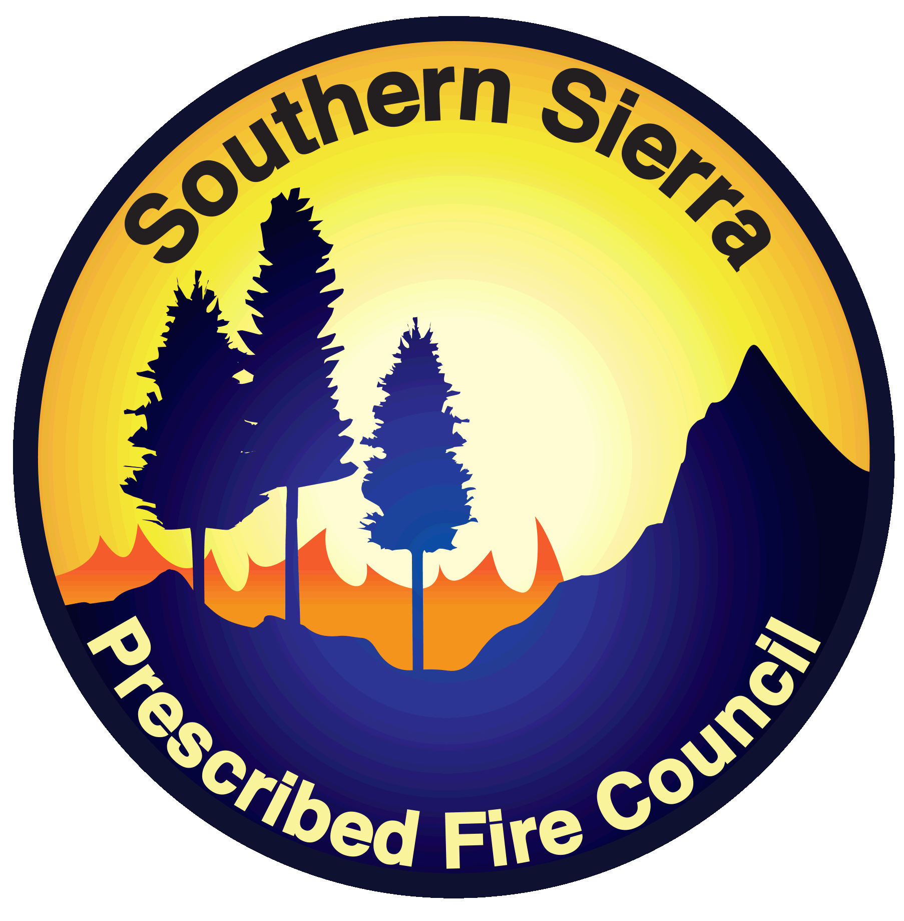
Southern Sierra
Prescribed Fire Council

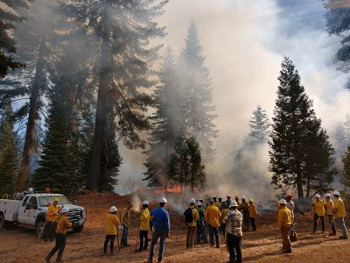
2020 Strategic Plan

Council overview

Vision
The Southern Sierra Prescribed Fire Council envisions the return of beneficial fire to the vegetative landscapes of the central and southern Sierra Nevada.

Mission
Our mission is to expand the responsible use of fire for the benefit of human and natural communities in the southern Sierra region.

scope
The Southern Sierra Prescribed Fire Council covers the southern Sierra foothills and adjacent areas, including the counties of Alpine, Amador, Calaveras, Fresno, Inyo, Kern, Kings, Madera, Mariposa, Merced, Mono, San Joaquin, Stanislaus, Tulare and Tuolumne.

purpose
The purpose of the Southern Sierra Prescribed Fire Council is to promote and facilitate an increase in the responsible use of fire as a management tool in the southern Sierra Nevada region.

goals

- Provide and engage in forums for information-sharing and collaboration between fire managers, policymakers, air regulators, and others involved with advancing the use of beneficial fire in the southern Sierra.
- Promote general public understanding of the natural role of fire in ecosystems as well as the use of fire for risk management.
- Advocate for government policies that promote responsible use of fire.
- Improve regional capacity to responsibly use fire.
- Mitigate conflict between the responsible use of fire and public health and safety.
- Advance the art, science, and practice of fire use by promoting education and research on prescribed fire.
- Collaborate with other Prescribed Fire Councils and Prescribed Burn Associations, including field training opportunities.
- Promote organizational sustainability through planning, capacity building, and accountability.

Operational Structure

Steering Committee
The Steering Committee organizes and leads the activities of the Southern Sierra Prescribed Fire Council. The Steering Committee is made up of representatives from a variety of stakeholder groups to serve as liaisons to communicate information between the Council and their spheres of influence. The Steering Committee guides the actions of the Council in promoting the mission and objectives set forth in the bylaws, strategic plan and annual action plan.

advisory committee
The Advisory Committee is chosen by the Steering Committee for their expertise and involvement within agencies and community organizations to provide guidance and keep the Council apprised of current developments in the realm of prescribed fire.

working groups
The Steering Committee may form working groups focused on a specific task or issue contributing to the mission of the Council. Working groups may be short-term or long-term and are overseen and guided by the Steering Committee.

council members
Council members include practitioners, agency and organization representatives, coalitions representatives and any interested individuals who would like to see the appropriate use of prescribed fire in the southern Sierra Nevada region.

Partner organizations

The Southern Sierra Prescribed Fire Council partners with likeminded organizations to promote the increased use of prescribed fire in the Sierra Nevada, including

- American Forests
- Bakersfield College
- Bureau of Land Management
- CAL FIRE
- California Fire Science Consortium
- Central Sierra Historical Museum
- Defenders of Wildlife
- Fire Restoration Group
- National Park Service
- San Joaquin Air Pollution Control District
- Sierra Forest Legacy
- Sierra National Forest
- SoCal Edison
- The Nature Conservancy
- UC Cooperative Extension
- US Forest Service
- Local Tribes

ONGOING Work plan

Goal 1
Provide and engage in forums for information-sharing and collaboration between fire managers, policymakers, air regulators, and others involved with advancing the use of beneficial fire in the southern Sierra.
- Obtain a bi-monthly update from collaborating agencies and partners to post to the SSPFC website or social media forums (ongoing).
- Conduct an annual membership meeting with updates disseminated among members and to the public (annually).

Goal 2
Promote general public understanding of the natural role of fire in ecosystems as well as the use of fire for risk management.
- Conduct at least one outreach event per year that includes public education on the responsible use of prescribed fire (TBD)
- Develop and disseminate partner outreach materials on the history and importance of prescribed fire on public and private lands (ongoing).

Goal 3
Advocate for government policies that promote responsible use of fire.
- Work cooperatively with agencies and partners to support burn laws and smoke management plans that encourage the use of beneficial fire (ongoing).
- Advocate for changes in policy to minimize liability and risk for landowners to utilize prescribed fire on their land (TBD).
- Promote increased collaboration between public and private land capacity (ongoing).

Goal 4
Improve regional capacity to responsibly use fire.
- Identify opportunities and barriers to the use of prescribed fire on public and private lands (2021).
- Advocate for the training of at least one individual from the southern Sierra for the first year in the CARX Burn Boss program (2021).

Goal 5
Mitigate conflict between the responsible use of fire and public health and safety.
- Identify the sources of conflict and establish a plan to mitigate said conflict (TBD).
- Collaborate with public health and air quality agencies to develop fact sheets and a notification system for persons with respiratory issues (TBD).
- Encourage the expansion of Purple Air or other air quality monitoring system networks in local communities in the southern Sierra (ongoing).

Goal 6
Advance the art, science, and practice of fire use by promoting education and research on prescribed fire.
- Disseminate research and outreach materials that supports the beneficial use of prescribed fire (ongoing).
- Collaborate with universities and colleges to support fire ecology and research programs that promote the use of prescribed fire (TBD).
- Promote collaboration with research organizations to conduct prescribed fire research on various vegetation types on burns being conducted in the southern Sierra (TBD).

Goal 7
Collaborate with other Prescribed Fire Councils and Prescribed Burn Associations, including field training opportunities.
- Identify and send representatives to encourage the formation of Prescribed Burn Associations in the southern Sierra (as applicable).
- Bring landowners and partners together through locally-based prescribed fire field training opportunities in collaboration with local Prescribed Burn Associations (TBD).
- Represent the Southern Sierra Prescribed Fire Council at national and state fire council meetings (ongoing).
- Participate in the Cal PBA coalition (ongoing).

Goal 8
Promote organizational sustainability through planning, capacity building, and accountability.
- Conduct bi-monthly steering committee meetings (ongoing).
- Encourage members to participate in committees and workgroups that advocate for the vision and mission of the Southern Sierra Prescribed Fire Council (as applicable).
- Periodically review bylaws and strategic plan to propose changes as needed (as applicable).
- Establish work groups as needed to promote council goals (as applicable).

