Useful Websites

*UC Master Gardeners: http://mbmg.ucanr.edu/
For upcoming workshops and Hotline information.

*Monterey Bay Friendly Landscapes: https://green-gardener.org/
For workshops, lists of certified green gardeners, landscape designers, and local rebate programs
from water districts.

*California Native Plant Society: https://chapters.cnps.org/montereybay/
Plant information and identification

*Calscape: https://calscape.org/
An indispensable website for native plant gardeners.

Books
Reimagining the California Lawn: Water-conserving Plants, Practices, and ...
Book by Bart O'Brien, Carol Bornstein, and David Fross
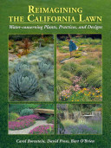

Description
"Reimagining the California Lawn" features water-conserving plants from around the world and offers design ideas and practical solutions to help you create a vibrant garden that complements our mediterranean climate. ...

Lawn Gone! Low-Maintenance, Sustainable, Attractive Alternatives for Your Yard
Book by Pam Penick
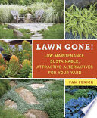

Description
A colorful guide covering the basics of replacing a traditional lawn with a wide variety of easy-care, no-mow, drought-tolerant, money-saving options that will appeal to today's busy, eco-conscious

Plant Sales and Nurseries
California Native Plant Society plant sale is Saturday, April 13 at the UCSC Arboretum

The Cabrillo plant sale is Mother's Day weekend
May 10-12 (May 10 members preview, $25 donation)

