Kids’ Hunger Doesn’t Take a Spring Break:

While closed for COVID-19, California districts can serve meals over spring break

School districts can keep providing their students with healthy meals over the spring break, even while they are closed for safety during the COVID-19 pandemic. Of course, these meals help kids stay healthy and ready to learn when school resumes. They also help families stretch their food budget by offering their children meals free of charge and bring revenue into financially strapped districts. In California, Governor Newsom has made continued non-congregate school meal service on school days a necessary condition of state funding during school closures related to COVID-19.

Exemplary Practice: Spring Break Meals in One California School District

What COVID-19 meal service was being provided before spring break?
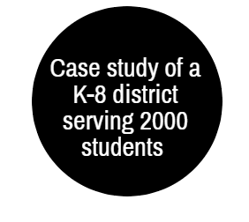
About 1,800 packages daily that include breakfast and lunch, with 2/3 distributed by curbside pickup and 1/3 by delivery.

What meal service is planned for the spring break?
Breakfast and lunch to cover each of the 5 spring break days.

- How is it authorized? Through the Seamless Summer Option.
Alternatively, districts could use the traditional Summer Food Service Program.

- How will it be reimbursed? The 2020 reimbursement rates for SFSP meals apply.

- Who is doing this work over spring break? To provide respite for food service staff, 5 days of meals were provided on the last scheduled day before spring break.

- When, where and how will the food be served? As with the pre-break meals, 1/3 will be delivered and 2/3 will be picked up on the last scheduled school day before the break, between 10 AM and 1 PM.

- What do the meals contain? Mostly meals requiring no preparation to accommodate those who are classified homeless. Individually wrapped frozen meals will be available after spring break for those who have access to microwave/oven with reheating instructions available in both English and Spanish. The no-preparation meals will still be available for those who do not have access to microwave/oven.
What other information and services are being offered with school meals?
Through partnership with a local hospital, the school meal program also provides a
vehicle for offering other important information to families (e.g., health, unemployment, housing and food assistance programs). The school also provides a trusted site for a Food Bank to deliver meals to fill in weekend days for households.

How is the community thanking essential food service staff?
Through a GoFundMe campaign, a local restaurant is providing free high-quality meals to food service staff and their families.

Is there any additional meal service for which the district is seeking approval?
The district has applied for a CACFP waiver, which will allow them to serve suppers in addition to breakfasts and lunches.

In what other ways are school districts coping with COVID-19 challenges?

- Distributing food: school buses make their usual rounds and drop off meal packages; meals or grab-n-go meals are provided at schools, community centers, libraries, apartment complexes, and churches; meal delivery directly to homes; increased outreach to families to boost participation, donations of fruits & veggies added to meals.

- Finances: leverage LCFF funding; seek community donations.

- Staffing: adjust service times, use volunteers.

- More at: http://www.lunchassist.org/covid-19.html

Let us know what is working well! Contact ceahecht@ucanr.edu

Other COVID-19 school meal information:

Pandemic-Electronic Benefit Transfer (P-EBT) Cards: California is applying for USDA approval to administer the P-EBT program. Created through the “Families First” Act, the P-EBT program is another way to support households containing children who are eligible for free or reduced-price meals (or who attend CEP or Provision 2 schools). Unfortunately, P-EBT will not be ready to administer before many schools are on spring break.
- Learn more at https://frac.org/research/resource-library/pandemic-ebt

USDA Waivers & CDE Guidance for CA Child Nutrition Programs
- Meals may be provided with non-congregate feeding options, https://www.cde.ca.gov/ls/he/hn/schoolmeals.asp
- Meals may be picked up without child present, https://www.cde.ca.gov/ls/nu/cnpparentmealpickupwaiver.asp
- Meal patterns can be modified, https://www.cde.ca.gov/ls/nu/covid19mealpatternwaiver.asp

Other Nutrition Program waivers and flexibilities include monitoring and CACFP. A webpage with quick explanation of the USDA waivers and links to information for CA may be found at https://cfpa.net/new-flexibilities-h-r-6201/
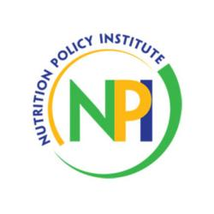
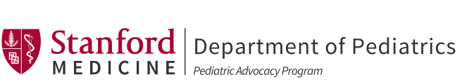

California schools or other community organizations must submit a request to SNPINFO@cde.ca.gov to request approval to operate the SSO or SFSP and serve non-congregate or multi-day meals during COVID-19 at school sites that are dismissed or closed. “The CDE Nutrition Services Division (NSD) can approve existing schools that typically operate SSO or SFSP in the summer months to open a COVID-19 SSO or SFSP site within 24 hours to 36 hours of their request.” See California Department of Education (CDE) webpage for more information, https://www.cde.ca.gov/ls/he/hn/coronavirus.asp

