**Nutrition Policy Institute, University of California, Division of Agriculture and Natural Resources logo** 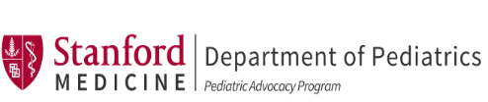

**Calling all Districts! USDA Summer Meals Can Keep Kids Healthy**

Despite COVID-19 school closures, California schools can continue to serve meals over the summer with support from USDA’s extension of waiver flexibilities.This resource will help you get started and provide tips for running successful and sustainable programs.

**The Critical Importance of School Meals This Summer**

California Heroes

California school districts are stepping up to provide school meals after closures due to COVID-19. Schools have played an indispensable role in keeping children and families healthy. We can apply lessons learned since March to set up a robust summer program that serves California’s communities during a time when it’s needed most.

CDE urges “that LEAs take steps to ensure that these opportunities are available to all students, especially disadvantaged students.”

With unprecedented levels of unemployment, far higher than at any time since the Great Depression, hunger is likely to look very different in your neighborhoods. Families whose children never before needed free and reduced-price school meals will need free, healthy food this summer.

**How to Operate While School is Closed**

All schools may be approved to operate under the NSLP’s Summer Seamless Option (SSO). Schools that have been approved to operate the Summer Food Service Program (SFSP) during the previous two years may select that option. To operate either program, submit a request to [SNPINFO@cde.ca.gov](mailto:SNPINFO@cde.ca.gov). Refer to [COVID-19 Guidance for K-12 Schools](https://www.cde.ca.gov/ls/he/hn/schoolmeals.asp) from California Department of Education (CDE) for complete and updated information on how to provide school meals during the COVID-19 pandemic.

**Who is Eligible for Summer Meals?**

Under the SFSP and SSO, **any child** 18 years or younger (and students of any age who are disabled) may receive meals. USDA’s flexibilities during COVID-19 waive area eligibility requirements so that all children may receive free meals through August 31, 2020. Schools with fewer than 50% of students eligible for free and reduced price meals must seek approval from CDE by submiting the online [Area Eligibility Waiver Application](https://surveys2.cde.ca.gov/go/cnpareaeligibilitywaiver.asp). For SFSP and SSO closed enrolled sites, use [SFSP Extension Waivers](https://surveys2.cde.ca.gov/go/sfspextensionwaivers.asp).

**What Meals or Food Assistance Can Be Offered?**

With CDE approval, **meals may be provided every day including weekends, holidays and previously scheduled non-instructional days**. Schools can apply to provide meals all summer long, regardless of whether summer activities or programs would have taken place. Meals may be offered daily or for [multiple days](https://fns-prod.azureedge.net/sites/default/files/resource-files/SSOCOVID.pdf) (up to 5 days) at one time. Depending on programs you are operating, allowable meals include up to three meals per day or two meals and one snack. Food items may be offered [in bulk,](https://www.cde.ca.gov/ls/nu/documents/bulkfoodsfactsheet.pdf) such as gallons of milk, loaves of bread, or whole fruits and vegetables. School sites that are eligible for the Fresh Fruit and Vegetable Program (FFVP) and CACFP At-risk Afterschool Meals may continue to offer program foods during school closures until June 30, 2020. Reimbursement rates vary by program. Visit the CDE website for the current [Child Nutrition Program reimbursement rates](https://www.cde.ca.gov/ls/nu/rs/).

See [FAQs from USDA](https://fns-prod.azureedge.net/sites/default/files/resource-files/SP14-2020s-a.pdf)and [CDE’s SFSP/SSO Summer Meals](https://www.cde.ca.gov/ls/nu/documents/sfspssofactsheet.pdf) 2-page factsheet with checklist.

**How to Take Advantage of Flexibilities Provided by Waivers**

[USDA’s Nationwide and California-specific waivers](https://www.fns.usda.gov/disaster/pandemic/covid-19/california) provide many flexibilities to ease during COVID-19. Many waivers are automatic but for some waivers, operators must apply online through the CDE. Operators must update CNIPS and maintain all applicable records during this time period. Check these resources for current [waiver deadlines](https://drive.google.com/file/d/1s1-R6S63gH33rTHvZOkwpswsW5GF0WhN/view) and [to-dos](https://drive.google.com/file/d/1crBWgoOY0FKT8Fl60Mf6k_6za1OE2X1b/view).

* Submit a request to CDE at [SNPINFO@cde.ca.gov](mailto:SNPINFO@cde.ca.gov) for approval to
  + Serve meals under the SSO/SFSP with USDA flexibilities
  + Provide home meal delivery
  + Provide multiple days’ worth of meals at one time
* At district discretion, [parents are allowed to pick up meals](https://www.fns.usda.gov/tn/child-nutrition-program-meal-service-during-covid-19) without children being present
  + Districts do not need to notify CDE of pick-up plans, but they must have a written policy in place that assures program accountability and maintain records
* If you need flexibility due to food shortages or supply chain issues, use the California [Meal Pattern Waiver Application](https://surveys2.cde.ca.gov/go/mealpatterncovidwaivers.asp), extended by USDA through August 31, 2020

**More Support for Children:**  **Pandemic-Electronic Benefit Transfer (P-EBT)**

California offers P-EBT! Created through the “Families First” Act, the P-EBT program helps families with funds for breakfast and lunch for up to five days per week for each week that school was closed because of COVID-19. P-EBT is another way to support households containing children who are eligible for free or reduced-price school meals (and **all children** who attend CEP or Provision 2 schools). **Families in the program are eligible for P-EBT benefits up to a total of $365 per child AND may still receive meals from their schools during SFSP/SSO meal services.** This program is co-administered by California Department of Social Services & Department of Education. Learn [more](https://www.cdss.ca.gov/home/pandemic-ebt).

You can build P-EBT public awareness!

* Families that are directly certified (enrolled in CalFresh, Medi-Cal or Foster Care benefits) should have received a P-EBT card in the mail in May for their child.
* If children are aged 18 and younger and are eligible for FRP school meals, but are not directly certified, families should apply online at [www.ca.p-ebt.org](http://www.ca.p-ebt.org/).
* **Registration is now open until July 15, 2020.**
* The only information required is: child's name, DOB, parent name, home & mailing address (NO income information, NO evidence of eligibility, NO citizenship status).
* CA Helpline: 833-780-0353. [CDSS Schools FAQ](https://www.cdss.ca.gov/Portals/9/EBT/Pandemic/202005-Pandemic-EBT-Info-for-School-and-School-District-Partners.pdf).
* Assure families that the program is real and that it is recommended they apply, and it does not impact immigration status and public charge.
* Many outreach materials are available at

[www.cdss.ca.gov/pandemic-ebt](http://www.cdss.ca.gov/pandemic-ebt) in English, Spanish and Chinese.

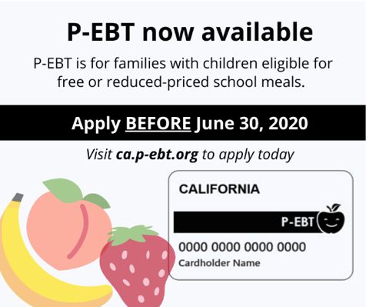

***New deadline!***

***July 15, 2020***

**Innovation & Success – Tips from Districts around California**

Staff Safety and Well-being

**Free COVID-19 Meal Service Resources:**

* [Safety Precautions Toolkit](https://s3.amazonaws.com/kajabi-storefronts-production/sites/91734/themes/1815492/downloads/r73ENmbsSI2VBgOK6XB2_COVID-19_School_Food_Service_Safety_Precautions.pdf)
* [Social distancing meal service signage cards](https://s3.amazonaws.com/kajabi-storefronts-production/sites/91734/themes/1815492/downloads/uqT9n3CQYOk44ynVM1Jg_Social_Distancing_Cards_English_Spanish_.pdf)
* [Safety tip sheets in English and Spanish](https://s3.amazonaws.com/kajabi-storefronts-production/sites/91734/themes/1815492/downloads/bIPs4EHTQYmtuYbLuMfg_Tip_Sheet_Safety_Precautions_English_Spanish_.pdf)
* [Mask use tip sheets in English and Spanish](https://s3.amazonaws.com/kajabi-storefronts-production/sites/91734/themes/1815492/downloads/qn25fGtBSvG81HQr3R59_Tip_Sheet_Face_Masks_English_Spanish_.pdf)
* Find all these and more, [here](https://www.lunchassist.org/covid-19)
* Create safety protocols and train staff on the protocol
  + Proper use of personal protective equipment (PPE)
  + Worker safety in food prep and cooking
  + “No contact” handoffs at drive throughs, walk up stations, and delivery sites
* Consider staffing strategies such as staggered or alternating shifts or designated teams
* Make time for check-ins and recognition to build trust and cohesiveness with your team

Food Supply and Meal Provision

* Increase quality, and reduce labor and food waste by providing items such as fresh fruit, vegetables and milk [in bulk](https://www.cde.ca.gov/ls/nu/documents/bulkfoodsfactsheet.pdf)
* Consider using some of your USDA Foods commodities entitlement to purchase otherwise expensive local fruit and vegetables through USDA’s DOD Fresh Program
* Leverage emergency procurement and micro-purchasing to support local farms
* Schedule meal pickup times that work for parents who are essential workers and work long hours
* A [School Nutrition Association survey](https://schoolnutrition.org/news-publications/press-releases/2020/sna-survey-reveals-covid-19-school-meal-trends-financial-impacts/) shows how districts across the country are distributing food:
  + 64% of districts utilize multiple meal distribution methods
  + 81% have drive through pick up sites
  + 58% allow students/families to walk up to feeding sites
  + 42% deliver meals directly to student homes
  + 32% utilize bus routes for distribution
  + 13.5% partner with local food banks/organizations to provide meals/food assistance

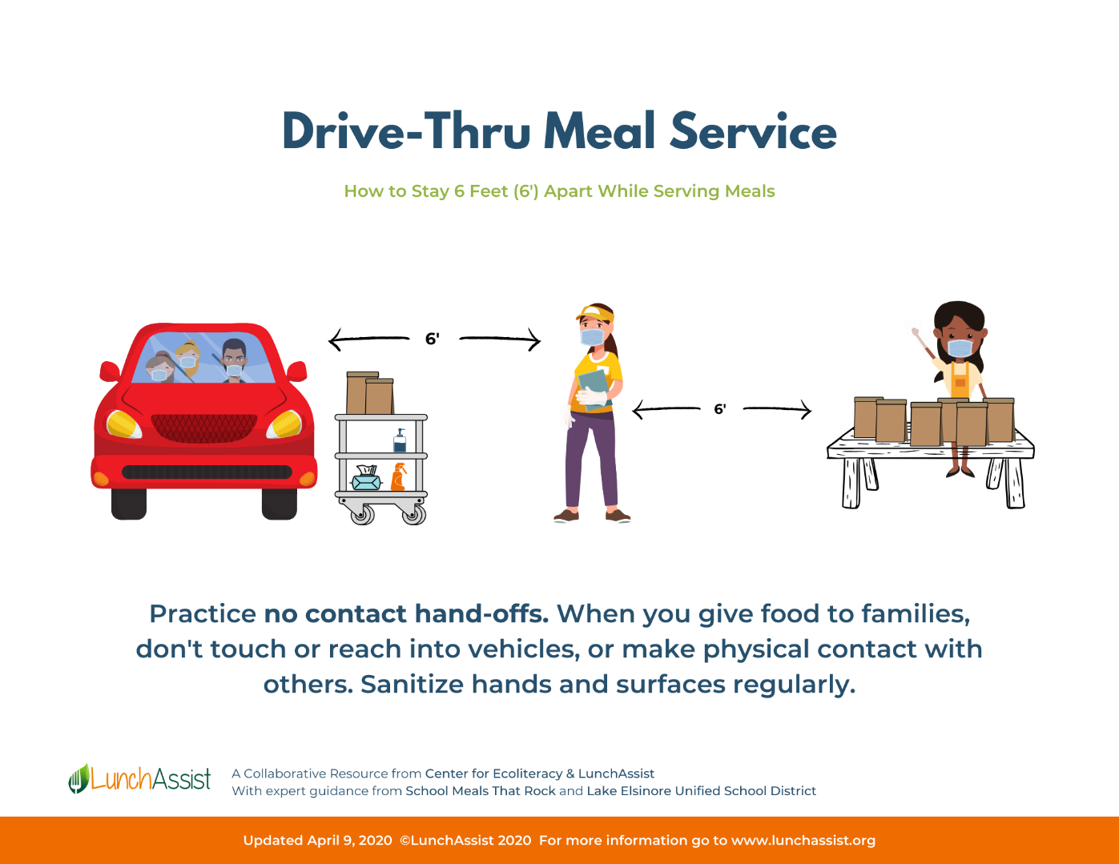

Financial Considerations

* Be sure to use up your Fresh Fruit and Vegetable Program (FFVP) funds by June 30
  + Note: in California, parents may pick up FFVP foods
* If you were previously approved to operate a CACFP At-risk Afterschool Meals program, send supper and snacks home for up to seven days per week between now and June 30
* Apply or re-certify for [Community Eligibility (CEP)](https://fns-prod.azureedge.net/sites/default/files/resource-files/COVID19-CEPDeadlinesNationwideWaiver.pdf?eType=EmailBlastContent&eId=323a47c2-eed7-4965-8eb5-02bc0bc8a3d6) by August 31, using 4/1-6/30/20 ISP data
  + Check for your district in the [Food Research and Action Center database](https://frac.org/community-eligibility-database/)
* Reduce packaging costs by sending foods in bulk rather than in individual portions
* If supply chain or staffing issues are making it difficult to source program foods, apply for the Meal Pattern waiver to give you more flexibility in menu planning
* Source seasonal produce directly from local farms to support the local economy and save money by purchasing direct
* Remember that providing summer meals allows you to continue providing employment and continue supporting your suppliers and your local community

Communications and Community

Boost Participation with Outreach!

* Public announcements on radio or TV
* Email blasts
* Social media messages
* Automated phone calls
* Website announcements
* Newspaper notifications
* Community partner newsletters (e.g. food banks, mayor’s office, YMCA)
* Provide program information:
  + Communicate as widely as possible and in multiple languages to ensure that parents, guardians, and children are aware of the availability of meals
  + Let families know about social distancing and mask use so they know what to expect at sites
  + Provide information about preparing and storing meals at home. This is required for meals sent in bulk
  + Update families on program changes or new opportunities at your site (e.g. visit from the food bank)
* Use meal distribution sites to:
  + Distribute curriculum materials
  + Offer other important information to families (e.g., health, unemployment, housing and food assistance programs)
  + Distribute additional food donations to families through partnerships with local food banks and businesses
  + Connect with local community stakeholders such as the library, farmers, or social services
* Connect with your local Cooperative Extension for nutrition education resources
* Qualify as a pick-up location for USDA Farmers to Families Boxes (program currently operates until August 30, 2020)
* Refer to CDE’s [Community Engagement](https://www.cde.ca.gov/ls/nu/cnpcommunityresource.asp) resource

The authors wish to thank the Center for Ecoliteracy and LunchAssist for providing information on food service innovations and successes, to FRAC, the Center for Ecoliteracy and LunchAssist for resources and review, and to CFPA for review. All of the authors of this publication are members of the ad hoc COVID-19 School Nutrition Implications Working Group, jointly supported by Healthy Eating Research, a national program of the Robert Wood Johnson Foundation, and the Nutrition and Obesity Policy Research and Evaluation Network (NOPREN). NOPREN is supported by the Centers for Disease Control and Prevention’s Division of Nutrition, Physical Activity, and Obesity Cooperative Agreement No. 5U48DP00498-05. The findings in this publication are solely the responsibility of the authors and do not necessarily represent the official views of the HER, CDC, RWJF, FRAC or CFPA.

**Nutrition Policy Institute, University of California, Division of Agriculture and Natural Resources logo** 