User manual – New Reviewer Dashboard in ANR Portal
Revised 3/18/2021

Background
This user manual is for utilizing the new reviewer dashboard in ANR Portal as a supplement to Interfolio. The new reviewer dashboard will allow all levels of supervisors/reviewers to review the appropriate candidate materials at any time. This allows secondary supervisors, ad hoc, and peer review committee members more time to review materials.

Supervisor/Reviewer Comments and Due Dates
Any comments that must be submitted have to continue to be submitted in Interfolio in the following order:

- Primary supervisors (with comments from secondary, tertiary, etc. supervisors) review is due in Interfolio by March 19nd at 11:59PM (advancement actions only) and April 16th at 11:59PM (Annual Evaluation)
- Ad hoc review committee comments are due in Interfolio by April 1, 2021
- Peer review comments are due in Interfolio by May 24. (AHR will upload those PRC comments reviewed by AAC PC)
- Advancement letters will be sent out on or around June 18, 2021

Logging in to the new reviewer dashboard
- Log in to ANR Portal
- In the middle column, find the ANR Academic Program Review section and click on the bold Your assigned reviews link to enter the new dashboard.

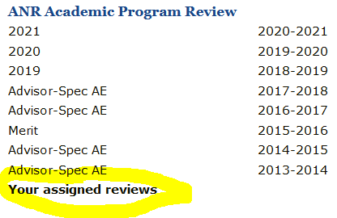

Step by step instructions for using the new reviewer dashboard

- Open a case - Click on any tile on the left to open a case.

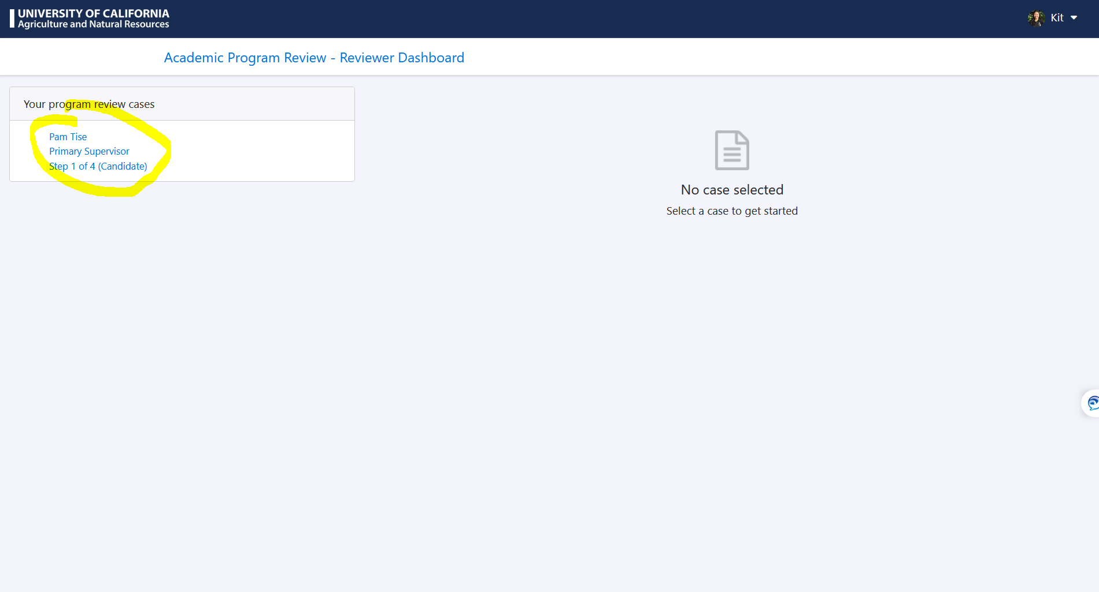

- Read candidate materials - Click on any file listed under Candidate Files. The file will be downloaded to your computer and/or pop up in a new web browser window.

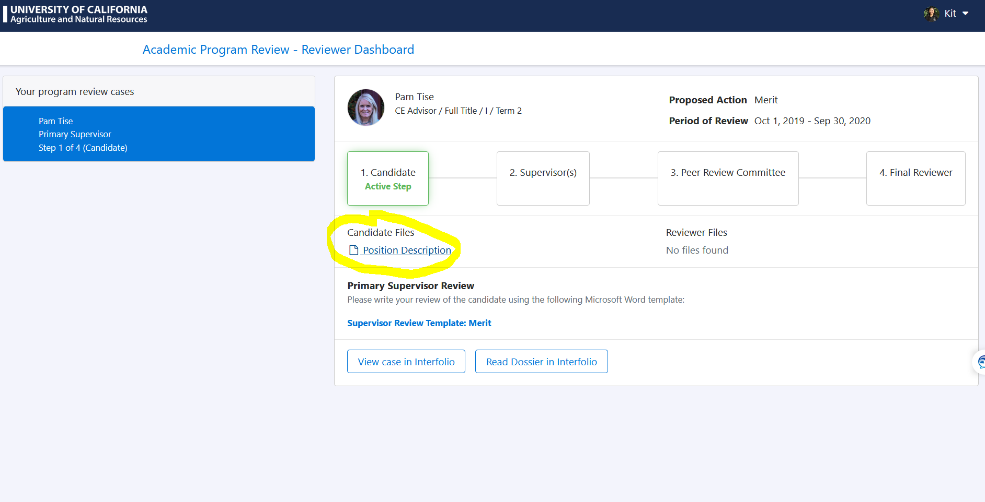

- To get back to the case, go back to the open web browser window with the opened case. To navigate to another case, click on any tile on the left with an individual’s name on it.

- The next step depends on the type of role you have as a reviewer.
  - If you are a primary supervisor, proceed to #5.
  - If you are a secondary+ supervisor who is not required to submit comments in Interfolio (e.g., other county directors), follow the next steps in your process, which may include conferring with the primary supervisor to discuss your comments.
  - If you are secondary+ supervisor who is required to submit comments in Interfolio (e.g., statewide program directors), proceed to #5 when it is your turn. The order of events is displayed in the steps on the screenshot above.
  - If you are an ad hoc review committee or peer review committee member, follow the next steps in your process, which may include conferring with other committee members to discuss your comments. You may proceed to #5 when it is your turn. The order of events is displayed in the steps on the screenshot above.

- Submitting comments in Interfolio - When it is your turn to submit comments in Interfolio, see one of the user manuals below for instructions. Remember that you cannot submit comments in Interfolio until the reviewers before you have submitted theirs. Hopefully, this obstacle will be removed in the future when we transition away from Interfolio.
Supervisor/Reviewer Experience
Peer Review Committee Experience
Ad Hoc Committee Experience

