Summary: Organic Seedling Production

January 18, 2022

Guest Speaker:

Christof Bernau, Center for Agroecology, UCSC

In the first session of the Lunchtime Series for Organic Growers, Christof Bernau shared important tips to consider when creating efficient systems for organic seedling production and improving your bottom line.

Location, Location, Location.
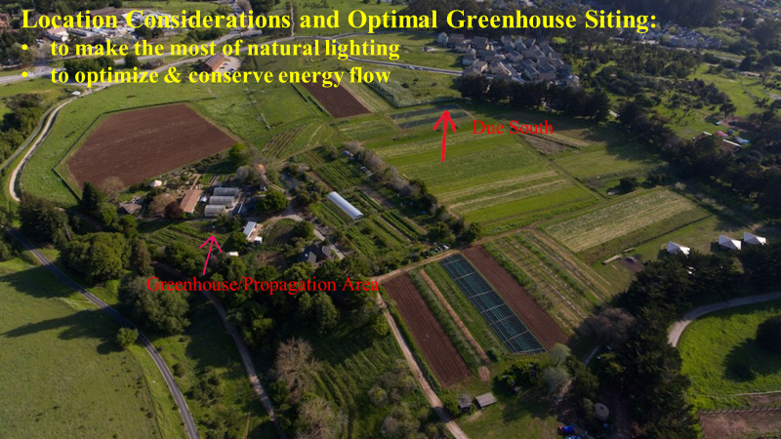
Christof explained it is very important to consider the location of your greenhouse for maximum efficiency. You should take into consideration the physical proximity to trees and other structures that may create unwanted shaded areas. It is also important to keep in mind the distance of the greenhouse to your planting beds. You want to reduce the time it takes to get to and from the beds and the greenhouse.

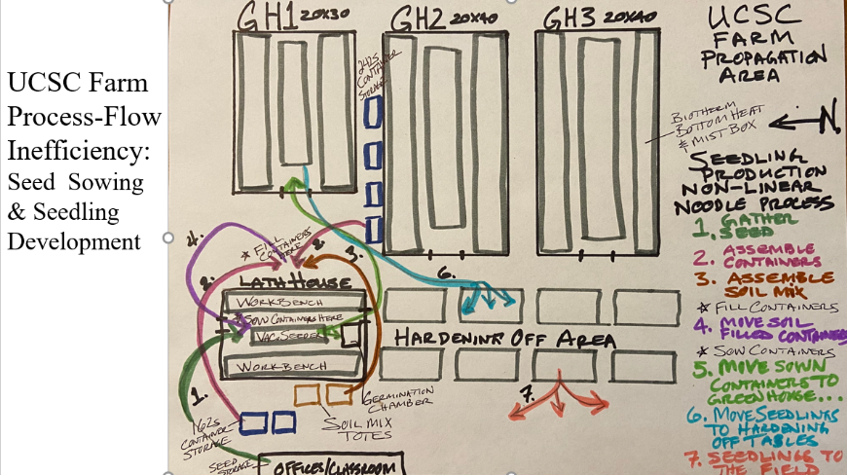
Workspace Design
To maximize your bottom dollar, it is important to consider the layout of your greenhouse workspace. The layout inside of the greenhouse can have a direct impact on the amount of time you spend walking around tables and other tools in your workspace. You can use this time to rearrange the space and tidy up any materials to maximize productivity.

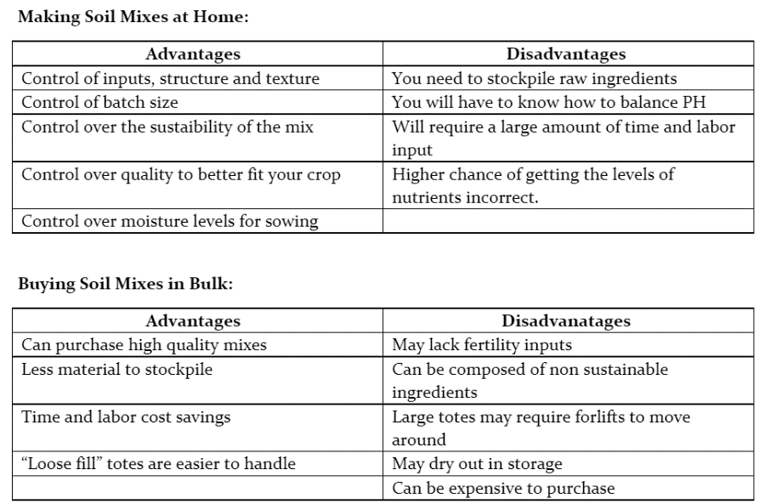
Soil Mixes: Mix or Buy?
There are advantages and disadvantages to making your own soil mixes and buying them. Christof laid out the key points to consider before making a decision on which route to take.

Propagation Containers
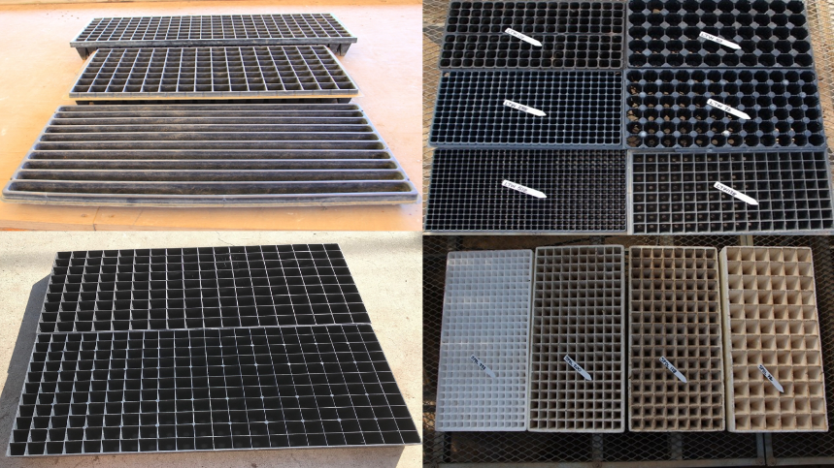
Propagation containers come in different shapes, sizes, and qualities.
When purchasing containers, consider the material of the container that allows for multiple uses. You also want to choose containers that are the right size for the type of seed you will be sowing into the cell. By targeting the perfect container for your seed, you create consistent and uniform seedlings that are easier to transplant.

Sowing Methods
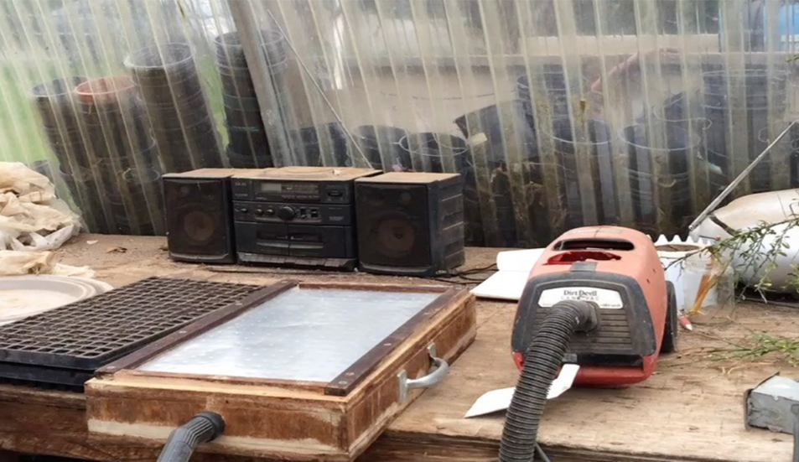
Sowing seeds is one of the more labor-intensive parts of growing your own seedlings. There are multiple tools which can help with the sowing process. Some tools are as simple as a trowel but can be more elaborate like vacuum-seeders.The vacuum seeder is intended to quickly separate individual seeds into their cells. Vacuum seeders can be bought or built at home at a relatively lower price point.

Germination Chambers

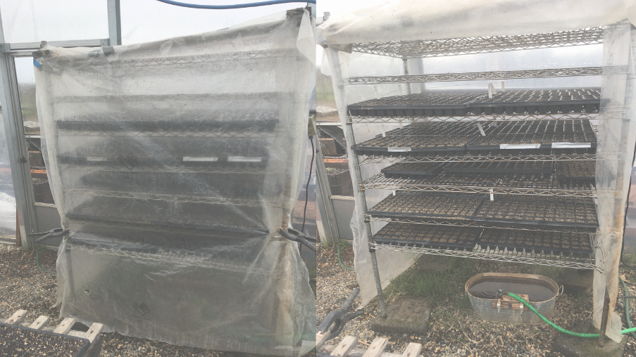
Germination chambers are also a great choice for organic seedling production. They provide an efficient use of space and are relatively simple to build your own.

Watering Methods

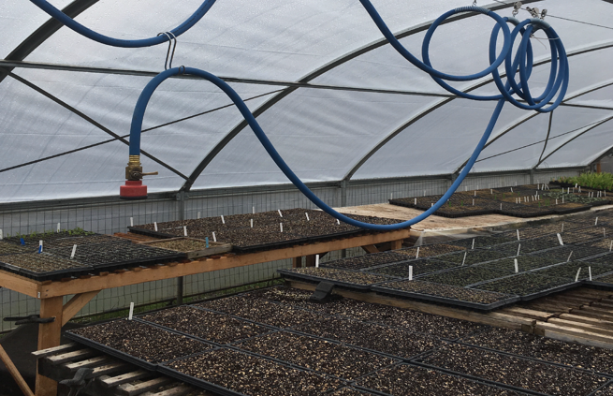
There are a couple of options when it comes to watering seedlings. Automated watering-systems are consistent and reliable however, they can require a large capital investment and may require deeper knowledge of the system to manually adjust it. Once the system is established it reduces the amount of time spent watering seedlings. The second option is the hand watering method. This route is more labor intensive but provides flexibility and success with diverse crops. The hand watering method also requires a learning curve for proper watering techniques but once those techniques are established can be a consistent and reliable method.

Pest and Disease Management

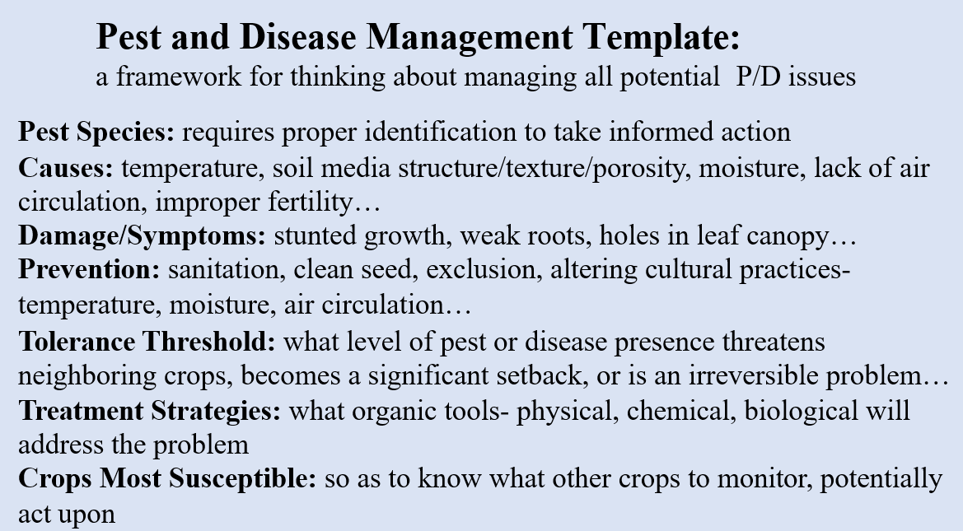
The best way to manage pests and disease is to create a schedule that encourages preventative strategies. This includes frequent monitoring, early detection, treatment and intervention.

