Site-Level Assessment Questionnaire (SLAQ) Protocol

for School, Early Care and Education (ECE), and Out-of-School Time (OST)Sites

Purpose: The Site-Level Assessment Questionnaires (SLAQs) provide comprehensive information for planning CalFresh Healthy Living (CFHL) work in schools, early care and education (ECE) sites and out-of-school time (OST) programs. When completed regularly, the SLAQs also help to track any changes happening related to nutrition and physical activity at these sites. The SLAQ is required for all sites partnering with local health departments (LHDs) to implement CFHL policy, systems, and environmental change (PSE) interventions.
The questionnaire assesses what nutrition and physical activity related policies, practices, programs, and environments are in place and helps to identify opportunities that can help make the healthy choice the easy choice for the children and families you serve. Responses should reflect the current status, even if the situation temporarily differs from “usual practice” due to a health and/or safety emergency such as the COVID-19 pandemic, wildfires, or another situation. Your responses should not include planned or anticipated changes. This helps establish a clear picture of the current situation and gives you and your CFHL program partners greater insight on what actions to prioritize.

If you’d like additional information on how the SLAQs were developed and how they can be used, take a look at the SLAQ one-pager.

Checklist for Completing a SLAQ

Use this checklist to track your progress towards SLAQ completion.

- Meet with your CFHL LHD partner to discuss why, how, and when to complete the SLAQ.
  - Identify a Site Lead (may be yourself) to coordinate SLAQ completion.
  - Identify additional staff at the site that may need to assist in SLAQ completion.
    - For some questions, you may need to reach out to people outside of your school/program (e.g., nutrition services director), or review documents like menus or wellness policies.
  - Discuss and record a deadline for completing the SLAQ

    - Completion date: ___________________
- Determine who on your team should receive a copy of the SLAQ responses and score summary, once completed and submitted online. You may include up to two email addresses. (Pictured below)
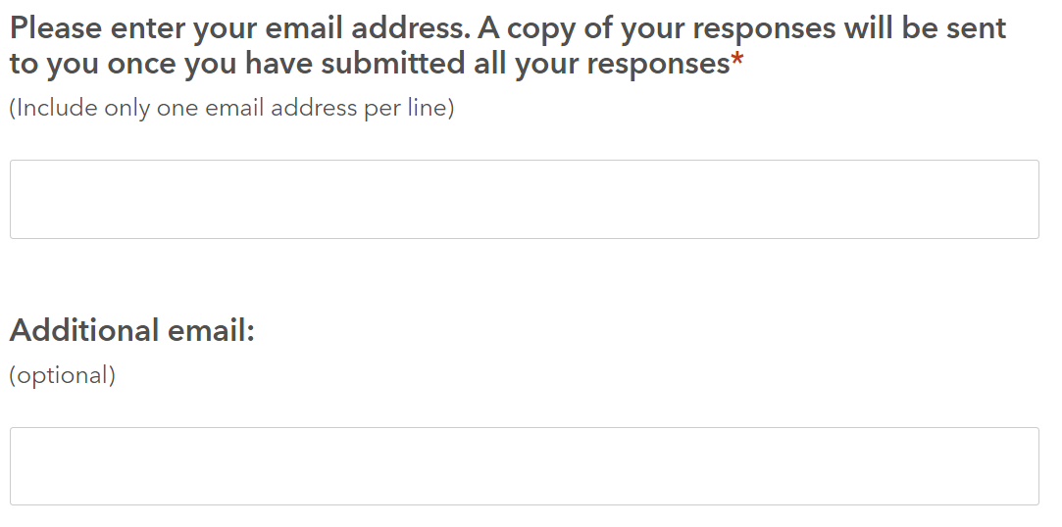
    - Important note! Only enter ONE email address into each field. If multiple addresses are entered into one field, the email summary will not be sent.

- Decide which method you will use to complete and submit the SLAQ: Method 1 (paper/electronic document) or Method 2 (online). Detailed steps for each method are on the next page.
  - Inform your CFHL partner of your chosen method.
  - Together with other staff, collect all information requested.
- The LHD will follow up with you to discuss:
  - Final responses and scores.
  - Action planning. What items have room for improvement and what areas your site may want to focus on as part of CFHL efforts. The LHD may want to use the SLAQ Action Planning Tool with you to help guide these discussions.
Congratulations! You have completed the SLAQ! Thank you for participating.
A step-by-step overview of the two methods you can use to complete a SLAQ
Review each option and decide which method to use. Inform your CFHL Partner of your choice.

Method 1: Using a paper or electronic document
- Download a Word or fillable PDF version of the SLAQ.
- Fill out the word or fillable PDF document.
- When the SLAQ is complete, decide with your CFHL partner who will enter the questionnaire into Survey 123.
    - Site Lead enters into Survey123: If your Site Lead will enter the SLAQ responses into Survey123, see instructions for Method 2 (online completion).
    - CFHL partner enters into Survey123: If the CFHL partner will enter the SLAQ responses into Survey123, double check your SLAQ for completeness and send back to your CFHL contact. If any questions are left blank, they will follow up with you.
Method 2: Online
- Your CFHL contact will send you the Survey 123 link or you can find it here.
- Click on the Survey123 link for the SLAQ you are completing.
- Complete the online survey (see notes below).
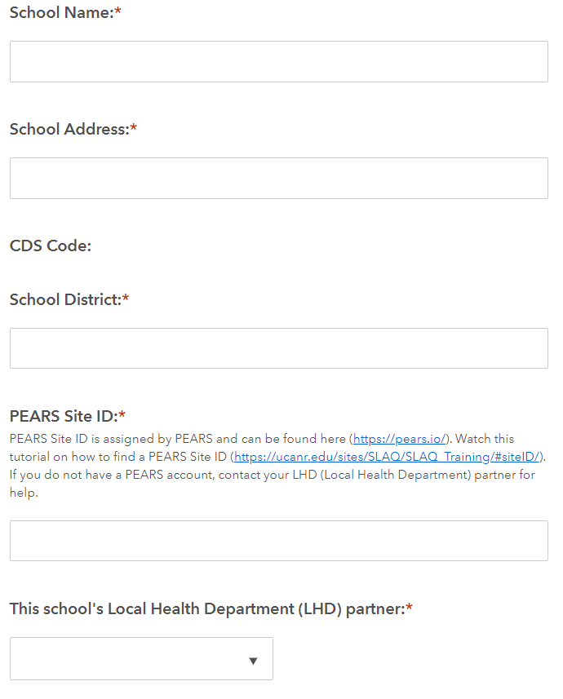
- ￼￼Let your CFHL contact know the SLAQ was submitted.
About the “PEARS Site ID”: The PEARS Site ID can be found using the NPI PEARS Site Search Tool. Watch this video tutorial on how to use this tool to search for a PEARS Site ID.

Notes about the site information section:
If you do not find your school or program’s name in the “Site” drop-down list, you can manually enter the school/site name, address, district name, and PEARS Site ID and Local Health Department partner name (pictured here).

