School District Organizational Assessment Questionnaire (OAQ) Protocol for LHDs

Have a question?

Send an email to [EvaluateSNAPEd@ucanr.edu](mailto:EvaluateSNAPEd@ucanr.edu)

# **NPI Assessment Questionnaires Website and Resources**

OAQ and related resources can be found on the [OAQ webpage](https://ucanr.edu/sites/SLAQ/SLAQ_Questionnaires/School_District_OAQ/):

**Website URL:** <https://ucanr.edu/sites/SLAQ/SLAQ_Questionnaires/School_District_OAQ/>

* Download digital copies of OAQs and LHD activity checklists (LACs)

Find links for Survey 123 to enter and submit completed questionnaires

* Download data collection protocols

Throughout our [NPI Assessment Questionnaires website](https://ucanr.edu/sites/SLAQ/), you can also…

* Access [trainings](https://ucanr.edu/sites/SLAQ/SLAQ_Training/)
* Access [resources](https://ucanr.edu/sites/SLAQ/Resources/), like the OAQ one-pager and [action planning tool](https://ucanr.edu/sites/SLAQ/Resources/#Planning)s to help introduce and use OAQs with school districts
* Review [FAQs](https://ucanr.edu/sites/SLAQ/FAQ/) and [get help](mailto:evaluatesnaped@ucanr.edu) with OAQ or LACs

Each school district you are working with to implement *district-level* Policy, Systems and Environmental (PSE) changes should complete an OAQ **before** PSE implementation begins for the year (ideally between May and October):

## **Checklist for Completing the OAQ**

Use to track your progress towards OAQ completion. Step-by-step instructions found below.

* Initiate a conversation with your school district about filling in the questionnaire.
  + Identify a District Lead to coordinate OAQ completion.
  + Talk to the district about the value and purpose of the OAQ and how to complete it.
  + Discuss WellSAT completion and whether the district currently uses it.
    - *If yes*, ask your district partner to look up their most recent scores and the date the WellSAT was completed.
    - *If no or if WellSAT is more than 3 years old*, work with your district partner to complete the assessment.
* Work with district to ensure completion of the questionnaire.
  + Complete the LHD questions on the “Site Information” page of the OAQ (pg. 2).
  + Send a Word or PDF version of the OAQ to the district by email or mail.
  + Collect the completed OAQ and review for completion. Follow up as needed.
* Enter the completed OAQ responses into Survey123.
* Follow up with the district
  + Share the district’s final responses and scores
  + Discuss action planning

### **Helping schools complete the OAQ**

#### Prepare and plan before sending the OAQ to a school district

1. The first step in completing an OAQ is to initiate a conversation with your partner school district to share the purpose of the questionnaire and develop a plan for completion:
   1. Explain to your school district partner that the questionnaire assesses the **current state** of the districtwide healthy eating and physical activity practices at the school district and is used to help guide conversations and inform future CalFresh Healthy Living efforts. Emphasize that the responses should reflect only the *current, districtwide* practices, not any anticipated changes. This helps to establish a baseline and accurately measure improvement.

**Helpful tip:** You can remind your partner school district that periodic assessment of public schools' compliance with the local school wellness policies is a required part of the Healthy Hunger Free Kids Act. The OAQ can help fulfill that requirement!

* 1. Identify and work with a District Lead to coordinate OAQ completion and communication with your LHD. This person can help identify the most appropriate school district staff who can complete the questionnaire. Depending on the district, OAQ completion may require multiple people, as a single person may not be aware of all of the relevant policies and practices in place at the school district.
     + LHDs should consider engaging the district wellness committee to help with OAQ completion, possibly as an agenda item at a standing or special meeting. In addition, the following district representatives may be helpful:
       1. District Superintendent
       2. Nutrition or Food Service Director or Assistant Director
       3. Physical Education Department
       4. Health Education Department
       5. Early Education Department
       6. School Nurse or Health Coordinator
       7. Wellness Champion or Wellness Policy Committee Lead
  2. If you already use or plan to use a Memorandum of Understanding (MOU) with your school district, we recommend adding in [language about the OAQ](https://ucanr.edu/sites/SLAQ/FAQ/Getting_Buy-In/#MOU).
     + We encourage you to work with the school district to build the OAQ into the Local Control and Accountability Plan (LCAP) in order to further formalize the assessment process. More information on LCAP can be found on the [California Department of Education website](https://www.cde.ca.gov/re/lc/).

Helpful tip: Even if you don’t have a formal agreement with your district, the [MOU language](https://ucanr.edu/sites/SLAQ/FAQ/Getting_Buy-In/#MOU) may be a helpful reference for you to guide conversations with Site Leads about OAQ completion.

1. The district will be asked to provide the scores from their most recent [Wellness School Assessment Tool (WellSAT)](https://www.wellsat.org/) administration as part of OAQ completion.
   1. WellSAT administration needs to have occurred within the **last 3 years.**
   2. About WellSAT: The Wellness School Assessment Tool (WellSAT 3.0) is an online tool used by school districts to evaluate the comprehensiveness and strength of their district’s wellness policies. Visit the [WellSAT website](https://www.wellsat.org/) for more information on how the WellSAT is used in the Triennial Assessment.
   3. Remind your school district to have their WellSAT scores available when they are completing the OAQ.
   4. If your district does not have a recently completed WellSAT, have them complete the assessment on the [WellSAT website](https://www.wellsat.org/).
      * Alternatively, the LHD can complete the WellSAT using a copy of the district’s wellness policy. To be sure you have all documents you need, please review [this video](https://youtu.be/HJZXSltE5SU).
   5. Further information on how the WellSAT is used as part of our district assessment can be found on the [OAQ FAQ page](https://ucanr.edu/sites/SLAQ/FAQ/OAQ/).
2. Work with sites to ensure completion of the OAQ questionnaire.

##### How to complete the OAQ on paper/MS Word/PDF:

We recommend having the district complete the OAQ either on paper, PDF, or a shared MS Word document and then have an LHD staff member enter the responses into Survey123. By using this method, you ensure all questions are accurately completed by the district.

To help a site complete the OAQ on paper, MS Word, or PDF, do the following:

1. **Before sending the form to the district**, fill out the LHD name and PEARS Site ID questions in the “School District Information” section of the OAQ (pg. 2 - pictured below). Make sure the district knows how to return their completed OAQ to you, whether electronically, by “snail mail”, etc.

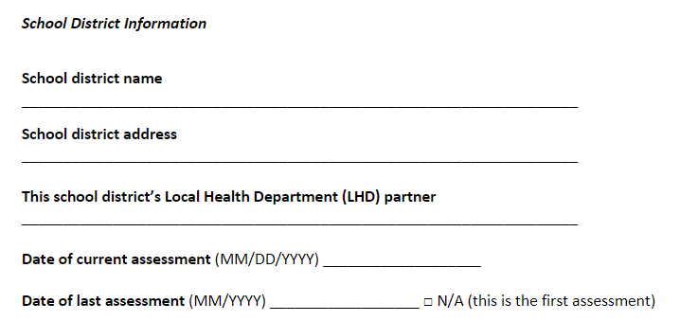

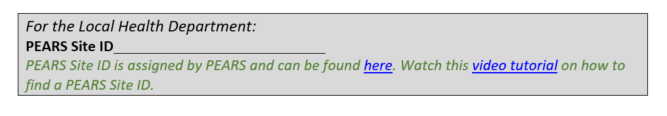

1. The PEARS Site ID can be found using the [NPI PEARS Site Search Tool](https://survey123.arcgis.com/share/281302f15fc549edbad838c30ed4a450?hide=submit). Watch this [video tutorial](https://youtu.be/jtC2PgjxF_I) on how to use this tool to search for a PEARS Site ID.
2. Send the OAQ paper form to the school district along with the district version of the OAQ completion protocol. Check in as needed to ensure timely completion of the OAQ.
   1. **Ways for district staff to complete the OAQ together include:**
      1. Separately e-mail or snail mail OAQ sections to the corresponding school district staff.
      2. Convert the OAQ to a Google Doc or other type of shared Word document and share the link with the appropriate school staff. You can separate the OAQ into multiple shared documents or keep it as one.
      3. Email fillable PDF OAQ and ask the District Lead to pass along to appropriate staff who will help complete the OAQ.
3. As needed, work with the district to score their wellness policy using WellSAT.
4. Collect the OAQ from your school district and **check for completion.** If questions are left blank, please contact the school district to complete the missing questions.
5. Enter the completed OAQ responses into [Survey123](https://ucanr.edu/sites/slaq/OAQ_Questionnaires/).
   1. At the very beginning of the questionnaire in Survey123, you can designate someone to receive an emailed copy of the OAQ responses and score summary.
      1. Two emails can be listed to receive the OAQ report (pictured below). We recommend listing a school district contact and an LHD contact.
      2. **Important note!** Only enter ONE email address into each field. When multiple addresses are entered into one field, the email summary will not be sent.

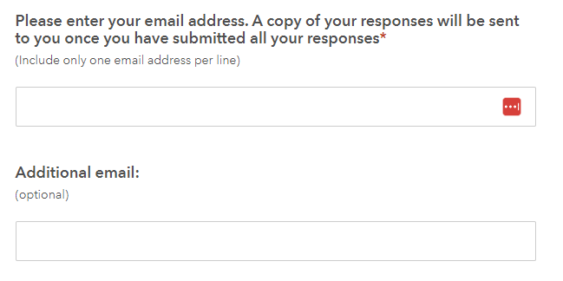

###### To complete the OAQ directly in Survey123:

Below are instructions for school districts who would like to complete their OAQ directly in Survey123. Only use this method if your partner school district is not able to complete the OAQ by paper/MS Word/PDF or requests to complete the OAQ online. To use this method, the school district must have WellSAT scores available prior to beginning the OAQ online. We do not recommend that sites complete their OAQs directly in Survey123 because LHDs are not able to check for completeness and accuracy of responses prior to submission, but sometimes this may be the best method for you and your partners.

1. If the school district opts for online completion, provide them with the information needed to complete the “School District Information” section. Schools Districts will be asked to provide the following information: District name, address, PEARS Site ID and Local Health Department (LHD) name.
2. The PEARS Site ID can be found using the [NPI PEARS Site Search Tool](https://survey123.arcgis.com/share/281302f15fc549edbad838c30ed4a450?hide=submit). Watch this [video tutorial](https://youtu.be/jtC2PgjxF_I) on how to use this tool to search for a PEARS Site ID.
3. Send the [Survey123 link](https://ucanr.edu/sites/slaq/OAQ_Questionnaires/) along with district version of the OAQ completion protocol to the school district. Check in as needed to ensure timely completion of the OAQ.
4. Instruct the District Lead or LHD subcontractor on how to designate someone to receive a copy of the OAQ responses and score summary.
5. At the very beginning of the questionnaire, two emails can be listed to receive the OAQ report (pictured below). We recommend that you list a district contact and an LHD contact (one per email field).
   1. **NOTE:** Only enter ONE email address into each field. When multiple addresses are entered into one field, the email summary will not be sent.

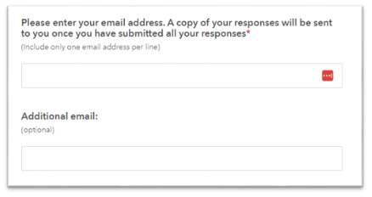

After the OAQ is completed

1. Use the results to guide CalFresh Healthy Living efforts at the school**:** Share a copy of the final OAQ responses and scores with the school.
2. Use the scores in each section to guide discussions on what items have room for improvement and what areas schools may want to focus on as part of CalFresh Healthy Living efforts.
3. Consider using the [School Wellness Policy Action Plan Template](https://ucanr.edu/sites/SLAQ/Resources/" \l "Planning) to guide these discussions.