Site-Level Assessment Questionnaire (SLAQ) Protocol for LHDs

for Out-of-School Time (OST) and Early Care and Education (ECE) Sites

# NPI Assessment Questionnaires **Website and Resources**

Have a question?

Send an email to [EvaluateSNAPEd@ucanr.edu](mailto:EvaluateSNAPEd@ucanr.edu)

All SLAQs and related resources can be found on the [NPI Assessment Questionnaires website](https://ucanr.edu/sites/SLAQ/):

**Website URL:** <https://ucanr.edu/sites/SLAQ/>

On the main [SLAQ Questionnaires page](https://ucanr.edu/sites/SLAQ/SLAQ_Questionnaires/), navigate to the page you need for ECE or OST SLAQ materials.

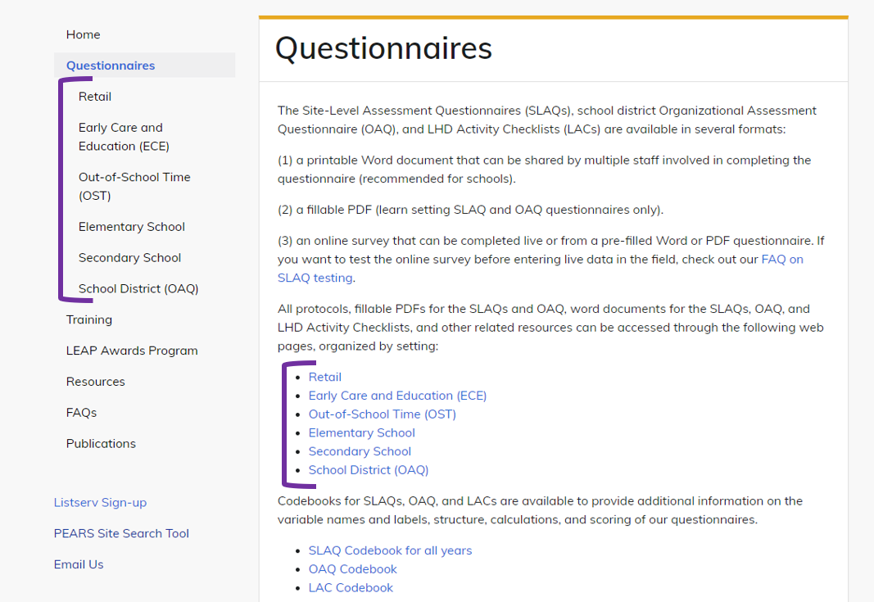

From there, you can download copies of SLAQs, protocols, LHD activity checklists (LACs), and find Survey 123 links to enter and submit completed questionnaires.

Throughout the NPI Assessment Questionnaires website, you can also…

* Access [trainings](https://ucanr.edu/sites/SLAQ/SLAQ_Training/).
* Access [resources](https://ucanr.edu/sites/SLAQ/Resources/), like the SLAQ one-pager and the action planning materials to help introduce and use SLAQs with sites.
* Review [FAQs](https://ucanr.edu/sites/SLAQ/FAQ/) and [get help](mailto:evaluatesnaped@ucanr.edu) with SLAQs or LACs.

Each ECE/OST site you partner with on site-level PSE work should complete a SLAQ **before** PSE implementation:

# **Checklist for Completing a SLAQ**

Use this checklist to track your progress towards SLAQ completion. Detailed, step-by-step instructions can be found below.

* Initiate a conversation with your site about filling in the SLAQ questionnaire.
  + Identify a Site Lead to coordinate SLAQ completion.
  + Talk to the site about the value and purpose of the SLAQ and how to complete it.
  + Work with Site Lead to decide if Method 1 or 2 is best for completing the SLAQ.
* Work with sites to ensure completion of the SLAQ questionnaire.

**Method 1: Paper**

* + Complete LHD name & PEARS Site ID questions in “Site Information”(SLAQ pg. 2).
  + Send a Word or PDF version of the SLAQ to the site by email or mail.
  + Collect the completed SLAQ and review for completion. Follow up as needed.
  + Enter the completed SLAQ responses into Survey 123.

**Method 2: Online**

* + Provide Site Lead with information needed to complete the “Site Information” section SLAQ (pg. 2 on the paper copy).
  + Send the Survey123 link for the SLAQ to the Site with Site Information details.
  + Verify SLAQ completion.
* Follow up with sites
  + Share final responses and scores with the site.
  + Discuss action planning.

LHDs should complete a LAC annually for each ECE/OST site with a SLAQ before the end of the fiscal year

# **Checklist for Completing a LHD Activity Checklist (LAC)**

Use this checklist to track your progress towards LAC completion. Detailed, step-by-step instructions can be found below.

* Check off boxes for policies or practices your LHD’s CalFresh Healthy Living program was involved in adopting or improving.
* Submit the LAC via [Survey 123](https://ucanr.edu/sites/slaq/SLAQ_Questionnaires/).

# **Helping sites complete the SLAQs**

1. The first step in completing a SLAQ is to initiate a conversation with your site to share the purpose of the questionnaire and develop a plan for completion:
   1. Explain to your site that the questionnaire assesses the **current state** of the nutrition and physical activity environment and is used to help guide conversations between your LHD and the sites to inform future CalFresh Healthy Living efforts at the site. Emphasize that the responses should reflect only the *current status* at the site, not any anticipated changes. This helps to establish a baseline and accurately measure improvement.
   2. Identify and work with a Site Lead to coordinate SLAQ completion and communication with your LHD. This person can help identify the most appropriate staff at the site who can complete the questionnaire. Depending on the site, SLAQ completion may require multiple people, as a single person may not be aware of all of the relevant policies and practices within the site.
      * If the program is part of a school district or another “parent” organization, school district/organization-level staff might also be useful for answering certain questions. More information on when to reach out to a school district is detailed in our [FAQ on working with district offices](https://ucanr.edu/sites/SLAQ/FAQ/LEARN/#district).
   3. If you already use or plan to use a Memorandum of Understanding (MOU) with your site, we recommend adding in [language about the SLAQ](https://ucanr.edu/sites/SLAQ/FAQ/Getting_Buy-In/#MOU).
      * Helpful tip: Even if you don’t have a formal agreement with your site, the [MOU language](https://ucanr.edu/sites/SLAQ/FAQ/Getting_Buy-In/#MOU) may be a helpful reference for you to guide conversations with Site Leads about SLAQ completion.
2. Work with sites to ensure completion of the questionnaire. Sites can either submit the SLAQ through Survey123 directly or they can complete a Word or PDF document version of the SLAQ that is returned to the LHD for entry into Survey123.

**NOTE:** if sites complete a paper, Word doc or PDF version of the SLAQ, then the LHD is responsible for entering their SLAQ responses into Survey123.

## To complete the SLAQ on paper or in Word or PDF:

1. **Before sending the form to the site**, fill out the LHD name and PEARS Site ID questions in the “Site Information” section of the SLAQ (pg. 2 and pictured below on page 4). Make sure the site knows how to return their completed SLAQ to you, whether electronically, by “snail mail”, or in-person.

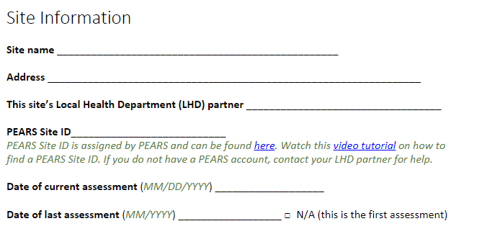

The PEARS Site ID can be found using the [NPI PEARS Site Search Tool](https://survey123.arcgis.com/share/281302f15fc549edbad838c30ed4a450?hide=submit). Watch this [video tutorial](https://youtu.be/jtC2PgjxF_I) on how to use this tool to search for a PEARS Site ID.

1. Send the SLAQ paper form to the site along with the site-facing version of the SLAQ completion protocol and check in as needed to ensure timely completion of the SLAQ.

**NOTE:** A number of translations are available for the ECE SLAQs. Download word document and (non-fillable) PDF versions from the [ECE SLAQ webpage](https://ucanr.edu/sites/SLAQ/SLAQ_Questionnaires/Early_Care_and_Education_ECE/).

1. Collect the completed SLAQ from your site and **check for completion.** If questions are left blank, please contact the site to complete the missing questions.
2. Enter the completed SLAQ responses into Survey123.
   1. At the very beginning of the questionnaire in Survery123, you can designate someone to receive an emailed copy of the SLAQ responses and score summary.
      1. two emails can be listed to receive the SLAQ report (pictured below). We recommend listing a site contact and an LHD contact.
      2. **NOTE:** Only enter ONE email address into each field. When multiple addresses are entered into one field, the email summary will not be sent.

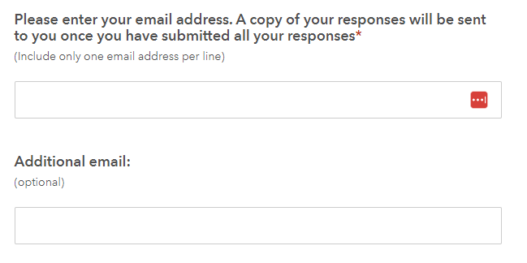

## To complete the SLAQ directly in Survey123:

1. If the site opts for online completion, provide the site with the information needed to complete the “Site Information” section. Sites will be asked to provide the following information: Site name, address, PEARS Site ID and Local Health Department (LHD) name.
   1. The PEARS Site ID can be found using the [NPI PEARS Site Search Tool](https://survey123.arcgis.com/share/281302f15fc549edbad838c30ed4a450?hide=submit). Watch this [video tutorial](https://youtu.be/jtC2PgjxF_I) on how to use this tool to search for a PEARS Site ID.
2. Send the Survey 123 link along with site-facing version of the SLAQ completion protocol to the site and check in as needed to ensure timely completion of the SLAQ.
   1. Instruct Site Lead or LHD subcontractor on how to designate someone to receive a copy of the SLAQ responses and score summary.
      1. At the very beginning of the questionnaire, two emails can be listed to receive the SLAQ report (pictured below). We recommend that you list a site contact and an LHD contact (one per email field).
      2. **NOTE:** Only enter ONE email address into each field. When multiple addresses are entered into one field, the email summary will not be sent.



|  |  |
| --- | --- |
| 1. To access different translations of the ECE SLAQ on Survey 123, click on the globe icon at the top of the Survey 123 webpage for the survey: | Snapshot of menu of languages available for ECE SLAQ |

## After the SLAQ is completed

Use the results to guide CalFresh Healthy Living efforts at the site**:**

1. Share a copy of the final SLAQ responses and scores with the site.
2. Use the scores in each section to guide discussions with sites on what items have room for improvement and what areas sites may want to focus on as part of CalFresh Healthy Living efforts. Consider using the [SLAQ Action Planning Tool](https://ucanr.edu/sites/SLAQ/Resources/) or [School Wellness Policy Action Plan Template](https://ucanr.edu/sites/SLAQ/Resources/) to guide these discussions.

# **LHD Activity Checklist (LAC) steps:**

LHDs should completeLACs at the end of the program year, once all CalFresh Healthy Living (CFHL) related activities are completed, for each site the LHD is working with. The LAC is a way for LHDs to report on where CFHL efforts were focused at a specific site and provide more detail on those CFHL efforts than what is reported in PEARS. The LAC can include in-progress and other work being planned but not yet implemented, unlike in PEARS reporting. This is also different from the SLAQ which assesses the current status of best practices at the site.

**NOTE:** Though encouraged,LACs do not need to be completed for work done at the organization level for ECE or OST sites.

1. Access a digital copy of the LAC from the SLAQ questionnaires [webpage](https://ucanr.edu/sites/SLAQ/SLAQ_Questionnaires/).
2. Check the box for each practice and each written policy that your LHD was involved in improving or adopting at the site during the fiscal year. If your LHD’s CFHL program contributed to policies or practices at a site in only specific areas, you may save time completing the LAC by only reviewing and completing the relevant areas of the checklist. It is not uncommon to have many blank sections of the LAC.

**Example:** Your LHD worked with ECE Site A to bring in more portable play equipment and added a physical activity policy prohibiting withholding physical activity for misbehavior. These were the only areas of practice and policy your CalFresh Healthy Living efforts were involved with during the current program year. You may skip to the relevant items about physical activity and mark those check boxes. Please note that sometimes related items may appear in more than one section.

**NOTE:** A box can be checked even if a site has not yet implemented any changes. LACs are intended to capture the important work that occurs prior to adopting or improving policies and practices, such as providing resources and holding meetings.

1. Go to the SLAQ questionnaires [webpage](https://ucanr.edu/sites/slaq/SLAQ_Questionnaires/), and navigate to the ECE or OST page to submit the LAC via Survey123.

**NOTE:** LACs should only be completed by **LHD staff and subcontractors** working on CFHL projects – you do not need to consult the site to complete the LAC.

If you have questions about when to complete the LAC, check the out the [FAQ on the LHD Activity Checklist (LAC)](https://ucanr.edu/sites/SLAQ/FAQ/LHD_Activity_Checklist/).