Do you have excess produce?
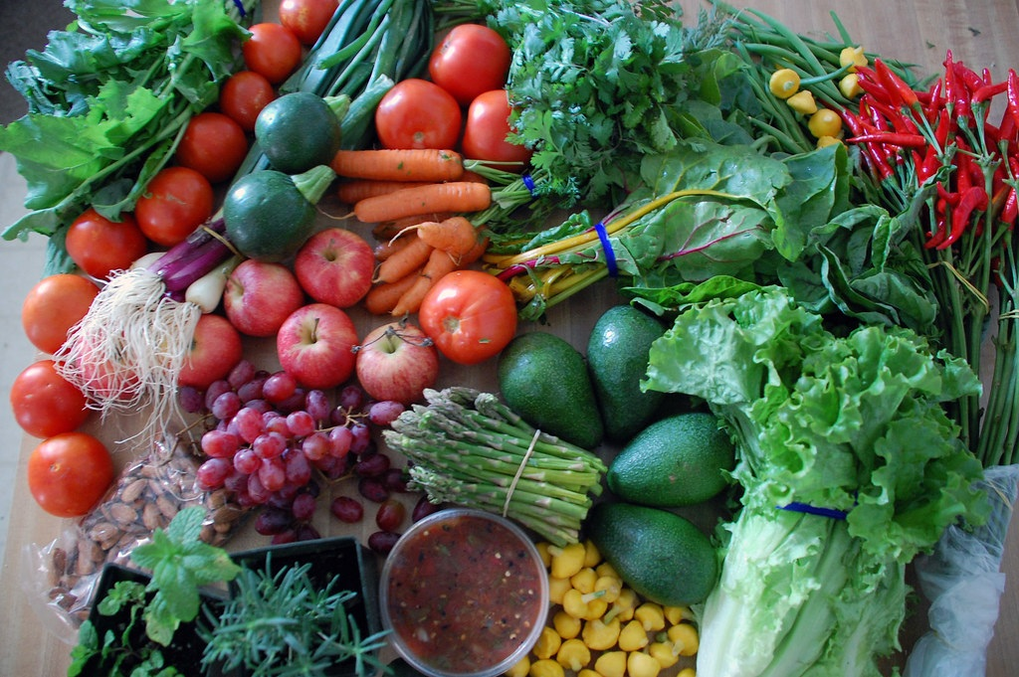
Donate and feed your community!
- Share your home grown or gleaned produce, seedlings, and cuttings! Please no fallen fruit.
- Events will be outdoors. Please wear a mask and observe 6ft of physical distance from others.
- Feel free to take what you can eat, but only touch what you will take.
- All remaining excess produce will be donated to a local food pantry or organization to feed hungry people.
[date/time/frequency]
[location/address]

