Test #__________

Score__________
Swine test level 3 ‘09

WHOLESALE CUTS

Swine Level 3

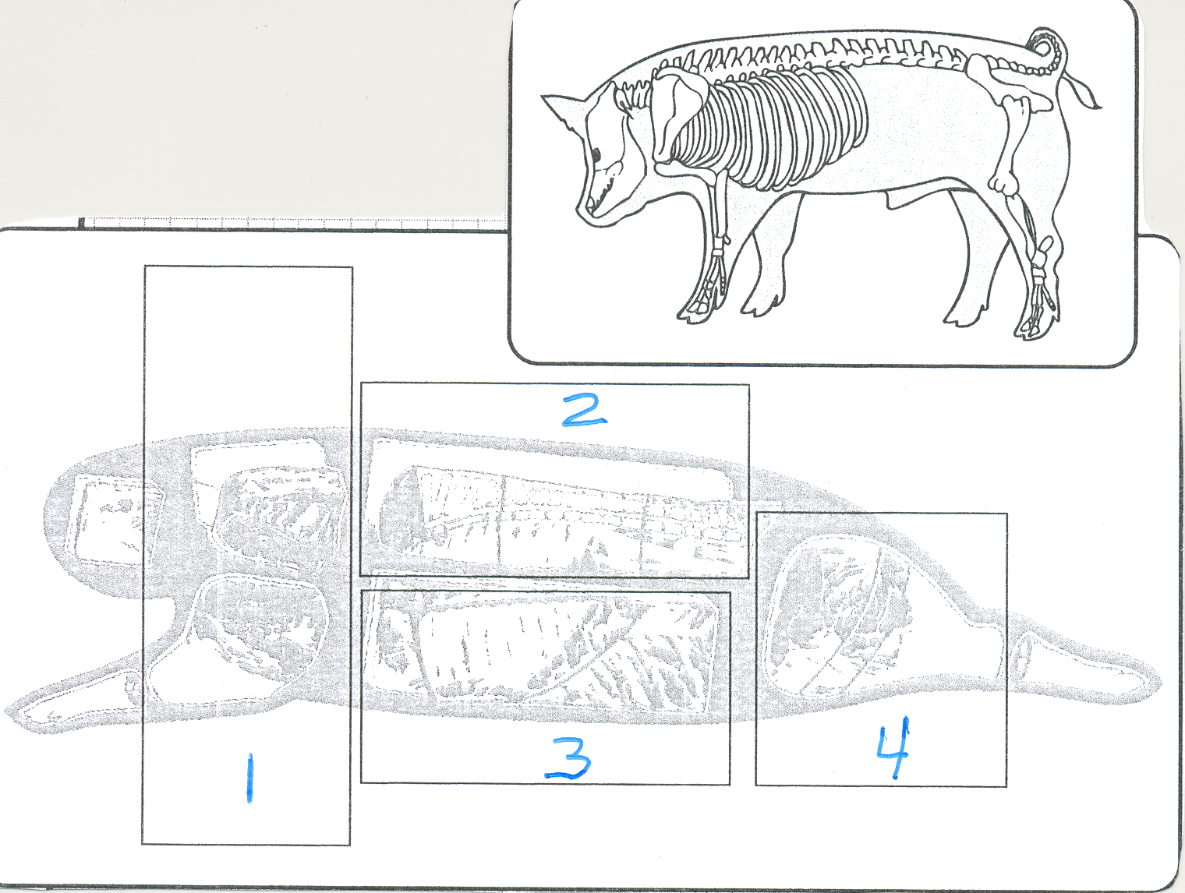
Name__________________________________ Club_________________________
Name 4 wholesale cuts.

1. ________________________

2. ________________________

3. ________________________

4. ________________________

Answers all of the following questions.

5. From what wholesale cut does spareribs and bacon come? _______________________________

6. From what wholesale cut does the picnic come? _______________________________
7. From what wholesale cut does the leg center slice come? _______________________________
8. From what wholesale cut does the center rib roast come? _______________________________
9. From what wholesale cut does Canadian-style bacon come? _______________________________
10. From what wholesale cut do hocks come? _______________________________

