PARTS ID

Test # _________
Score __________________

Swine Level 1 & 2

Name______________________ Club_________________
Put the number next to the name. Identify as many as you can. You will not be penalized for incorrect answers. Level 1 scored up to 10 parts. Level 2 scored up to 20 parts
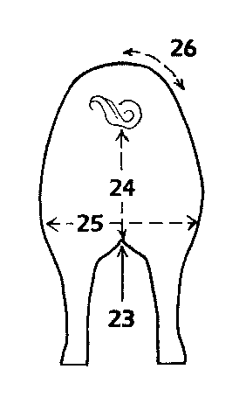
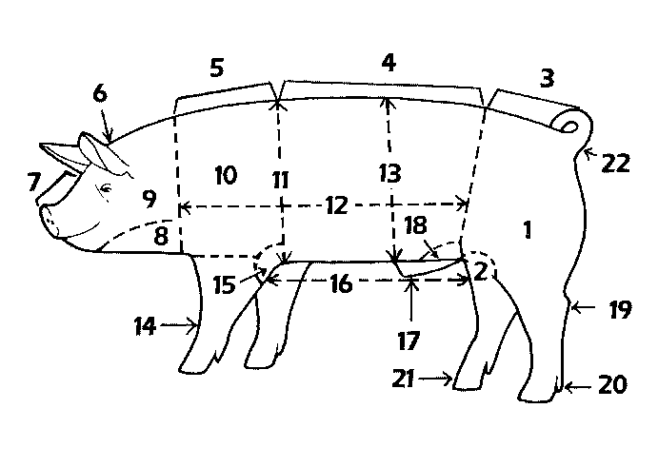

______Elbow

______Pastern
______Jowl
______Shoulder
______Loin
______Shoulders
______Hock
______Dew claw
______Poll
______Width of Stifle
______Depth of side
______Knee
______Underline
______Face
______Rump
______Sheath
______Ham
______Heartgirth
______Neck
______Rear flank
______Stifle region of ham
______Seam or Crotch
______Length of side
______Tail setting
______Depth of Seam or Crotch
______Turn over loin edge

Swine test level 1 & 2 ‘15

