Test #__________
Score__________
Sheep test level 3 ‘09
WHOLESALE CUTS

Sheep Level 3

Name__________________________________ Club_________________________
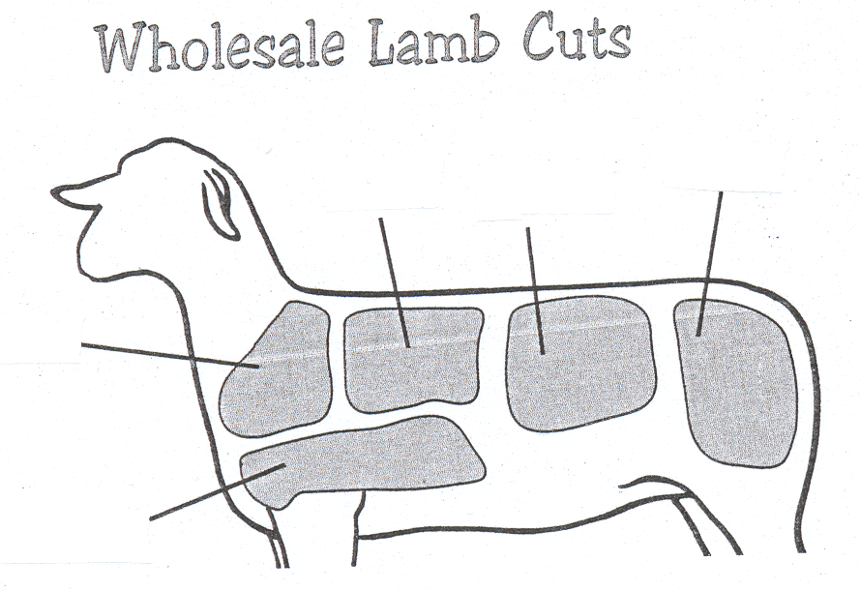
Name 5 wholesale cuts.

1. ________________________
3
4
5

2. ________________________

3. ________________________
2

4. ________________________
1

5. ________________________

Answers all of the following questions.

6. From what wholesale cut does the Fore Shank come? ______________________________

7. From what wholesale cut does the English Chop come? _______________________________
8. From what wholesale cut does the Crown Roast come? _______________________________
9. From what wholesale cut does the Spareribs come? _______________________________
10. From what wholesale cut does Blade Chop come? _______________________________

