PARTS OF THE ANIMAL

Test # ________

Score_________

Sheep Level 3
Name_________________ Club_______________

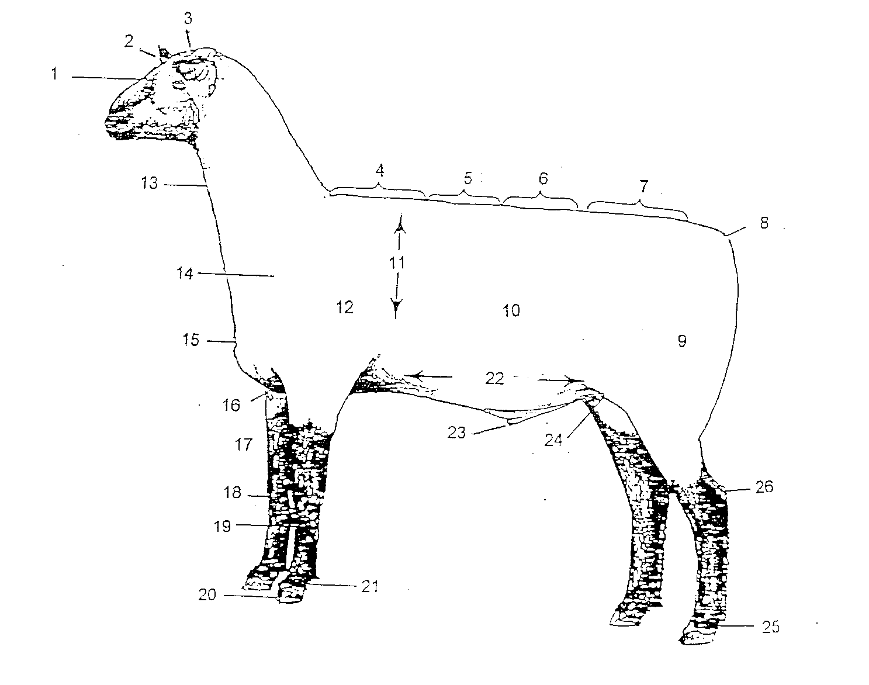
Identify as many as you can. Put the number next to the name. You will not be penalized for incorrect answers. Level III scored up to 25.

- _______________________________
- _______________________________
- _______________________________
- _______________________________
- _______________________________
- _______________________________
- _______________________________
- _______________________________
- _______________________________
- _______________________________
- _______________________________
- _______________________________
- _______________________________
- _______________________________
- _______________________________
- _______________________________
- _______________________________
- _______________________________
- _______________________________
- _______________________________
- _______________________________
- _______________________________
- _______________________________
- _______________________________
- _______________________________
- _______________________________

