Test # ____________
Score _____________
DIGESTIVE SYSTEM
Swine Level IV

Name_________________________________________ Club______________________________
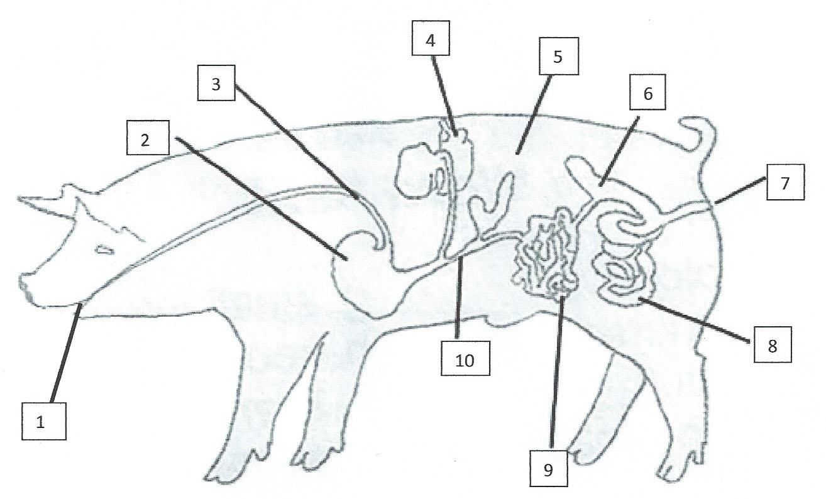
Name 10 Digestive Parts.

1.____________________________ 6._____________________________
2.____________________________ 7._____________________________
3.____________________________ 8._____________________________
4.____________________________ 9._____________________________
5.____________________________ 10.____________________________

Answer all of the following questions.

11. What digestive part is often called the "blind gut"? ______________________________

12. Where are most nutrients absorbed? ______________________________

13. What secretion of the liver aids in the digestion of fats? _____________________________

14. Swine have what kind of digestive system? ______________________________

15. Where does digestion begin? ______________________________
Swine Test Level 4 - 2013

