Dairy Goat
TEST # _______________
NAME _______________
CLUB _______________
SCORE _______________
Dairy Goat Test
Updated 2018
Digestive Quiz - Level 4

Answer the following questions.
- Name the 4 compartments of the rumen stomach. ( 4 points)
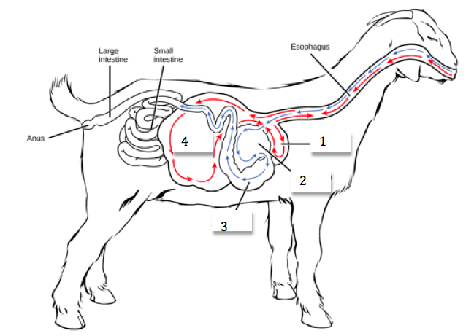

1. ________________________
2. ________________________
3. ________________________
4. ________________________
- The fermentation vat refers to which compartment of the ruminant stomach?
  - Rumen
  - Reticulum
  - Omasum
  - Abomasum

- In young kids that are drinking only milk, which is the only one functioning compartment in the stomach?
  - Rumen
  - Reticulum
  - Omasum
  - Abomasum

- Which of the following is not a compartment in the ruminant stomach?
  - Rumen
  - Macro-Stomach
  - Reticulum
  - Omasum

- Which of the following is referred to as the true stomach?
  - Rumen
  - abomasum
  - Reticulum
  - Omasum

- Which body system is affected by bloat?
  - Mammary
  - Digestive
  - Reproductive
  - Cardiovascular

- What activity distinguishes a ruminant from non-ruminant?
  - Grazing
  - Chewing cud
  - Head butting
  - Producing milk

- What part of a goat’s diet will cause rumen development to occur?
  - Fiber or roughage
  - Minerals
  - Water
  - Fat

- Name the least expensive diet ingredient, which when lacking will affect milk more quickly than any other nutrient?
  - Selenium
  - Salt
  - Hay
  - Water

- What is the largest part of an adult goat stomach?
  - Abomasum
  - Rumen
  - Omasum
  - Reticulum

