Stanislaus County 4-H
Rabbit Proficiency Program
Level 1
____________________________________________________________________________________

Project Leaders must initial and date each item for credit. When the level is completed and signed off, it is to be turned into the County Office .

Name: _______________________________ Year in Project: ________ Age: ______

Club: ________________________________ Project Leader: ___________________

________ 1. Name 6 breeds of rabbits, recognized by the American Rabbit Breeders
Association.
1. ________________ 2. _______________ 3. _________________
4. ________________ 5. _______________ 6. _________________

________ 2. Demonstrate how to handle your rabbits properly. Pick up your rabbit from a carrier, from a cage, from a table.

________ 3. Demonstrate basic grooming. Explain the equipment you are using
and why you are using it.

________ 4. An ulcerated foot pad is also known as ________________________.

________ 5. Demonstrate how to determine the sex of a rabbit.

________ 6. What are the correct terms for:
A male rabbit _____________
A female rabbit____________
A baby rabbit _____________

________ 7. What is the recommended amount of protein a rabbit needs in its feed to maintain a balanced, healthy diet. ________________

________ 8. Demonstrate how to clip toenails.

________ 9. Attend a rabbit event outside your Club.
(another Club’s meeting or activity, rabbit show, County Skills Day)

________ 10. Name the 5 body type profiles and one breed for each profile.

1. ___________________________ ________________________
2. ___________________________ ________________________
3. ___________________________ ________________________
4. ___________________________ ________________________
5. ___________________________ ________________________

________ 11. Name a general disqualification for a rabbit. ___________________

________ 12. What is the purpose of a tattoo. _____________________________

________ 13. Define the following terms:
Fault __________________________________________________
Disqualification __________________________________________
Malocclusion ____________________________________________

________ 14. Identify the following body parts on the picture below.
Ears Dewlap Hock Foot Leg Chest Hip Neck Eyes Mouth Tail

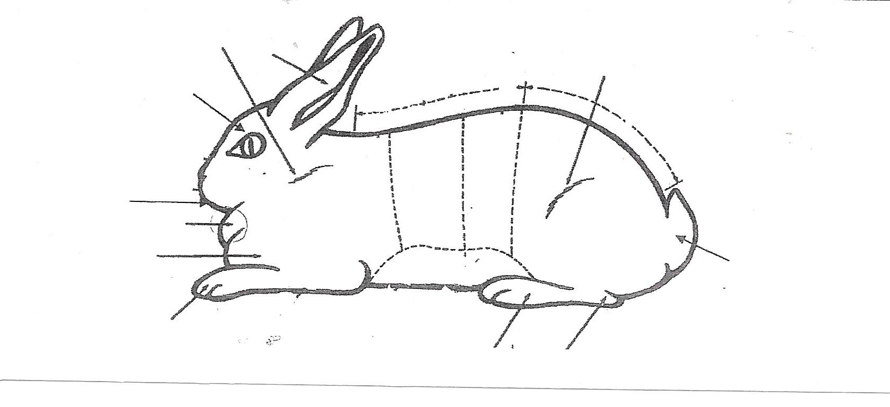

________ 15. For sanitation purposes, what is a good material for flooring in your rabbit cage.

1. Wood ____ 2. Chicken Wire _____ 3. Heavy Gauge Wire ____

________ 16. Describe basic housing for a rabbit, specific to a breed.

________ 17. Explain how heat affects your rabbit, and some things you can do to
relieve your rabbit’s heat stress.

________ 18. Explain the daily nutrition requirements of your rabbit.
(how, when, what, how much you feed and what kind of feed)

By signing below I am agreeing that each of these items has been
completed, therefore completing Level 1 in Rabbit Proficiency.

________________________________ _________________________________
4-H Member Signature Project Leader Signature

________________________________ _________________________________
Parents Signature Date Completed

