Stanislaus County 4-H
Rabbit Proficiency Program
Level 2
____________________________________________________________________________________

Project Leaders must initial and date each item for credit. When the level is completed and signed off, it is to be turned into the County Office .

Name: _______________________________ Year in Project: ________ Age: ______

Club: ________________________________ Project Leader: ___________________

________ 1. Name 12 breeds of rabbits, recognized by the American Rabbit Breeders Association.
1. ________________ 2. _______________ 3. _________________
4. ________________ 5. _______________ 6. _________________
7. ________________ 8. _______________ 9. _________________
10. ________________ 11. _______________ 12. _________________

________ 2. What is the proper term for a rabbit giving birth? ____________________

________ 3. Match the name of the ailment or disorder with the described symptom.

a. Sore Hock _____ Buck Teeth, Butting, Wolf Teeth
b. Wry Neck _____ Signs of nasal discharge, sneezing
difficulty breathing
c. Fur Mites _____ Listless, Loss of appetite, diarrhea
d. Conjunctivitis _____ An ulceration of the foot pads.
e. Snuffles _____ A venereal disease in rabbits, affecting both sexes.
f. Malocclusion _____ An inflammation of the inner membrane of the eyelid.
g. Coccidiosis _____ When the head carries to one side at an angular plane, instead of the normal position.
h. Vent Disease _____ A tiny insect that can infest a rabbit, causing loss of fur on the neck and other areas.

________ 4. Using a breed of rabbit you raise, explain how you would select replacement stock or a project rabbit.

________ 5. Participate in a competition using your rabbit.
(ARBA Show, County Fair, Presentation Day, Skills Day)

________ 6. Identify the following parts on the picture below.
Eyes Ears Dewlap Hock Toes Chest Mouth Tail Belly
Flank Ribs Cheek Neck Leg Foot Hip Shoulder

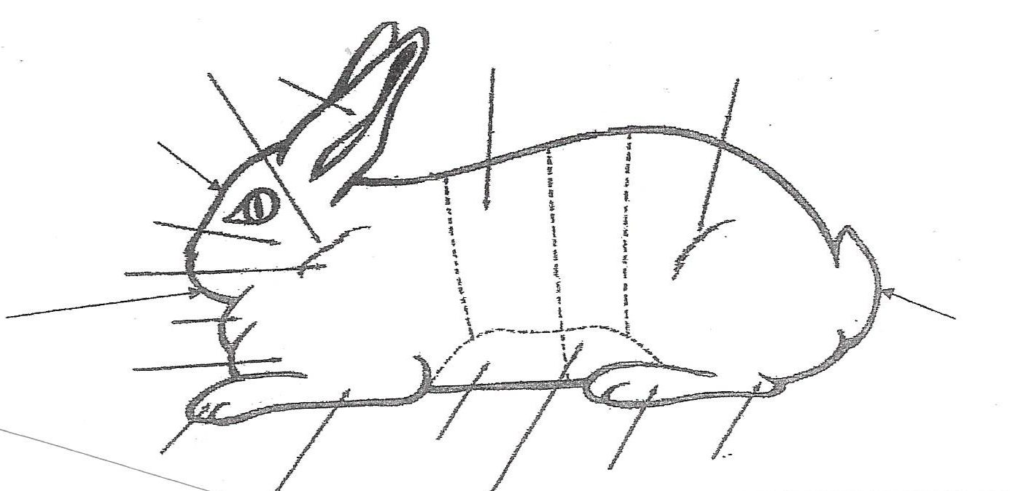

________ 7. Explain and demonstrate how to tattoo a rabbit.

________ 8. Name the six types of fur. Name one rabbit breed with each fur type.

1. _____________________ _____________________
2. _____________________ _____________________
3. _____________________ _____________________
4. _____________________ _____________________
5. _____________________ _____________________
6. _____________________ _____________________

________ 9. Describe the characteristics of each fur type.

1.

2.

3.

4.

5.

6.

________10. What makes Satin fur different from all of the other fur types?

________ 11. List two breeds of rabbits for each body type.
1. Commercial ____________________ _____________________
2. Compact ____________________ _____________________
3. Cylindrical ____________________ _____________________
4. Full Arch ____________________ _____________________
5. Standing Cylindrical _____________ _____________________
6. Semi Arch ____________________ _____________________
7. High Held Head ________________ _____________________

________ 12. Compare and contrast three rabbit breeds with different fur types.

________ 13. Describe and give control measures for three rabbit related health problems.

1.

2.

3.

________ 14. Describe how and why you clean and sanitize your rabbit equipment and facilities.

________ 15. Name the 5 recognized rabbit eye colors.
1. ____________________ 2. _____________________
3. ____________________ 4. _____________________
5. ____________________

________ 16. Demonstrate with competency how to do rabbit showmanship.

________ 17. Name the four possible classes for a light weight breed of rabbit.
1. _____________________ 2. _____________________
3. _____________________ 4. _____________________

________ 18. Name two breeds of rabbit that should not have a dewlap.
1. _____________________ 2. _____________________

________ 19. Wry, dead, bobbed and broken tail are all ______________.

________ 20. What is smut?

By signing below I am agreeing that each of these items has been
completed, therefore completing Level 2 in Rabbit Proficiency.

________________________________ _________________________________
4-H Member Signature Project Leader Signature

________________________________ _________________________________
Parents Signature Date Completed

