Prop 63 – Mental Health Services Act (MHSA).

Building a Healthy California
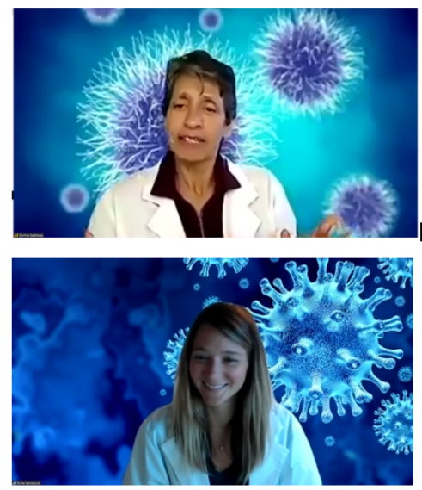
Prop. 63 provides the framework to transform our California mental health system from a crisis-driven system to one focused on prevention and wellness that expands services to reach underserved populations across all of California’s diverse communities. UC ANR has proven programs operating at the community level to positively impact MHSA’s priority areas of 1) Suicide Prevention, 2) Stigma and Discrimination Reduction, and 3) Student Mental Health.

A Focus on Health
The needs of counties varies, but priorities identified by the Mental Health Services Act include:
UC 4-H has a proven record of youth to youth dissemination to build strong leaders and strong lives.
- Childhood trauma prevention and early intervention
- Suicide prevention
- Youth outreach and engagement strategies that target secondary school and transition age youth, with a priority on partnership with college mental health programs
- Culturally competent and linguistically appropriate prevention and intervention
- Strategies targeting the mental health needs of older adults
- Early identification programming of mental health symptoms and disorder

UC ANR can positive impact all these areas. Further our efforts aren’t starting from scratch. We are already a trusted and active partner in communities across all 58 counties.

Opportunity and the Outcomes
UC ANR is ideally situated to strengthen county health efforts. We can build social and emotional health and wellbeing amongst adults and youth by strengthening nutrition, gardening, after-school and physical activities. UC ANR has a strong and proven track record in adult education and positive youth development. We are the proud implementers of
- the country’s largest youth education program (UC 4-H)
- the country’s largest garden education program (UC Master Gardener)
- the states leading natural environment program (UC California Naturalist)
- two of the state’s major nutrition education programs (CalFresh Healthy Living and EFNEP)
- UC Master Food Preserver – a national program that teaches youth and adults to prepare and preserve food safely.

Here’s what we can do and why it matters:

Nutrition. There is a strong link between better eating and healthier lifestyles. “We are what we eat?” (Example References: Nutritional Psychiatry: Your Brain on food Harvard Health and Diet and mental health Mental Health Foundation). Relevant programs: UC Master Food Preserver; EFNEP, UC CalFresh, UC 4-H

Activity - Positive Youth Development makes for stronger societies and greater college preparedness. Managing the largest youth development program in the state, our programs offer multiple benefits for our future leaders (Example Reference: Tufts positive youth development reports UC 4-H). Relevant programs: UC 4-H, UC MG + UC 4-H

Gardening. The mental health and wellbeing benefits of gardening and outdoor activities are well documented. (e.g., 5 Health Benefits of gardening AARP; Petal power: Why gardening is so good for our mental health Psychology today; Reconnect with Nature for your Mental Health Each Mind Matters). Relevant Programs: UC Master Gardener; Junior Master Gardener (UC MG + UC 4-H); UC 4-H, UC CalNat,, UC CalFresh

As a cohort, the UC ANR Health System Resilience Network will
- Provide training and promotion to support youth development along with health and preventative measures.
- Work with other businesses and agencies to adopt practices that reduce the spread of communicable and preventable disease (e.g. working with schools to install windows that open for proper ventilation, working with restaurants to encourage sanitizing tables between patrons, providing training on safe in house product use (e.g., disinfectants), etc.)
- Work on “Health-in-All Policy” initiatives at the county level (e.g. remove incentives for children to go to school sick - “100% attendance awards”, mandate hand-washing facilities at all public venues that meet capacity, encourage cart sanitation at retail stores)
- Educate Californians on how infectious diseases are spread, and the measures they can take to reduce their risk.

Impacts
UC ANR’s programs have a proven history of supporting community behavior change in the areas of health and wellness. The consequence of our efforts is improved community health, reduced health care costs, a vibrant local economy, enhanced youth and adult education, and improved quality of life.

We can reach all elements of communities. Firstly, through our existing school and after-school activities (implemented through our extensive 4-H youth programs, and our talented CalFresh Healthy Living and EFNEP “army” of community-based educators) as well as through our many broader community efforts (implemented through our advisors, UC Master Gardeners, UC Master Food Preservers, UC CalNat, UC IPM, etc.). Of particular note is that our UC 4-H program already has experience in strengthening health and youth development. A further benefit of our youth program is that it is well documented that youth learning builds greater peer acceptance and positively influences adult learning.

By strengthening our cohort of UC ANR community educators we can further strengthen basic health-building behavior. The multi-tiered aspects of what we offer will not just support one part of healthier communities, but will strengthen multiple foundational tenets required for broader community health. Our network will (as it already does) directly engage county and city governments, schools, local health and food system players, county planners, non-profit organizations, and the public to reduce California’s social vulnerabilities.

Why UC ANR
UC ANR has network of UC Cooperative Extension (UCCE) experts with proven expertise to build stronger and resilient communities through leadership, outreach and technical skills in natural resources, agriculture, nutrition, youth development and community health. The UC ANR network is embedded with county governments and communities and provides direct access for communities to the extensive, world renowned and impactful research of the full University of California system. We empower communities at every level. This effort will offer much needed support to bolster those efforts and fill critical needs.
Appendix for reference:

Suggestions on approach:

- Check your counties report : https://www.dhcs.ca.gov/services/MH/pages/mhsa-county-plans-and-updates.aspx
- Use your county report to identify the local health contact for the Mental Health Services Act.
- Review the major activities for your county (using the report)
- Contact the local MHSA representative.
- Ask how might we help them in their program.
- Be prepared to outline the options contained in this fact sheet as to how we (UC ANR) could help them achieve their goals.

Possible support

- As a point of reference, a $1M investment (plus any IDC) would get a coordinator plus 7 to 9.0 Community educators for a year. That could provide programming and impact for a large part of the state using the existing employee connections.

