33rd Annual Fall Desert Crops Workshop
University of California Cooperative Extension - Imperial County held its 33rd “Fall Desert Crops Workshop” at Farm Credit West in Imperial on November 30th. The workshop was run as a hybrid event with in-person and virtual speakers and attendees. At this event, 15 speakers from UC Riverside, UCCE Imperial and Riverside Counties, University of Arizona, Imperial County Agricultural Commissioner Office, Imperial Irrigation District, Western Farm Press, and water industry and private sectors came together to bring innovative ideas and solutions; and disseminate the outcomes of their recent studies and experiences in the desert region. The event was co-organized by UCCE Imperial County advisors; Ali Montazar and Oli Bachie. We thank all presenters, growers, industries, and other participants for making this event successful.
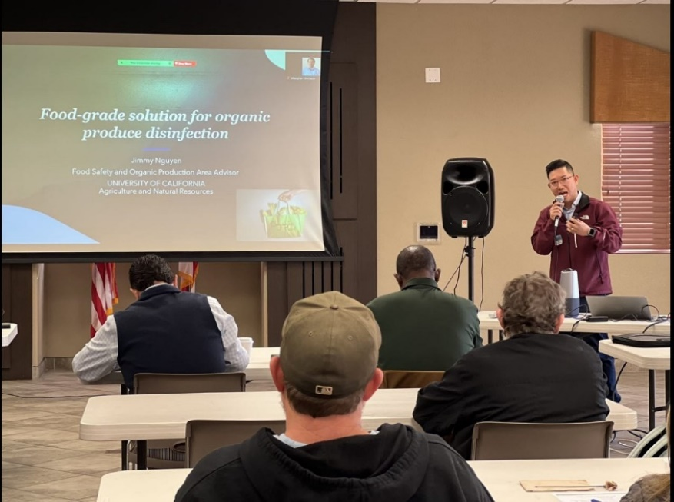

Cuong Nguyen, UCCE Food Safety and Organic Production Advisor, delivers a talk on food-grade solution for organic produce disinfection.

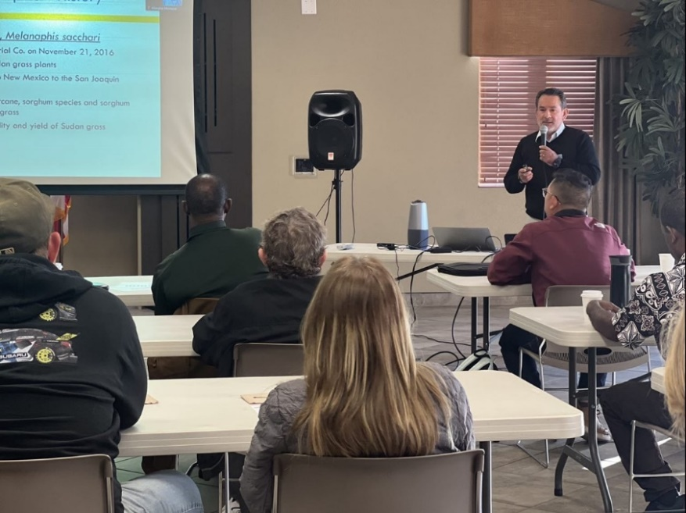

Carlos Ortiz, Imperial County Agricultural Commissioner, delivers a brief on the current pests of concern in Imperial County.
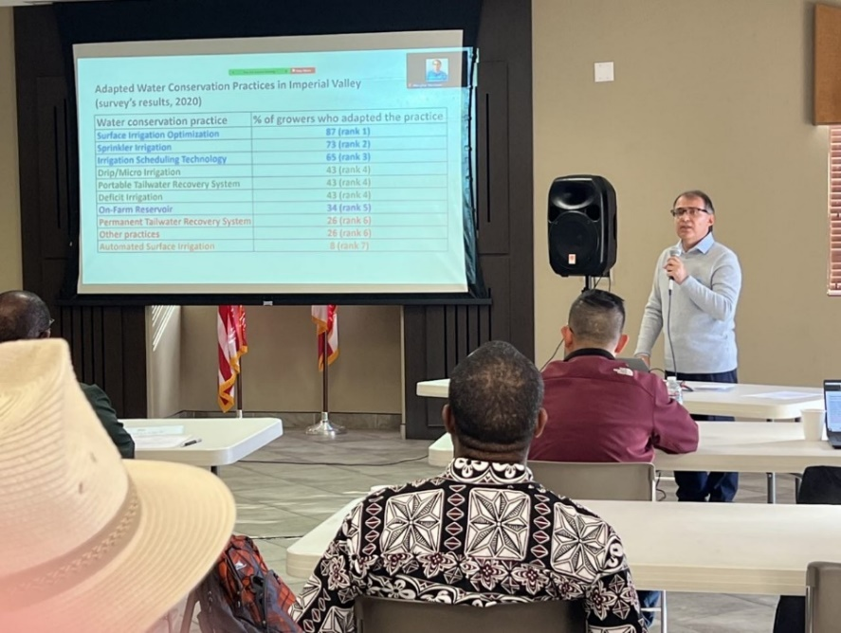

Ali Montazar, UCCE Irrigation and Water Management Advisor, delivers a talk on effective water conservation practices in the low desert region.

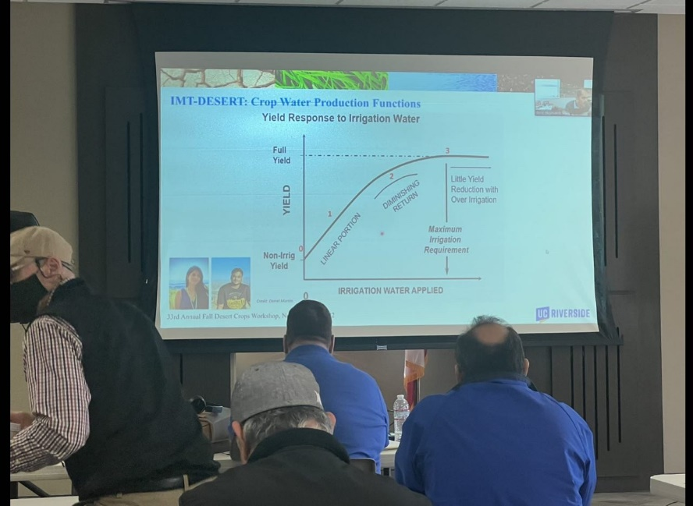

Amir Haghverdi, Associate CE Professor of Irrigation and Water Management at UC Riverside, delivers a talk on IMT-DESERT: An irrigation management tool for southern California desert region (this talk was presented virtually).

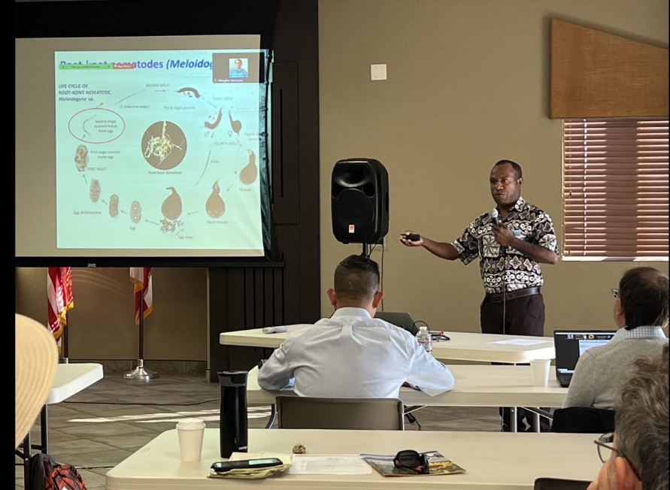

Philip Waisen, UCCE Vegetable Crops Advisor, delivers a talk on integrated nematode and soil health management in vegetable cropping systems.

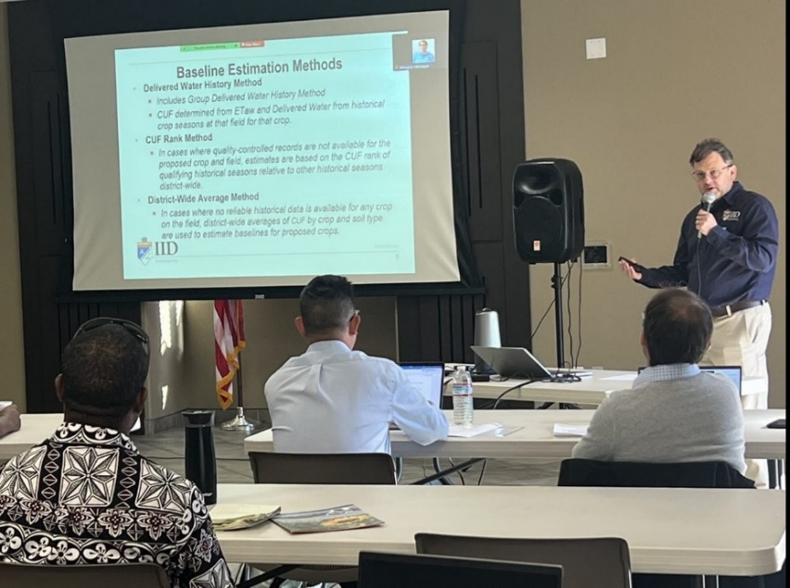
Benjamin Brock, Program Manager of IID On-Farm Efficiency Conservation Program, delivers updates on the IID water conservation program.

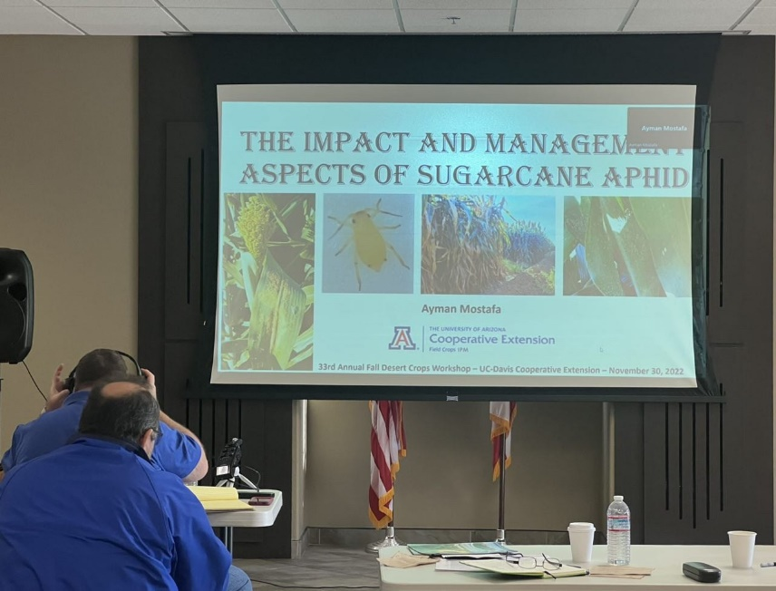
Ayman Mostafa, Area Programmatic Agent and Regional Specialist at the University of Arizona, delivers a talk on the impact and management aspects of sugarcane aphid (this talk was presented virtually).

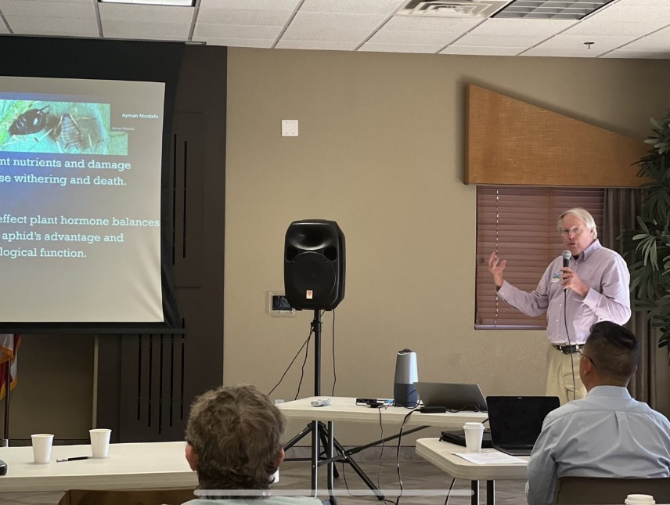

Michael Rethwisch, UCCE Crop Production and Entomology Advisor, delivers a talk on Cowpea aphids in low desert alfalfa.

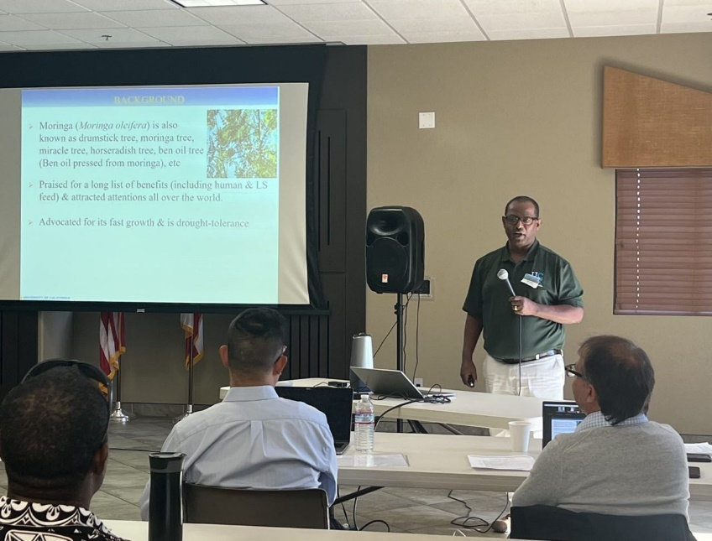

Oli Bachie, UCCE Agronomy & Weed Management Advisor, delivers a talk on Moringa, an emerging multi-purpose crop.

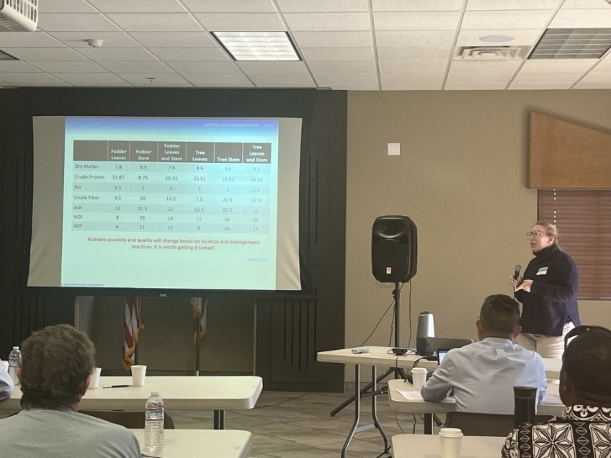
Brooke Latack, UCCE Livestock Advisor, delivers a talk on Moringa, an emerging multi-purpose crop.

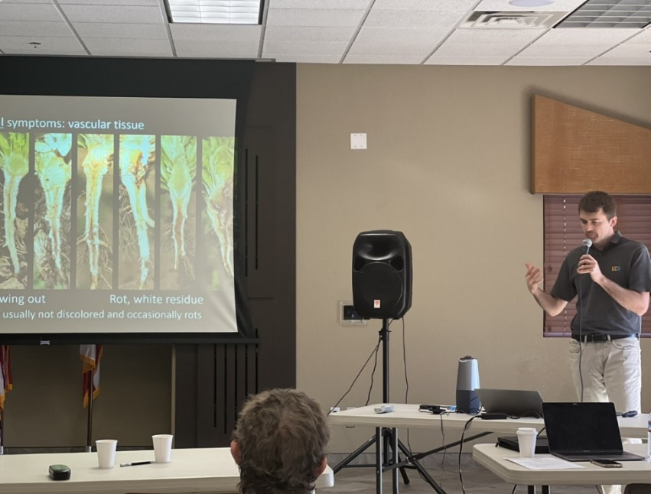

Alex Putman, Assistant Plant Pathologist at UC Riverside, delivers an update on lettuce Fusarium wilt in California.

