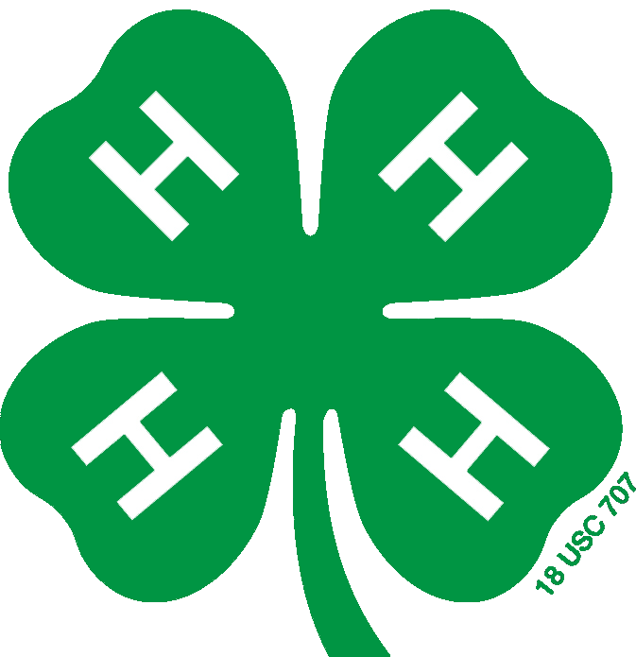
Summary of Previous 4-H Involvement

Include your specific involvement (attended, competed, presented) and the level of participation:
I = Individual, L = Local Club/Unit/Project, C = County/Area/District,
M = Multi-county/Section, S = State, N = National/Multi-State, G = Global

Summary of 4-H Projects

Program Year(s) | Involvement & Level | Project Title and Brief Description

Summary of 4-H Leadership Achievements/Activities

Program Year(s) | Involvement & Level | Leadership Position/Activity and Brief Description

Summary of 4-H Citizenship Activities

Program Year(s) | Involvement & Level | Citizenship Activity and Brief Description

